VCEE Certified Economics Educator: K-3
a program of
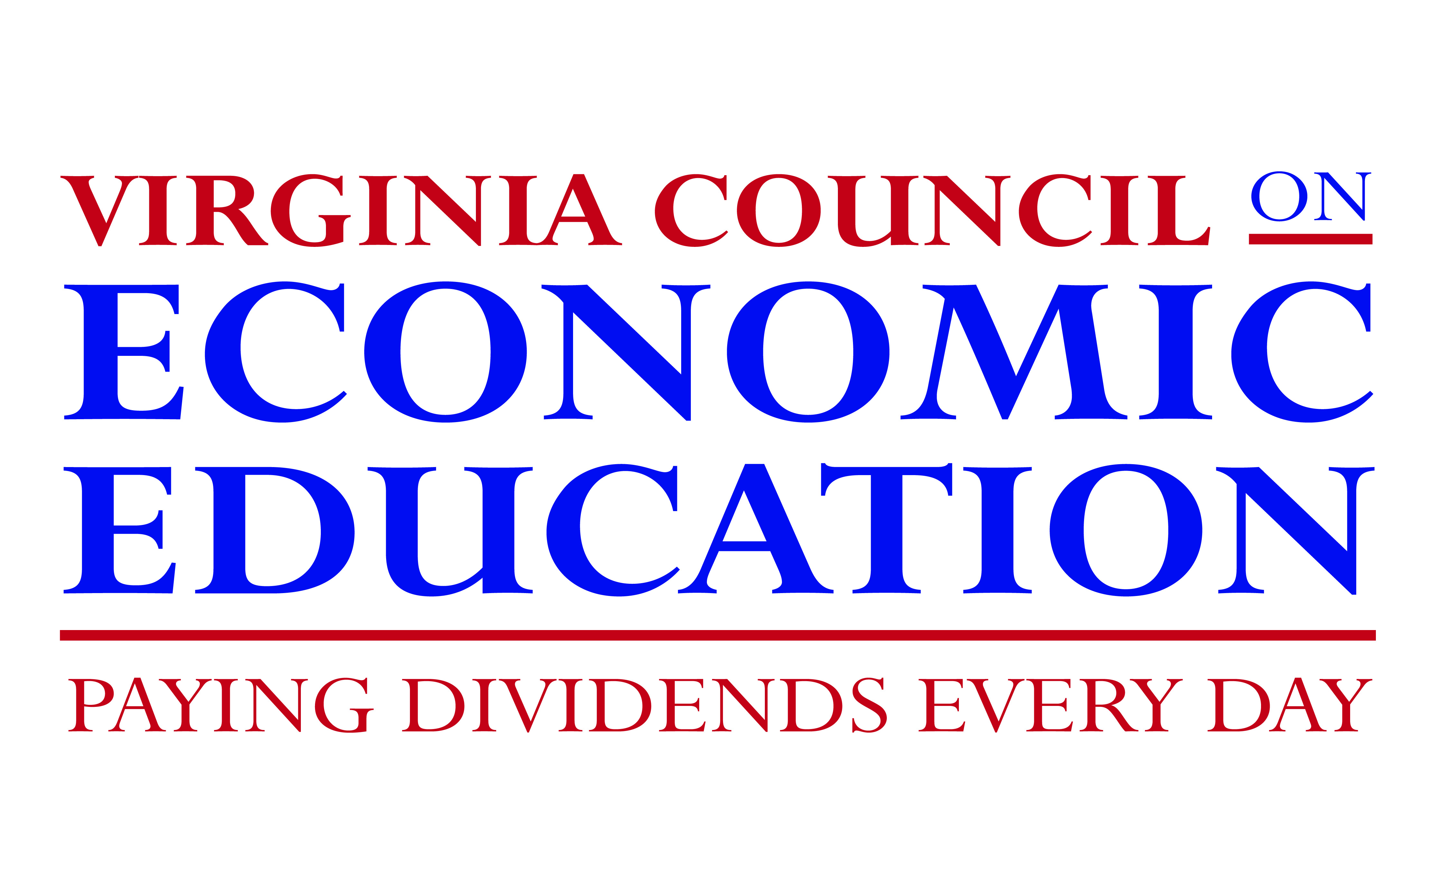
“An investment in knowledge always pays the best interest.”
~ Benjamin Franklin
“If you care about what you do and work hard at it, there isn't anything you can't do if you want to.”
~ Jim Henson

Developing the "economic way of thinking" in students will serve them well throughout their lives as they face a vast array of economic decisions. The broad goal of economic education is to prepare students to function in society as informed consumers, effective decision makers, and productive citizens in an increasingly interdependent, global environment.
The Virginia Council on Economic Education and its affiliated university-based centers for economic education provide professional development programs to assist K-3 elementary school teachers to:
- master the learning objectives (see below) which include a basic understanding of economic concepts and the economic way of thinking,
- teach the economics strand in Virginia’s K-3 Standards of Learning in a manner that is engaging and relevant for their students, and
- become leaders in economic education in their divisions.
This document outlines the objectives of, and overview for, the K-3 Elementary Institute (12 instructional hours.) Teachers who satisfactorily complete this will be recognized as a VCEE Certified Economics Educator: K-3.
Learning Objectives:
Knowledge
The course is designed for K-3 elementary school teachers so that they will be able to identify, demonstrate understanding of, and teach the implications of
- choices and unlimited wants. People have unlimited wants; however, their resources are limited. All choices involve costs. All decisions come with costs.
- human capital. Understanding the relationship between a student’s ability to earn income based on their education and training has important implications for a child’s future.
- production. To get goods and services, people must engage in production. Producers use productive resources (human, natural and capital) to provide goods and services.
- financial literacy. As consumers, students make decisions about spending and saving and must understand that each choice has an opportunity cost.

Attitudes & Behaviors
Students will become:
- Responsible citizens — By acting on relevant information, students will become responsible participants in the political process.
- Productive workers — By investing in their own human capital, students will become more productive throughout their working lives. Introducing “the value of acquiring knowledge and skills” early and often inspires motivation to learn. Kindergarten is not too early to inspire our youngest students to celebrate learning and take pride in it.
- Knowledgeable and prudent consumers, savers and investors — By assessing the costs and benefits of their consumption, savings and investment decisions, students will be better able to provide for their own, their families’, and the nation’s well-being. Young students should have the opportunity to consider whether to spend or save and experience the concept that saving can result in obtaining something better than is possible without saving.
- Effective participants in the global economy — By gaining perspective on their role in the world economy, students will develop the ability to compete in the global marketplace.
- Lifelong decision makers — By exercising reasoning skills and applying economic knowledge, students will learn to make more effective choices in an ever-changing society.

Teachers will be able to:
- Demonstrate how economic concepts can be integrated throughout the curriculum.
- Identify resources and adapt activities for use in teaching the economic strand of the grade specific Standards of Learning.
- Recognize economic concepts in children's literature to enhance student understanding of the economics strand of the Standards of Learning.
- Share enthusiasm for learning the economic way of thinking with administrators, other teachers, students and parents, and thereby become ambassadors for economic education.

K-3 Elementary Institute
As summarized below, the Institute includes four three-hour modules designed to assist K-3 teachers with the content envisioned by Virginia’s Standards of Learning (SOL) as well as creative lessons and resources to use with students. Teachers who
- satisfactorily participate in all 12 hours of in-class instruction and
- complete a pre-test and satisfactory complete a post-test of economic literacy
will be recognized as a VCEE Certified Economics Educator: K-3. All participants will be eligible to earn 12 recertification points from their school division.

Module 1: Economics is About Making Choices
Economics is the study of how individuals, producers, governments and other groups make decisions when faced with a scarcity of resources. Helping students make rational decisions based on facts rather than emotion is an important life skill. This module will provide teachers with decision-making models and cost-benefit analyses as they apply to everyday life. In making rational decisions, people weigh costs and benefits and respond to incentives. Since every choice has an opportunity cost (that is, the choice that is given up), this cost too must be considered, as well as likely consequences, recognizing that the consequences of each choice lie in the future.
Skills K.1, 1.1, 2.1 and 3.1 The student will demonstrate skills for historical thinking, geographical analysis, economic decision making, and responsible citizenship
h) using a decision-making model to make informed decisions;
(Note: This SOL was adopted March, 2015. It and the curriculum framework will be finalized in the 2015-16 school year to become effective in the 2016-17 school year)
K.7a The student will recognize that people make choices because they cannot have everything they want.
1.8 The student will explain that people make choices because they cannot have everything they want.
2.10 The student will explain that scarcity (limited resources) requires people to make choices about producing and consuming goods and services.
3.9 The student will identify examples of making an economic choice and will explain the idea of opportunity cost (what is given up when making a choice).

Module 2: Production: It’s Off to Work We Go!
It is important to help students understand that they are producers and the work they do at school and at home has value. When people work they use resources to help them produce goods and services. These include natural, human and capital resources. Each of us is our own most valuable resource, and an investment in our own knowledge and skills (human capital) is the best investment we can make. We depend on producers in our economy to make the goods and services that satisfy our wants. People work to acquire the things they want such as housing, food, and movie tickets. When we are working, we are human resources either selling our physical and intellectual skills to our employers, or providing services to our families that would otherwise require paying someone to perform. Our income, or saving through home production, allows us to have the goods and services we choose.
Skills K.1, 1.1, 2.1 and 3.1 The student will demonstrate skills for historical thinking, geographical analysis, economic decision making, and responsible citizenship
h) using a decision-making model to make informed decisions;
(Note: Per the note above, this SOL was adopted March, 2015.)
K.8 The student will match simple descriptions of work that people do with the names of those jobs.
1.7 The student will explain the difference between goods and services and describe how people are consumers and producers of goods and services.
2.7 The student will describe natural resources (materials that come directly from nature), human resources (people working to produce goods and services), and capital resources (goods made by people and used to produce other goods and services).
3.8 The student will demonstrate an understanding of different cultures and their natural, human, and capital resources in the production of goods and services.
(Note: This SOL is slightly revised from the 2008 SOL. It is anticipated the curriculum framework will be finalized in the 2015-16 school year to become effective in the 2016-17 school year)
3.9 The student will recognize that because people and regions cannot produce everything they want, they specialize in what they do best and trade for the rest.

Module 3: Personal Finance – When to Spend and When to Save
Many students recognize that they have to make choices about “allocating” their limited income - spending it now or saving it to spend on something larger in the future. Large purchases often require patience and sacrifice in the present to reap rewards in the future. The earlier saving begins, the easier it is to achieve those future rewards. One goal of this Institute is to assist teachers in how to help their students generalize from the concept of scarcity to understand that all people, including their parents or other adults, have to make choices about allocating their limited income. None of us can have everything we want.
Skills K.1, 1.1, 2.1 and 3.1 The student will demonstrate skills for historical thinking, geographical analysis, economic decision making, and responsible citizenship
h) using a decision-making model to make informed decisions;
(Note: Per the note above, this SOL was adopted March, 2015.)
K.8 b The student will explain that people work to earn money to buy the things they want.

1.9 The student will recognize that people save money for the future to purchase goods and
services.

2.9 The student will distinguish between the use of barter and the use of money in the exchange for goods and services.

Math K.7 Recognizing the value of coins.
Math 1.10 Counting money helps students gain an awareness of consumer skills and the use of money in everyday life.
Math 2.11 Understand the money system used in the United States – bills and coins.

Module 4: Bringing it All Together
Economics is a part of everyday life and can be integrated throughout the curriculum. This last module will concentrate on bringing economic instruction into your language arts, math, music, art, and science curriculum with an emphasis on overarching understandings and the resources available to help teachers reach their goals in economic instruction.

