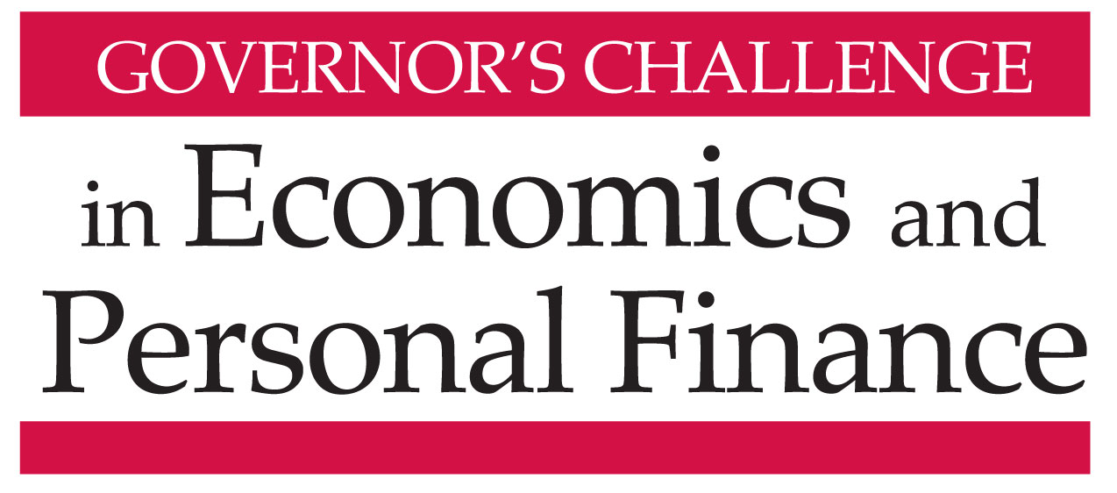

Virginia Commonwealth University Student Commons
Wednesday, April 26, 2017

AGENDA

9:00-9:30am Registration and refreshments in James River Terrace - Teams report to their rooms

9:30-11:25 Personal Finance Challenge – Forum Room
Host: Barbara Haynes, VCEE Economic Education Consultant

Group 1 – Shockoe Room
Host: Rebecca Booth, Director, Center for Economic Education at Lynchburg College
Judges:
- Patricia Gordon, Fiduciary Controls And Grants, GRASP
- Mark Newfield, CFP®, Newfield Financial Solutions
- Joey Stemmle, CFP®, Financial Advisor, Riverstone Wealth Advisory Group
Time keeper: Omar Kemp, Foresters Financial Services

Group 2- Canal Room
Host: Dr. Cheryl Ayers, Associate Director, Virginia Tech Center for Economic Education
Judges:
- John McFarland, CFP®, Coordinator of Financial Planning, VCU School of Business
- William Moore, CFP®, Wealth Benefits Manager, Northwestern Mutual
- Dr. David Upton, CFA® Emeritus Professor of Finance, VCU School of Business
Time keeper: Dr. Tricia Jacobs, CTE Coordinator for Curriculum and Instruction, VDOE

9:30-11:20 Adam Smith Economics Challenge – Richmond Salons
Hosts: Dr. Stephen Day, Director, VCU Center for Economic Education;

9:30-11:20 David Ricardo Economics Challenge –Virginia Rooms
Hosts: Ruth Cookson, Program Manager, ODU Center for Economic Education
Rachel Powell, Program Coordinator, GMU Center for Economic Education

11:30-12:20pm David Ricardo Division – Commons Theater
Welcome and announce winning teams: Daniel Mortensen, Executive Director, VCEE
Online Regional Winners Recognized: Nathalie Molliet-Ribet, Deputy Secretary of Education, Office of the Governor

Quiz Master: Judy Pahren, Senior Vice President, Capital One
Judges:
- Nicholas Haltom, Director, Economic Education, Federal Reserve Bank of Richmond
- Dr. Edward Millner, Professor , Department of Economics, VCU School of Business
- Dr. Carol Scotese, Chair, Department of Economics, VCU School of Business

Presentation of Awards: Nathalie Molliet-Ribet, Deputy Secretary of Education, Office of the Governor

12:20-12:50 Lunch: Students, Richmond Salon rooms/ Music / Prize Drawings
Teachers and adult guests have lunch in Virginia Rooms

12:50 TAKE YOUR SEATS FOR CONTINUATION OF CHAMPIONSHIP ROUNDS
in the Commons Theater

12:55-1:40 Personal Finance Division
Online Regional Winners Recognized: Dr. Tricia Jacobs, CTE Coordinator for Curriculum and Instruction, VA Department of Education

Championship Round
Master of Ceremony: Judy Pahren, Senior Vice President, Capital One
Judges:
- Wendell B. Fuller, CFP®, NAPFA-Registered Financial Advisor, Fuller Wealth Advisors
- Leon L Litz, MBA, Agency Owner/CEO, State Farm Insurance and Financial Services
- Judith Sams, Business & Information Technology Specialist, VA Dept. of Education

1:40-2:30 Adam Smith Division
Online Regional Winners Recognized: Dr. Tricia Jacobs, CTE Coordinator for Curriculum and Instruction, VA Department of Education

Championship Round
Quiz Master: Dr. Carol Scotese, Chair, Department of Economics, VCU School of Business

Judges:
- Nicholas Haltom, Director, Economic Education, Federal Reserve Bank of Richmond
- Dr. Oleg Korenok, Associate Professor of Economics, VCU School of Business
- Dr. Fletcher Mangum, Managing Partner, Magnum Economics, LLC

Presentation of Adam Smith and Personal Finance Awards: Chris Saneda, Sr. EVP/Data and Digital Innovation, Virginia Credit Union

2:30pm Adjourn

We gratefully acknowledge financial support for the Governor’s Challenge provided by:

