Building an Understanding of Stocks, Bonds and Mutual Funds

The Stock Market Game in Twelve Easy Steps!
…and additional information
(rev. 10/24/2017)

www.vcee.org

and
www.stockmarketgame.org

Diane Neylan
SMG Coordinator

smg@vcu.edu
804-828-1627

The Stock Market Game™ in Twelve Easy Steps!

The Stock Market Game™ (SMG) can be fun and educational for students of all ages, grades 4 through high school. Teams of 2-4 students use $100,000 in virtual cash to invest in stocks, bonds and mutual funds in a real-world investment simulation. There are statewide and regional competitions with prizes for the highest valued portfolio and an optional InvestWrite (www.investwrite.org) essay competition. You will also be able to register with Invest It Forward (https://investitforward.sifma.org) so you can arrange for an industry expert to visit your class.

Step1 GET THE INFORMATION YOU NEED

- Attend a free VCEE workshop or webinar. Visit the Virginia Council on Economic Education’s website for dates and times.

- Go to www.stockmarketgame.org. “Explore,” take a brief look at our “Resources,” and then click on “Register” at the top of the page.

(NOTE: You will have to register to explore the full site, but there are numerous promotional games available for no fee during the summer, fall and winter. Also, you may register for a regular game, but if you decide not to participate you will need to notify the SMG coordinator (smg@vcu.edu) as soon as possible to avoid any team fees.)

- Once you’ve registered, you will receive an advisor Id and password that will allow you to access the Teacher Resource Center. A pop-up page will appear with important information like dates/deadlines and or rules of the game.
- Scroll down to the bottom of the page to “Just getting started?”
- This is the best starting point for those who are new to the SMG. You will be able to access the Teacher’s Guide. Note that there is also an “Afterschool Guide.”
- “Understanding Portfolios” takes you through the functionality of the portfolio dropdown menu and the process for trading stocks.

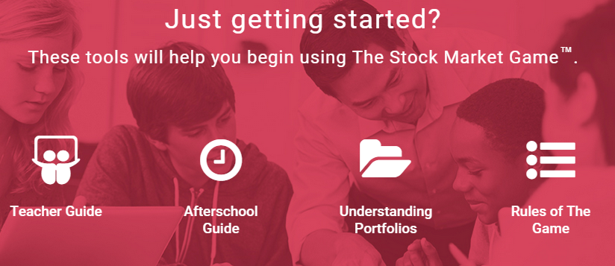
- “Rules of the Game” covers both the national rules and our Virginia rules, along with the Code of Participation. It is very important that you read all the rules carefully!
- If you don’t always have access to a computer, it would be a good idea to print out a copy of the Teacher’s Guide.

Step 2 GROUP YOUR STUDENTS INTO TEAMS

- Divide the class into teams of 2-4 students so you know how many teams you will need. Teams should have no less than 2 or more than 4 students in order to be eligible for end-of-game awards). You may add or delete teams up until the cut-off date.

- Each team will create on online team portfolio in the simulation.
- Students will research and make stock selections as a team.

- Suggestion: Have the teams keep a folder with their research, stock selections, journals, charts, or any other materials they may produce using SMG.

Step 3 REGISTER YOUR TEAMS FOR THE FALL, YEAR-LONG OR SPRING GAME(S)

- If you registered for a promotional game, you will need to register again for the actual game. Complete the online registration form for the Stock Market Game™ Program at www.stockmarketgame.org. If you need to add/delete/change/update, please contact the SMG Coordinator for assistance. (smg@vcu.edu )
- You must provide a valid email address since all communications between the SMG and you will be delivered via email.
- We strongly encourage each teacher/advisor to register individually rather than have one person register multiple teachers. The system sends out emails and notices only to the person who registered. If that person then created “classes” for multiple teachers, those teachers will not be on our email list and will therefore not receive any important updates or notices. In addition, all teachers will have to share the advisor Id and password in order to view student portfolios—every teacher will be able to see everyone else’s team portfolios.

- After enrolling, within a few minutes you will receive an email with an Advisor ID and password. The following day you will receive another email with the team IDs and passwords. If you do not receive the second email message in 2 or 3 days—be sure to contact the SMG Coordinator at smg@vcu.edu. (Note: team Id/password generation starts 3 weeks prior to the competition. You will not receive any team information before that time.)
- The fee for the Fall or the Spring game is $10 per team if you register multiple teams or $25 for a single team. The fee is $20 per team for year-long game if you register multiple teams or $25 for a single team.

- You may delete teams prior to the beginning of the game. Once a team trades, it cannot be deleted and you will be responsible for the team fee. (Contact the SMG Coordinator at smg@vcu.edu prior to the posted cut-off date and you will not be charged for deleted teams.)

- You are responsible for full payment of all teams still registered after the cut-off date… whether they are used or unused.

- You may add teams at any time prior to the cut-off date. Contact the SMG Coordinator smg@vcu.edu and she will handle the change; do not register again.
- You will be invoiced within a few weeks of the official beginning of a game session. Invoices will NOT be sent to you; rather, they will be mailed to your school (addressed to the contact person you indicated on your registration, to “bookkeeper/accounts payable”) or to your central office. If you have a purchase order number, please provide it when you register or within the first two weeks of the game. This information is needed to properly prepare the invoices. Note: It is most helpful to have the correct name and address of the person to whom the invoice should be sent.

Step 4 CHOOSE YOUR LESSONS

- Enter the Teacher Support Center on the SMG web site (use your teacher ID and password). Check out the resources, lessons, etc. to help your class get started.
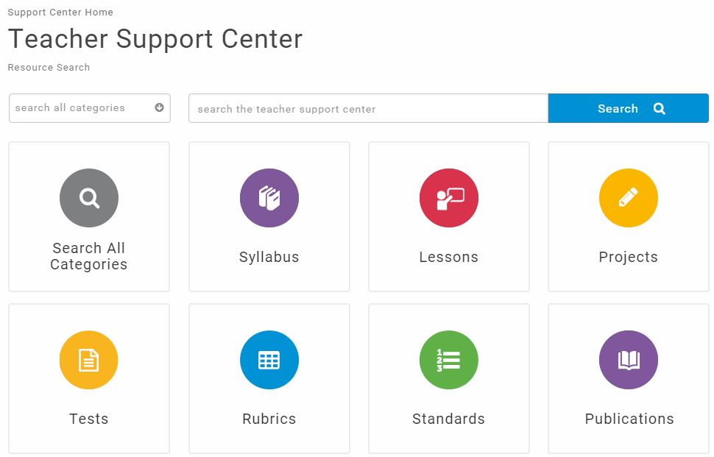
- Use our robust search engine to look for lessons by subject, grade level, content topic, etc.
- Find a specific lesson sequence for your particular grade level or display a complete outline of all lessons.
- Introduce students to concepts like:
- What is a company?
- What is a stock? a bond? a mutual fund?
- What is risk?

Step 5 PRE TEST (OPTIONAL)

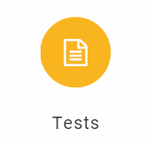
Administer the SMG pre-test before you start teaching and post-test students at the end of game. You can find the pre- and post-tests online in the Teacher Support Center in the Assessments Section.

Step 6 EXPLORE STOCKS

- Have students start thinking about and researching stocks they may want to trade as you introduce the basic concepts to them.

- Have them read/watch TV and discuss current events about companies, stock market performance, and the economy.

- Visit websites focused on stock research: http://moneycentral.msn.com/, http://finance.yahoo.com, http://thestreet.com and the multiple resources on the student portfolio pages.

Tip: For older students, have different teams research a financial website and share information they found with the class. For younger students, try using the Yahoo website (probably easiest to navigate.) I also recommend TheStreet.com, a website which is built into the Stock Market Game simulation.

Step 7 TEACH STUDENTS HOW TO PARTICIPATE

- Do the core lesson “Understanding the SMG” from the Teacher Support Center (In the Classroom/Lesson Sequence).
- Go over the information included in “Understanding Portfolios” in the Teacher Support Center
- Allow students to explore their team portfolio pages. Remember: students can access their portfolios—but not make trades—prior to the official start of the game. You need to assign the team Ids/passwords before they can access the website.

Step 8 TEAMS LOG-IN

- Log-in! Assign a student team ID and password to each team and have them login to their team portfolio at www.stockmarketgame.org. (You received these IDs/passwords by email.)
- Students can log in before the program begins but they cannot trade until the first day of the simulation.
- Students may begin making trades any time after the competition begins.
- Team Ids (log ins) cannot be changed, but you may allow your teams to create their own team nicknames for classroom use. This is completely optional!
- You will need to enter the nicknames by going to “View Rankings and Portfolios.” If you have more than one class participating, you will need to click on each class name to see the following:
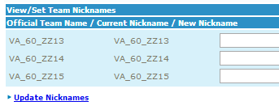  
- Enter the nickname in the box next to the correct team Id and click “update nicknames” when you are finished.
- Students may change their passwords, but be sure they remember them! You can contact the SMG Coordinator if there is a problem.

Step 9 REVIEW THE RULES

- Complete rules can be found on the home page of the online portfolio (under “Resources”). Be sure to include all local rules in this review. (See the short version in this handout.)

- Remind students that this is a team competition, and that trades should be made based only on a team decision. Once a trade has been entered, it cannot be “undone”!!

Step 10 MAKE DECISIONS AND TRADE

- Let students meet to discuss their trading ideas and make their first purchases.
- You may want to have them journal each meeting.

- After they’ve made their first buys, allow time each week for them to review their portfolios, rankings, and discuss more buys or sells.

- If you are short on classroom time: Have teams buy 1 or 2 stocks in their first meeting.  Then allow them to watch their stocks, sell, and/or re-invest as a team on their own time.
- Students can buy/sell as often (or as little) as you want, whatever best fits your class time.

- Portfolios are updated every evening.
- Teams may view both their state and regional rankings from their portfolio.
- Teachers may access portfolios and rankings through the Teacher Support Center

Step 11 LEARN AS YOU GO

- Try to focus on at least one lesson a week from the Teacher Resource Center to teach students about investing concepts: i.e., stocks, risk, markets, diversification, etc. When questions arise about topics such as stock splits, dividends, etc., teachers use these teachable moments to introduce and explain these terms and concepts. (Teachers can learn about these and find lessons in the Teacher Resource Center!)

- Be sure to reinforce the fact that investing for the long-term (retirement) would be a different strategy than the short-term SMG.

Step 12 FOLLOW-UP (optional BUT encouraged!)

- Take part in InvestWrite, the national essay competition ( http://investwrite.info).

- This is an individual essay competition for Stock Market Game students only, grades 4-12.

- Each semester has different essay prompts at each level (elementary, middle, high).

- Students write a (maximum) 700-word essay.

- Teachers electronically submit their 10 best essays from each class to be judged by investment industry professionals.

- There are great state and national prizes for elementary, middle and high school levels.

- Select “Troubleshooting” and read the FAQs.
- Encourage students to troubleshoot their own problems before coming to you.
- Most problems result from incorrectly entered Ids/passwords and failure to understand the rules of the game. Be sure to emphasize the 20% equity rule, minimum purchase requirements and minimum price/stock rules.
- If you are unable to resolve the problem, contact the SMG coordinator (smg@vcu.edu). I will need your name, school, which game you are playing (fall, year or spring), the specific team Id and a very specific description of the problem. If I am unable to resolve the problem, I will ask the national office for assistance.

NOTE: The coordinator will not respond to inquiries from students, so please contact her on their behalf.

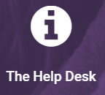
Inquiries through the “Help Desk” link on the student portfolio pages and from the Teacher Support Center go to the national office but are actually forwarded to the coordinator. This will only delay resolution of the problem, please contact your coordinator directly at smg@vcu.edu .

TEACHER RESOURCES

Teacher Resource Center - Use your Teacher ID and password to logon to the Teacher Resource Center at www.stockmarketgame.org for a multitude of resources—like tutorials, curriculum for elementary, middle or high school level, printable lessons, assessments, rubrics, and more! Sections include:
- View the Teacher’s Guide, the Rules of the Game and a thorough discussion of the student portfolio
- Manage Student Portfolios – allows you to view student portfolios, daily rankings, a troubleshooting guide, and print certificates for all of your students.
- Use the search feature to find grade specific curriculum, lessons, activities, projects, publications, assessments, rubrics, and an alignment of lessons to Virginia standards in economics, language arts, social studies, and math.

Visit VCEE’s website at www.vcee.org/stock-market-game-program for more information and resources.
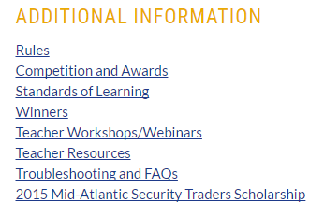
Competitions and Recognition

SMG Competition:

Teams are placed in regions based on the geographic location of the VCEE Centers for Economic Education. Elementary, middle and high school teams compete in the same Region for state awards.

There are two rankings: Regional and Coordinator (state). Rankings are based on the value of the portfolio and are updated daily.

To be eligible for end-of-game prizes:
- teams must have at least 2 and no more than 4 students.
- no student on a team is participating on more than one team.
- all team fees are paid at least two weeks prior to the end of the competition portion of the game.

SMG Recognition:
Regional: prizes are determined and awarded by VCEE’s affiliated university-based Centers for Economic Education.

State (Coordinator): Recognition at the annual SMG Awards Program in May
- Top 3 state-ranked teams for Fall, plus the highest ranking team in elementary, middle and high school if not included in the top three.
- Top 3 state-ranked teams for Spring games, plus the highest ranking team in elementary, middle and high school if not included in the top three.

- Top state-ranked team in the Year-long game

- Fall InvestWrite: 1st place winner at elementary, middle and high school levels (statewide)
- Spring InvestWrite: 1st place winner at elementary, middle and high school levels (statewide)
Stock Market Game Rules
(shortened version of national/local rules)

See the full version of the rules under “Just getting started?” in the Teacher Support Center at www.stockmarketgame.org .

National:

- Each team begins with $100,000 in cash (See rule 1 for further explanation.)
- Interest is earned on money not yet invested at an annual rate of .75% and posted weekly. (See rule 1 for further explanation.)
- Teams may borrow additional funds to invest (going on margin). Cost is 7% per annum and is posted weekly. (See rule 1 for further explanation)
- Transactions entered with a limit price will not be held past the initial attempt to price the transaction. This applies to End of Day or Real Time Games. (See rule 3 for further explanation.)
- All buy orders must be a minimum of 10 shares. (See rule 4 for further explanation.)
- Trades are limited to stocks at/above $3.00/share value. (See rule 6 for further explanation.)
- A 1% broker’s fee is charged for all transactions. (See rule 7 for further explanation.)
- Trade pricing is real time (with a 20-minute delay). (See rules 8, 9 and 10 for further explanation.)
- Teams do not have to liquidate their portfolios at the end of the game.
- Winners are based on equity of the portfolio.

Additional Local rules:

- A team must have at least 2 and no more than 4 students in order to participate in the competition portion of the SMG.
- A student may compete on ONLY ONE team.
- Teams may invest NO MORE THAN 20% of portfolio equity in a single position.
- All financial obligations must be met at least two weeks before the end of competition in order for a team to qualify for a regional or state award.

Stock Data Found on the Internet

Try sites like: http://money.msn.com, http://finance.yahoo.com or http://www.thestreet.com/. Students will need to look up ticker symbols for making trades. This may be done directly from their portfolio site.
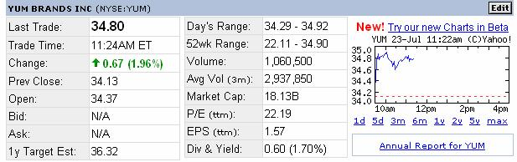

*LastTrade is the time and price of the last trade made for the stock (current price).

*Change is the change in price for the day. This is the difference between the last trade and the previous day’s closing price (Prev Close).

*Prev Close is the closing price for the trading day prior to the last trade reported.

Open is the first price paid after trading starts, usually when the stock exchange "opens its trading doors", usually in the morning.

Bid price is the price you will get if you sell your stock Ask price is the price you will pay to buy a stock

*1y Target Est - This value is an estimated stock value in 1 year provided by analysts following this stock.

*52-Week Range – high and low prices over the past 365 days *Volume is the volume of trading (number of shares)

Avg Vol is the Average Daily Volume which is the monthly average of the cumulative trading volume during the last 3 months divided by 22 days.

Market Cap - way of measuring the size of a company and is calculated by multiplying the current stock price by the number of outstanding shares

*P/E is Price to Earnings Ratio. This number is the previous closing stock price divided by the

earnings per share, and reflects the value the market has placed on a stock. In general, a high P/E, compared to like companies, means high projected earnings in the future.

EPS is Earnings Per Share – stated for the most recent 12 months. EPS is calculated by dividing earnings by the average number of shares of common stock outstanding during the period. Analysts typically look for steadily increasing EPS.

Div is the Dividend per Share. Annual dividend per share of stock, as reported by the company. Yield is the annual dividend per share divided by the previous closing stock price, as a percentage (multiplied by 100).

*Students do not necessarily use all of this information in making stock selections, but some of the data can be helpful in making decisions. Fields marked with * are most commonly used.

National and State Essay Contest www.InvestWrite.info

InvestWrite is a highly successful extension of The Stock Market Game program designed

to help students sharpen critical thinking and writing skills as they compose essays on investment related topics. The program builds a bridge between classroom learning and potential real-world investment decision.

Students are provided a topic and an investment scenario, which requires them to assess, research, and then formulate possible solutions based on their own findings, logic, and ideas.

How much additional time will I need to learn the InvestWrite curriculum? Everything you need to know is on the website. Other than discussing the topics with your students and giving them a little direction, you’re done. InvestWrite is designed to enhance the Stock Market Game program without adding planning time to your current curriculum demands. You might wish to incorporate this competition into your writing assessment.

Do my students work in teams or individually? Individually. Here’s a chance for students to take what they have learned as a member of their team and apply their critical thinking and writing skills individually.

How many essays can I submit? You can submit ten teacher-judged entries per qualified classroom and only one essay per student.

How long does it take to submit InvestWrite entries? Just a few minutes, all you have to do is sign in for each submission, fill in a few information boxes (i.e. your contact info, student’s name, etc.) and cut and paste or type the entry into our online submission box.

Is the contest free to enter? Absolutely! The only requirement is that you and your students must be participating in The Stock Market Game.

With whom do my students compete? Students complete statewide and nationally for prizes in their own divisions: 4-5 grade, 6-8 grade, or 9-12 grade. Visit the InvestWrite website for national prizes…which range from all-expense paid trips to NYSE, laptops, and gift cards for teachers, parents and students!

Invest It Forward™ is an industry-wide capital markets literacy initiative convening hundreds of financial firms helping young Americans learn about and gain access to invaluable tools to achieve their dreams. Invest It Forward connects educators and classrooms with financial industry professionals and firms. The program features a new capital markets curriculum and a variety of volunteer opportunities across the country and throughout the year.

Go to www.investitforward.sifma.org to register.

When a volunteer selects one of your registered classes, you and your volunteer will receive an e-mail with your respective contact details to initiate communication. SIFMA Foundation and the Invest It Forward™ Team will monitor teacher and volunteer requests on a weekly basis to ensure that no classroom or volunteer is left without a requested opportunity.

Filling a Gap in Financial Education – The NEW Capital Markets Curriculum
A central goal of the Invest It Forward™ initiative is to help young people better understand the role of the capital markets in their everyday lives. The SIFMA Foundation and the Federal Reserve Bank of St. Louis are providing a free curriculum to help students better understand the role and benefits of the capital markets and more. There are five topics/units in the curriculum. Each topic includes:
- Icebreaker video for volunteers to show the students
- Powerpoint presentation with notes to guide the volunteer's discussion
- Online short-course for teachers, educators or volunteers to use with students
- Online interactive worksheets within the short course for students to complete
- Pre/post tests to assess progress and learning

UNIT 1. CAPITAL MARKETS
UNIT 2. WEALTH CREATION FOR ALL.
UNIT 3. BUILDING BRIDGES TO A BETTER FUTURE.
UNIT 4. ACHIEVING LIFE GOALS.
UNIT 5. A NATION PROTECTED.

Tools, Topics & Materials
Invest It Forward™ wants your volunteer experience to be foolproof! When you request a volunteer, you can specify what topic you'd like them to present. The SIFMA Foundation provides related volunteer presentations that enable guest speakers to share meaningful, relevant content with your students. A volunteer might choose to use their own firm's financial education materials or the following Invest It Forward™ Volunteer Presentations:
What Are Capital Markets? (Includes Video, Short Course and PPTs for Middle and for High School Groups)
What Is A Stock? (PPT for All Age Groups)
What Causes Stock Prices To Change? (PPT for All Age Groups)
Buy, Sell Or Hold (PPT for Elementary & Middle School); Buy, Sell Or Hold (PPT for High School)

Staying Engaged with Invest it Forward™
Our aspiration is that Invest It Forward is not a "one off "experience for you as a volunteer. We hope that you will find ongoing activities and longer-term interactions that enable you and your colleagues to bring value and support to your educational efforts, your students, and your school or afterschool programs. These might be face-to-face or they might be virtual. SIFMA Foundation is delighted to support this process, both now and in the future.

Please contact your SMG coordinator at smg@vcu.edu if you have questions.
SMG Culminating Activity Ideas

Research/Writing Skills

- Use the InvestWrite topic for critical thinking and essay writing to research a topic and relate it to a real-life experience. (InvestWrite provides new topics each semester with scenarios and a question.) www.investwrite.info

- Use the core lesson How Successful Was My Investment Strategy? found in the Teacher Support Center

- Research a company back to its inception.

- Write to a company

- Use the newsletters In the News and/or Stock Talk writing suggestions

Oral/Presentation and Technology Skills

- Make oral presentations:

• Why did my investment strategy not work? What would I do different next time?
• How to diversify a portfolio (using industry/sectors and or bonds, mutual funds, etc.)

- How my investment strategy would be different for long-term investing.
- Research a company in portfolio and tell why it did/or did not perform well.
- Explain how the economy has affected your portfolio.
  - How to use an investment website to research stocks

B. Enhance oral presentations and use technology skills to create a presentation with:
  - Spreadsheet and charting
  - Graphic organizers
  - PowerPoint.

Creative Skills

- Write a skit about a broker making stock recommendations to a client.
- Create a rap or song about a topic, or the Stock Market Game experience.
- Create a video and place it on YouTube.

Rubrics can be found in the Teacher Resource Center for all types of skills enhancements and presentations.

