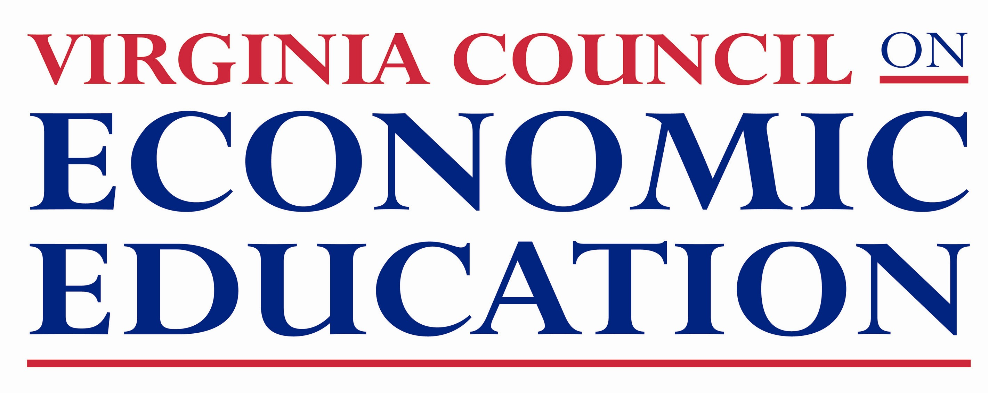
Virginia Council on Economic Education
Excellence in Economic Education Awards

Outstanding Economic Educator – Nomination Form

VCEE annually selects an individual who has particularly advanced their students’ understanding of economics or personal finance over the course of their teaching career. Considerations for this award include leadership, professional development, and evidence of student comprehension. We encourage you to nominate a K-12 teacher or administrator who you believe is outstanding in these areas. Self nominations are allowed.

Please use this form as the cover page for your nomination.

Name ___________________________________________________________________________
Home Address_____________________________________________________________________
_________________________________________________________________________________
Phone (______) ________________________ E-mail _____________________________________
School Name______________________________________________________________________
Address __________________________________________________________________________
Phone (_____) ________________________
Principal ______________________________Email _______________________________________
Superintendent ________________________________ School Division _______________________
Address___________________________________________________________________________
Local Newspaper ______________________________Web Address __________________________

On a separate page, the nominee should describe their involvement and accomplishment in each of the following areas as it relates to economic and financial education. Limit each item to no more than one page.

I. Leadership in Economic and Financial Education
II. Professional Development
III. Student Comprehension and Achievement

Attach one to two letters of recommendation supporting your nomination.

On or before August 1, 2017 mail, fax or e-mail this cover page, personal information, letter(s) of recommendation to:

Sarah Hopkins Finley, Director of Programs
Virginia Council on Economic Education
301 W. Main Street / P.O. Box 844000 / Richmond, VA 23284-4000
Phone: (804) 828-1627 / Fax: (804) 828-7215
E-mail Page Ritter: fpritter@vcu.edu

