

This Certificate of Recognition is Awarded to

________________________________

For Participation in The Stock Market Game ProgramTM

____________________________________________

Advisor

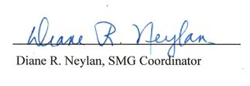

______________________________

Date

Virginia Council on Economic Education

Virginia Council on Economic Education