Time Travel with Economics and Augmented Reality

By Lilo Stephens
Middle School Social Studies
ABSTRACT

ACADEMIC CONTENT
The overall purpose of this lesson is to have students explore and review events in U.S. history through the lens of economics. The instructional approach is to combine a timeline with augmented reality, thus producing an interactive timeline. The timeline spans the years 1865 to 2000, and the events represent the time periods of Reconstruction, industrialization, the Progressive Era, imperialism, the Great Depression, World War II, and post-World War II. The interactive quality of the timeline comes from linking, via the web tool Aurasma, a student-created video of an event to the image of that same event installed on the timeline. The timeline is in the hallway (see photo) and available to anyone. When a student holds up a mobile device to the image on the timeline, its video appears on the mobile device. The student can learn more about that event by watching and listening to the video that was created by fellow students. By combining a familiar format (the timeline) with augmented reality, student engagement and technological skills are increased by creating a task that previously would have been inconceivable without 21st-century technology.

SKILLS
Students must draw upon and develop many skills to engage in this activity. First, students develop their research and writing skills by creating video presentations. Second, students evaluate what is important to include in their presentations and how to communicate it concisely because their presentations could not exceed one minute in length. Finally, students create a product for an authentic audience from which they receive constructive feedback. Both the givers and receivers of feedback hone their abilities to evaluate and revise their work output.

OUTCOMES/EFFECTIVENESS
This learning experience is an effective approach to improving student economic literacy because it addresses different learning styles and provides repeated exposure to content. First, students initially chose the event they would research, and they chose the format of their presentation. Presentations ranged from simple oral presentations to visual presentations using SMART Boards to skits with memorized dialogue. Second, because of the videotaping and the responsibility of teaching others, students approached their presentations with seriousness and a desire to be successful, as evidenced by the numerous times students self-corrected during presentations. Finally, students exposed themselves to the economic content numerous times. They researched the content. They presented the content. They listened to other presentations in the classroom, and they reviewed the same content when they completed the timeline scavenger hunt. Engaging in preferred learning styles and revisiting content in numerous ways, assisted in content understanding and memory retention.
Economic Content and Standards
Timeline Event | SOL Objective
13th Amendment  (outlaws slavery) | USII.3a - Outlawing slavery changes the economy of the South after the Civil War by eliminating its traditional source of labor.
Transcontinental Railroad  (joins east and west coasts of U.S.) | USII.2b - illustrates the relationship between transportation, resources and U.S. industrial development after 1865
Levi Strauss and Blue Jeans  (inventor of blue jeans; fills 19TH-century miners’ demand for sturdy pants) | CE.12a - illustrates the role of entrepreneurship
Henry Ford and Assembly Line  (His moving assembly line improves labor productivity, resulting in lower costs to consumers and higher wages for workers) | USII.6a - illustrates how the changes in labor productivity affected income and the affordability of consumer goods
Sherman Anti-Trust Act | CE.13a - illustrates government's role in U.S. economy by examining competition in the marketplace and protecting consumers’ rights
16th Amendment | CE.13c - enables the Government to levy direct income tax on U.S. citizens
Federal Reserve Act | CE.13d - the Fed acts as the nation's central bank, maintaining currency value, managing circulation of currency
Panama Canal  (U.S. construction of the canal increases international trade opportunities, political influence, and military troop movement for the U.S.) | CE.12d - examining the relationship of VA and the U.S. to the global economy
Annexation of Hawaii  (American planters in Hawaii sought U.S. annexation of Hawaii to avoid tariffs and increase political influence.) | CE.11c - illustrates how this decision was motivated by profit, market competition and tariffs
Stock Market Crash of 1929 | USII.6d - a cause of the Great Depression
Hawley-Smoot Tariff | USII.6d - exacerbated negative effects of Great Depression by raising tariffs on imported goods  CE.12d - examines the relationship of the U.S. to a global economy
Federal Deposit Insurance Corporation | CE.13e - protects consumers' bank deposits
Federal Trade Commission | CE.13a,e - protects consumers, avoids monopolies and encourages competition
Japanese Bombing of Pearl Harbor | USII.7a - a cause of U.S. involvement in WWII that increased employment in war factories and ended Great Depression
1973 Arab Oil Embargo  (Arab countries halt oil exports to the U.S. because of political reasons, causing a shortage of gasoline for U.S. consumers.) | CE.11a - addresses scarcity, resources, choice, opportunity cost, price, supply and demand, production, and consumption.  CE.12d - examining the relationship of VA and the U.S. to the global economy

Students working in groups select one of these events to be the subject of their video presentation. They create their presentations for the purpose of teaching their classmates about that event, maintaining the SOL objective as their focus.

INSTRUCTIONAL PROCESS
Note: My students have their own iPads in the classroom, enabling them to engage in research almost immediately without the need to reserve time in the library. I have the Aurasma app installed on these iPads. Also, I facilitated this lesson in three stages:
Stage 1 – students creating presentations; done in March.
Stage 2 – teacher creates trigger images of events and links them to student video presentations using the web tool Aurasma at www.studio.aurasma.com
Stage 3 – students engage in scavenger hunt; done towards the end of the year to serve as a review.
MATERIALS LIST:
- physical timeline (Mine was made by my students with the help of the tech ed teacher. See photo.)
- list of events and sign up
- presentation rubric (one per student)
- mobile devices w/internet access or access to library for research
- one physical image for each event on timeline
- videotaping equipment (I used an iPad.)
- account with Aurasma
- scavenger hunt sheet (one per student)
- scavenger hunt key (one for teacher)
- award certificates (for students who complete scavenger hunt successfully)
- mobile devices with Aurasma app installed (free app)
STAGE 1 - PRESENTATIONS:
Day 1:
- introduce timeline project and rubric (see attached) to students
- provide students with event choices
- have students sign up for the event they choose
- students begin their research
Day 2-3:
- research event using mobile devices (i.e., iPads) See attached guide for research.
- work on presentation
Day 4:
- complete presentation
- rehearse presentation
Day 5:
- present presentation to class
- teacher grades presentations using the rubric
- teacher or student videotapes presentations with iPad
STAGE 2 – AURASMA: (Time needed depends upon how many events and videos you have.)
- teacher installs an image for each event on the timeline
- teacher creates account with Aurasma on the web and follows the tutorials to link images on timeline with students’ videos
- You can have more than one video for each event, but each video will need its own dedicated image on the timeline.
STAGE 3 – SCAVENGER HUNT:
Day 1:
- students must have access to a mobile device that contains the Aurasma app
  - To keep my login information secure, I entered my Aurasma login information into each student’s device.
- each student receives a copy of the scavenger hunt and proceeds to the timeline
- teacher checks completed scavenger hunt sheets for accuracy and awards certificates to students who completed the scavenger hunt successfully
THOUGHTS FOR LESSON REVISIONS:
In the future, I plan to add a stage between 2 and 3, where students interact with the timelines to fill in personal note-taking timelines upon which they can build and reference as we move through the year.

_______________________________
Logo and “Time Lord” references on scavenger hunt and award certificate come from the television show “Dr. Who.”
Name: ___________________________________________________ Period:_________
Directions: Follow this plan as you research your chosen event.
- Use at least two sources.
- Fill in the blanks as you collect information.
- When done, show it to the teacher for feedback.
INTERACTIVE TIMELINE: RESEARCH PLAN**

- Name of Event:

- Research Question: Why should this event be on the timeline?

- Hook – What’s interesting about this event that would make other students want to know more about it?

Looking at Sources – List the facts from each source.

- Source #1 (Name of Source)_________________________________________

WHO are the important people?
WHAT happened?
WHEN did it happen?
WHERE (if relevant) did it happen?
WHY did it happen?
HOW did it happen?
- Source #2 (Name of Source)_________________________________________
Only list what is new or different from Source #1.
WHO are the important people?
WHAT happened?
WHEN did it happen?
WHERE (if relevant) did it happen?
WHY did it happen?
HOW did it happen?
Conclusion: What is the answer to #2 – Why should this event be on the timeline?
**modified from: O’Day, Sandra Alicia. “Scaffolding Methods for Research Paper Writing.” Read WriteThink. Accessed November 7, 2015. http://www.readwritethink.org/classroom-resources/lesson-plans/scaffolding-methods-research-paper-1155.html

TIMELINE PROJECT - RUBRIC

Names: Period:

Name of Event/Person:
Where will it go on the timeline (date)?

Schedule for Completing Project:
- Complete Research: Tuesday, 3/17
- Complete Presentation: Wednesday, 3/18
- Rehearse/Videotape: Thursday, 3/19
RUBRIC
Criteria  (what the teacher wants to see) | YES  (10 pts.) | SOMEWHAT  (7 pts.) | NO  (5 pts.) | MISSING  (0 pts.)
The presentation is 1 min. or less.
The information is accurate.
The students teach the importance of the event or person.
The presentation is easy to understand.
The presentation is creative/interesting.
SUBTOTAL

TOTAL POINTS:
45-50 = A 30-34 = D
40-44 = B <30 = E
35-39 = C
Comments:
WHERE IN TIME IS IT?
You will be put to the test to see if you are
the next Time Lord.
TIMELINE SCAVENGER HUNT
- Find the first wearers of jeans.

_____________________________________________________________________

- What provides protection for your savings account.

______________________________________________________________________

- Find the event that eventually ended high unemployment in this country.

_______________________________________________________________________

- How would natural resources in the West get to factories in the East?

_______________________________________________________________________

- Find the fruit company that took over Hawaii.

_______________________________________________________________________

- Find the 100-year-old piece of legislation that gave Microsoft a lot of legal trouble.

_______________________________________________________________________
- Find the event that makes April 15 an important day for American tax payers.

_______________________________________________________________________

- Find the event that created “the bank for banks.”

__________________________________________________________________

- Find the event that caused long lines at the gas station.

___________________________________________________________________

- What shortcut increases U.S. trade in global markets?

____________________________________________________________________

- Who is there to make sure you, the consumer, won’t be cheated by a company?

_____________________________________________________________________

- Find the first day of the Great Depression

______________________________________________________________________

- Find the event that was meant to help U.S. farmers, but ended up causing harm to the whole country by hurting U.S. relations with other countries.

______________________________________________________________________

- Find the event that changed the source of labor in the South.
______________________________________________________________________
WHERE IN TIME IS IT?
You will be put to the test to see if you are
the next Time Lord.
TIMELINE SCAVENGER HUNT

- Find the first wearers of jeans. MINERS

_____________________________________________________________________

- What provides protection for your savings account. FEDERAL DEPOSIT INSURANCE CORPORATION
______________________________________________________________________

- Find the event that eventually ended high unemployment in this country. JAPANESE BOMBING OF PEARL HARBOR

_______________________________________________________________________

- How would natural resources in the West get to factories in the East? TRANSCONTINENTAL RAILROAD
_______________________________________________________________________

- Find the fruit company that took over Hawaii. DOLE

_______________________________________________________________________

- Find the 100-year-old piece of legislation that gave Microsoft a lot of legal trouble. SHERMAN ANTI-TRUST ACT

_______________________________________________________________________

- Find the event that makes April 15 an important day for American tax payers. 16TH AMENDMENT
_______________________________________________________________________

- Find the event that created “the bank for banks.” FEDERAL RESERVE ACT

__________________________________________________________________

- Find the event that caused long lines at the gas station. ARAB OIL EMBARGO

___________________________________________________________________

- What shortcut increases U.S. trade in global markets? PANAMA CANAL

____________________________________________________________________

- Who is there to make sure you, the consumer, won’t be cheated by a company? FEDERAL TRADE COMMISSION
_____________________________________________________________________

- Find the first day of the Great Depression BLACK TUESDAY

______________________________________________________________________

- Find the event that was meant to help U.S. farmers, but ended up causing harm to the whole country by hurting U.S. relations with other countries. HAWLEY-SMOOT TARIFF

______________________________________________________________________

- Find the event that changed the source of labor in the South. 13TH AMENDMENT

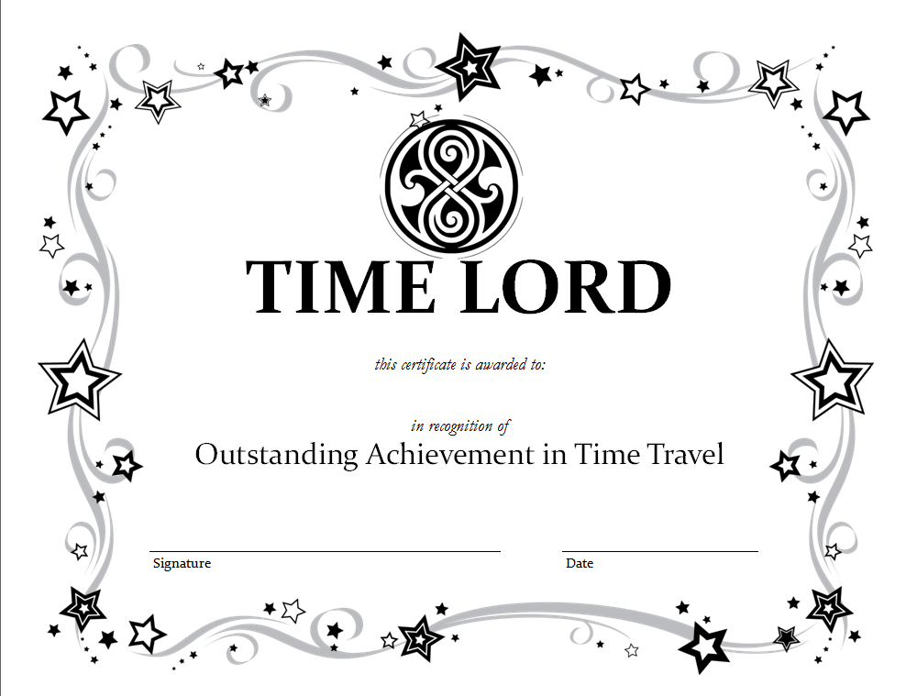

EVALUATION OF STUDENT LEARNING
Students, supplied with iPads equipped with the Aurasma app, interacted with the timeline to complete a scavenger hunt. In the photograph, one sees active student engagement, student collaboration and attention to the content as they search for the answers to the scavenger hunt. The same student behavior was evident in all the classes that day. Those who successfully finished the scavenger hunt earned a “Time Lord”* award certificate. Surprisingly, students responded with delight in receiving the award, indicating that they felt pride in their accomplishment.
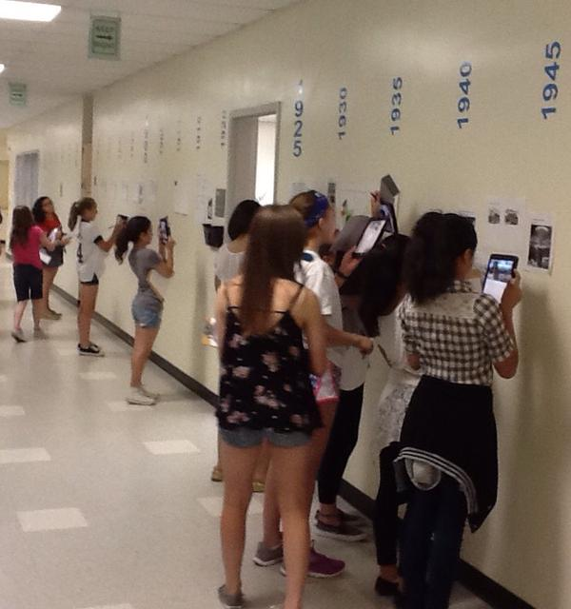

____________________________
*Time Lord is a reference to characters in the science-fiction television show “Dr. Who.”

