My Rows and Piles of Coins
Written Tololwa Mollel
Illustrated by E.B. Lewis
Houghton Mifflin, 1999

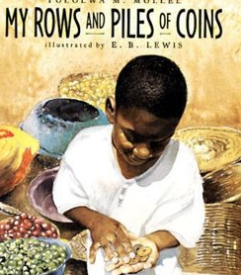

Book Synopsis: Saruni, a Tanzanian boy, helps his mother carry produce from their home to sell at the market. Saruni’s mother pays him for his help with a few coins and urges him to spend his earnings on something he wants. His goal is to buy a bicycle that will help his mother transport goods to the market. With this goal in mind, Saruni saves his money. The disappointment he has when he realizes how expensive bicycles are is replaced with delight when his parents surprise him with a used bicycle. Saruni quickly plans a new savings goal. He will save money to buy a cart for the bicycle.

Lesson
Saruni Makes a Choice
Cost-Benefit Decision Grid

Introduction: Saruni has a choice to make. He can spend the money his mother has given him for helping her at the market, or he can keep it in his pocket and save it. His ambitious goal is to buy a bicycle which has the potential to help his mother earn more money in the future.

Time: 25-30 minutes

Grade Level: 2-4

Materials:
- Visual 1- My Rows and Piles of Coins Economic Concepts
- Visual 2- Saruni Makes a Choice Cost-Benefit Decision Grid
- Activity Sheet- Activity Sheet Cost-Benefit Decision Grid
- Writing Tools

Students will

- Review the definitions for economic concepts: benefit, cost, consumer, producer, goods, services, savings, choice, and opportunity cost.
- Identify a savings goal and explain that people must make spending and saving choices to meet goals.
- Use a decision-making model to reach a decision by weighing the costs and benefits of their options.
- Develop skills using a decision-making model in order to improve students’ ability to make reasoned decisions.
- Identify the opportunity cost of a decision given two or more alternatives.

Virginia Standards of Learning – History and Social Science:
K-3.1h | The student will demonstrate skills for historical thinking, geographical analysis,  economic decision making, and responsible citizenship by using a decision-making model to  make informed decisions.
K.9 | The student will  a) recognize that people make choices because they cannot have everything they want; and  b) explain that people work to earn money to buy the things they want.
1.7 | The student will explain the difference between goods and services and describe how people are consumers and producers of goods and services.
1.8 | The student will explain that people make choices because they cannot have everything they want.
1.9 | The student will recognize that people save money for the future to purchase goods and services.
2.10 | The student will explain that scarcity (limited resources) requires people to make choices about producing and consuming goods and services.
3.10 | The student will identify examples of making an economic choice and will explain the idea of opportunity cost (what is given up when making a choice).

Procedure:
- Prepare and collect materials prior to class.
- Introduce the lesson by telling the students that the story in today’s lesson takes place in the African nation of Tanzania. Show them this location on a globe or a map. Ask students to name the continent they live on (North America) and locate the country (USA) and state where they live (Virginia.) Compare the location of Virginia to Tanzania and how far apart they are. Explain that the main character in this book, Saruni, is a boy who must make an important decision.
- Read the book My Rows and Piles of Coins to the class.
- Display Visual 1. Review the listed economic concepts by relating each term to its connection to the story.
- Explain that all decisions have costs and benefits and that Saruni got some benefits, but paid some costs, when he decided to save his money for a bicycle rather than spend it right away.
- Display Visual 2. Solicit suggestions from the students concerning the costs and benefits of buying at the market vs. saving for a bike and record them on the Cost-Benefit Decision Grid visual. Accept all reasonable responses. (A possible responses document is provided on page six.)
- What decision did Saruni make? What was his opportunity cost? Remind students that opportunity cost is the next best choice that is given up when you make a decision.
- Distribute the activity sheet and writing tools. Instruct the students to create a cost/benefit decision grid based on some real life situation that require choices to be made. Possible topics could include: whether to pack lunch or buy the school lunch, which movie to attend (give two options), or what activities to do over the weekend (give two options.) Students may work in small groups.
- Conclude the lesson by reminding the students that all choices have costs and benefits. And there is always an opportunity cost to your decision—your second choice, the one you gave up. The “best” decision for one person isn’t necessarily the best decision for another, but each of us will usually make better decisions if we stop and think about our costs and benefits before we choose what to do.

Extension Activities:
- Saruni saved his coins in a box. Ask the students if they think this was a good idea. Brainstorm a class list of places to save money. (Piggy banks, credit unions, banks, savings bonds, etc.)

- As time went on, Saruni’s coins added up to an impressive total. Have the students research local charities and pick one they consider to have merit. Provide a large jar and encourage the students to put their extra coins in it. When the jar is full, count the coins and donate the total to the selected charity.

- For Discussion: What are some differences and similarities of the marketplace in Tanzania and a supermarket in Virginia?

Visual 1
My Rows and Piles of Coins
Economic Concepts
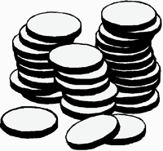

Benefit- A benefit is what satisfies your wants.
A benefit is the positive effect of a decision. ☺

Cost- A cost is what you give up when you decide to do something. A cost is the negative effect of a decision.

Consumer- A person who uses or buys goods and services is a consumer.

Producer - A person who makes goods or provides services is a producer.

Goods - Things people make or use to satisfy wants are goods.

Services - Activities that satisfy people’s wants are services.

Savings - Money not spent now so it can be spent in the future is called savings.

Choice (or Economic Choice) - You cannot have all the goods and services you want, so you must choose some things and give up others. A choice is the decision you make among alternatives or possibilities.

Opportunity Cost - The next best choice that is given up when you make a decision is your opportunity cost.

Visual 2
Saruni Makes a Choice
Cost-Benefit Decision Grid
The story in My Rows and Piles of Coins takes place in Tanzania, a country in east Africa. Here, Saruni receives payment for helping his mother carry produce to sell at a market. His mother encourages him to buy something he would like to have. Saruni would like to do this, but he also thinks that saving his money to buy a bicycle would be a good idea too. What should he do? Help him decide by filling in this chart with some of the advantages and disadvantages of his two possible alternatives (choices). Then, using the information on the grid, make a decision and state the opportunity cost of this decision.

 | Alternative 1  Saving Money for a Bike | Alternative 2  Spending Money at the Market
Benefits
A benefit is what satisfies a want.

Costs
A cost is what you give up when you decide to do something.

Decision:

Opportunity Cost:

Possible Responses -
Saruni Makes a Choice: Cost-Benefit Decision Grid

 | Alternative 1  Saving Money for a Bike | Alternative 2  Spending Money at the Market
Benefits  A benefit is what satisfies a want. | A bike would make taking produce to the market easier.  Bikes are useful and fun to ride.  It takes less time to ride a bike to the market than walking does. | Roasted peanuts and rice cakes are delicious and good to eat.  It would be fun to have a toy truck or a kite to play with.  The producers selling food and toys would appreciate getting money for their hard work.
Costs  A cost is what you give up when you decide to do something. | Bikes are expensive and it will take a long time to save enough money to buy one.  Saving coins in a box is risky because these coins could get lost or stolen.  Once you have a bike you may need more money for things like a basket, bell, or new tires. | Sweet treats are expensive and, once eaten are gone.  Toys are expensive and can be broken, lost, or stolen.  There are some many goods at the market that it’s hard to decide what to buy.

Decision: Saruni will save his money to buy a bike.

Opportunity Cost: He will give up the chance to buy things at the marketplace.

Activity Sheet-
Cost-Benefit Decision Grid
State the Problem:

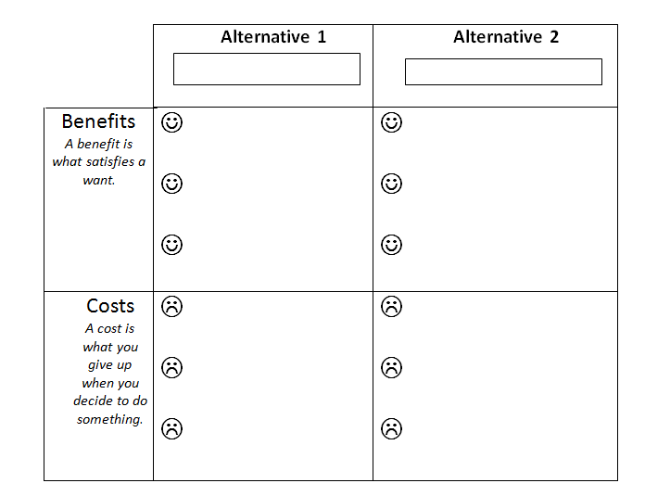
Decision:

Opportunity Cost:

