United States History: 1865 to the Present Performance Assessment
The Great Depression
Grades 6-7

TEACHER GUIDE

Targeted Content
Economics of the Great Depression

Brief Summary of Performance Assessment
The students will assume the roles of workers for the U.S. National Archives and Records Administration and will create an exhibit about the Great Depression for the Franklin D. Roosevelt Presidential Library. Students will choose the best objects to put in the museum exhibit. Objects are to reflect the economic causes of the Great Depression, the economic impact on Americans, and the major features of the New Deal.
Objectives
Students will be able to:
- analyze the economic causes of the Great Depression.
- investigate the Great Depression’s economic effects on Americans.
- examine the major features of Franklin D. Roosevelt’s New Deal.

Students will also demonstrate skills for economic, historical, and/or geographical analysis and/or 21st Century Skills including:
- analyzing and interpreting artifacts and primary and secondary sources to understand events United States history;
- interpreting charts, graphs, and pictures to determine characteristics of people, places, or events in Untied States history;
- determining relationships with multiple causes or effects in United States history;
- investigating and researching to develop products orally and in writing

2015 Virginia Standards of Learning
- USII.6d The student will apply social science skills to understand the social, economic, and technological changes of the early twentieth century by analyzing the causes of the Great Depression, its impact on Americans, and the major features of Franklin D. Roosevelt’s New Deal.
Time Required
- 90-150 minutes

Materials Needed
- Student Handout (one copy per student)
- Source Documents (one copy per student)
- Rubric (one copy per student)
- Internet access for each student to view source videos
- Small boxes or shoe boxes for Informational Diorama exhibit choice
- Art Supplies for Informational Diorama and Infographic exhibit choices
- Video recording devices (iPad, tablet, video camera, smart phone, etc.) for Video Broadcast exhibit choice
- Voice recording devices (iPad, tablet, laptop with microphone, smart phone, etc.) for Radio Broadcast exhibit choice
- Plain paper for Trifold Brochure exhibit choice
- Markers, Pens, Color Pencils for Trifold Brochure exhibit choice
- Computer with presentation software for PowerPoint exhibit choice
- Computer with internet access and printer for Infographic exhibit choice
  - www.canva.com
  - www.venngage.com
  - www.piktochart.com
  - www.easel.ly
  - www.visme.co

Literature to Support and Reinforce Learning
The Babe and I by David Adler (1999) Kindergarten - 3rd grade
- During the Great Depression, a young boy discovers that his Dad is unemployed. He finds a way to earn income by taking a job as a newsie which leads him on an unforgettable adventure.
Meet American Girl Kit, 1934 by Valerie Tripp (2000) Grades 3-6
- Kit Kittredge is a nine year old girl with a nose for news. However, when her Dad loses his business during the Great Depression, her world turns upside down when her dad leaves home to find work in the city and as boarders move into her family’s house.
Uncle Jed’s Barbershop by Margaree King Mitchell (1998) Grades 3-5
- Sarah Jean’s favorite Uncle Jed had a dream of owning his own barbershop. He saved for many years to achieve that goal; however, he experienced may set backs along the way such as Sarah Jean’s emergency surgery and the bank failures of the Great Depression.
How to Build a Museum: Smithsonian’s National Museum of African American History and Culture by Tonya Bolden (2016) Grades 5-12
- A chronicle of how ideas, ambitions, and actual objects came together in one incredible museum. It includes behind-the-scenes photos of how a museum is built.

Some Suggested Lessons and Resources to Build Prior Knowledge
The Great Depression’s impact on Americans
- “Meet Kit: An American Girl,” Federal Reserve Banks of St. Louis and Philadelphia: https://www.stlouisfed.org/~/media/Education/Lessons/pdf/Meet-Kit.pdf
Causes of the Great Depression
- “Whatdunnit? The Great Depression Mystery,” Focus: Understanding Economics in U.S. History (also available on Virtual Economics 4.5) https://www.uwp.edu/learn/departments/economics/upload/focus_ushistory_lesson30.pdf
- “What Do People Say Caused the Great Depression?” Federal Reserve Bank of St. Louis: https://www.stlouisfed.org/~/media/Files/PDFs/Great-Depression/the-great-depression-lesson-2.pdf
- “What Really Caused the Great Depression?,” Federal Reserve Bank of St. Louis: https://www.stlouisfed.org/~/media/Files/PDFs/Great-Depression/the-great-depression-lesson-3.pdf
Major features of the New Deal
- “Did the New Deal Help or Harm the Recovery?,” Focus: Understanding Economics in U.S. History (also available on Virtual Economics 4.5)
- “Turn Your Radio On,” Federal Reserve Bank of St. Louis: https://www.stlouisfed.org/~/media/Files/PDFs/Great-Depression/the-great-depression-lesson-5.pdf

Procedure

- Discuss the following background information with students. After discussing the background information, you may wish to take a virtual tour of FDR’s presidential library at the following site: http://www.fdrlibraryvirtualtour.org/page01-00.asp
Background: As an avid amateur historian, Franklin D. Roosevelt recognized the value of his papers and believed they should be saved for future historians and the American people. At a press conference held December 10, 1938, Roosevelt explained the need for a place to keep his own papers after his presidency, saying, “For the last two years I have been considering more and more the final disposal of what amounts to probably the largest collection of original source material of almost anybody over the last quarter of a century.” To solve this problem, FDR wanted to build a library to house his collections on his family property in Hyde Park. Presidential Libraries are archives and museums, bringing together the documents and artifacts of a President and his administration and presenting them to the public for study and discussion without regard for political considerations or affiliations.
- Distribute the following to each student: Student Handout, Rubric, and Source Documents.
- Discuss the students’ role for the performance assessment:
Students’ Task: You work for the U.S. National Archives and Records Administration and have been placed in charge of creating an exhibit about the Great Depression for the Franklin D. Roosevelt Presidential Library. You get to choose the best objects to put in your museum exhibit. Major information in your exhibit choice are the economic causes of the Great Depression, the economic impact on Americans, and the major features of the New Deal.
- While referring to the student’s tasks which are shown on the Student Handout, instruct the students to look over the Source Documents. (Note: students’ will need internet access to view the source videos)
- Instruct students to choose one item to create for the exhibit using one of the presentation options below. The content of their exhibit item should be supported by at least two sources. Students must show or refer to the sources they are using to support their exhibit. Encourage students to wisely select their sources as they will describe their decision making process in writing.
Presentation Options
Informational Diorama – Create a diorama that depicts the four major economic impacts that the Great Depression had on Americans. | Tri-Fold Brochure – Create a tri-fold brochure that outlines the four major economic impacts that the Great Depression had on Americans.
PowerPoint Presentation – Create a 5-slide PowerPoint presentation highlighting the key points of the five major features of the New Deal. | Radio Broadcast – (Length 3–5 minutes) You are a radio news announcer reporting on the five major features of the New Deal.
Video Broadcast – (Length 3-5 minutes) You are a TV news anchor reporting on the four economic causes of the Great Depression. | Infographic – Create an infographic depicting the four economic causes of the Great Depression.

- Direct students’ attention to the performance assessment Rubric. Encourage students to revisit the rubric while completing their work as a means of self-assessment.
- Once students have completed their exhibits, we encourage you to invite school administrators, parents, and local law makers to visit the students’ Great Depression exhibit.
Instructional Modifications/Accommodations/Differentiated Instruction
- This performance assessment builds on the prior knowledge from previous lessons conducted by the instructor which could include suggested lessons above. Also, we encourage students to build on prior knowledge from their family members’ experiences during the Great Depression which may have come from stories handed down from previous generations.
- Reading and vocabulary supports can be found in a glossary available at https://www.stlouisfed.org/the-great-depression/curriculum/glossary
- A rubric is attached. Classroom teachers can decide how and if to count this as a grade. This can be attached to a current assessment or given as a stand-alone assessment. It can also be given over several days and multiple attempts may be made to ensure mastery.
- To accommodate for varying abilities:
  - Sources can be limited to those that are given, or research and gathering of outside sources can be permitted. Recommended site for gathering outside resources: https://memory.loc.gov/ammem/index.html
  - Students could work in small groups of 3-4 to produce the exhibit item.
- A variety of writing prompts could be used to enrich the assessment process. Sample writing prompts are listed below:
  - How was life different for someone your age living during The Great Depression compared to your life today?
  - What were the goals of Franklin D. Roosevelt’s “fireside chats”? How did they impact the Great Depression?
  - Why did the Great Depression occur? Give evidence supporting your thoughts.
- To help defray monetary cost associated with this performance assessment, you may wish to ask for donations of art supply and shoe boxes from local businesses and/or parent teacher associations.

The Great Depression
Performance Assessment

STUDENT HANDOUT

Goal
To provide exhibits about the Great Depression which could be displayed at Franklin D. Roosevelt’s presidential library. The exhibits should depict the economic causes of the Great Depression, the Great Depression’s economic impact on Americans, and the major features of Franklin D. Roosevelt’s New Deal.

Role
You work for the U.S. National Archives and Records Administration and have been placed in charge of creating an exhibit about the Great Depression for the Franklin D. Roosevelt Presidential Library. You get to choose the best objects to put in your museum exhibit. Major information to include are the economic causes of the Great Depression, the economic impact on Americans, and the major features of the New Deal.

Audience
Fellow students, school administration, parents, and local law makers.

Situation
As an avid amateur historian, Franklin D. Roosevelt recognized the value of his papers and believed they should be saved for future historians and the American people. At a press conference held December 10, 1938, Roosevelt explained the need for a place to keep his own papers after his presidency, saying, “For the last two years I have been considering more and more the final disposal of what amounts to probably the largest collection of original source material of almost anybody over the last quarter of a century.” To solve this problem, FDR wanted to build a library to house his collections on his family property in Hyde Park. Presidential Libraries are archives and museums, bringing together the documents and artifacts of a President and his administration and presenting them to the public for study and discussion without regard for political considerations or affiliations.
Products or Performances
Presentation Options
Informational Diorama – Create a diorama that depicts the four major economic impacts that the Great Depression had on Americans. | Tri-Fold Brochure – Create a tri-fold brochure that outlines the four major economic impacts that the Great Depression had on Americans.
PowerPoint Presentation – Create a 5-slide PowerPoint presentation highlighting the key points of the five major features of the New Deal. | Radio Broadcast – (Length 3–5 minutes) You are a radio news announcer reporting on the five major features of the New Deal.
Video Broadcast – (Length 3-5 minutes) You are a TV news anchor reporting on the four economic causes of the Great Depression. | Infographic – Create an infographic depicting the four economic causes of the Great Depression.

Task:
- Look over your items that you have discovered through your research (attached source materials).
- Choose one item to create for the exhibit using one of the presentation options listed in the table above. The content of your exhibit item should be supported by information from at least two sources. You must show or refer to the sources you are using to support your exhibit. Below write two paragraphs giving your reasons for selecting the two sources that you used.
Reasons for using source:
___________________________________________________________________________________________________________________________________________________________________________________________________________________________________________________________________________________________________________________________________________________________________________________________________________________________________________________________________________________________________________________________________________________________________________________________________________________________________________________________________________________________________________________________________________________________________________________________________________________________________________________________________________________________________________________________________________________________________________________________________________________________________________________________________________________________________________________________________
Reasons for using source:
___________________________________________________________________________________________________________________________________________________________________________________________________________________________________________________________________________________________________________________________________________________________________________________________________________________________________________________________________________________________________________________________________________________________________________________________________________________________________________________________________________________________________________________________________________________________________________________________________________________________________________________________________________________________________________________________________________________________________________________________________________________________________________________________________________________________________________________________________
Source 1
The Great Depression affected many Americans in various ways. Margaret Barrett was born in 1917. In the following video, she talks about bank closings, struggles in farming communities, her jobs and salary, going to school during the Great Depression, and the wonder of modern conveniences like electricity, indoor plumbing and the radio. Watch the video using the following link: http://bcove.me/vjlkqvtq

Source 2
Letter writing was a major source of communication during the early 1900’s. Read the letter below that communicates the Great Depression’s impact on an American family. This letter is taken from a lesson entitled, “What Do People Say Caused the Great Depression?” by the Federal Reserve Bank of St. Louis. This is a representative letter from the time period. It was written based on a composite of many actual letters.
https://www.stlouisfed.org/~/media/Files/PDFs/Great-Depression/the-great-depression-lesson-2.pdf

March 1931

Dear Mae,

We are doing fine here. I hope you are all well. Sorry to hear that Sam was laid off from the Ford plant. Has he tried to get on at Chevrolet? I am relieved that cars are not made here.

Ernest is making $1 a day painting the bridge. He says he’s happy that we have our truck farm. I sell eggs for seven cents a dozen. It helps pay for groceries.
We took the money daddy left me and paid off our little truck farm. Small farmers like us are being hurt badly by low prices for crops and produce. We never could afford much, and now that agricultural prices are lower everywhere, we still can’t buy what we would like. We did, however, get a new radio. Our payment is 50 cents a month, and I sell enough eggs to make the payment. I want a new electric iron next. Maybe one day.

Ernest says that the big farmers across the river are the ones who are really hurting. They borrowed a lot of money from the bank and now have to pay it back. Cotton is selling for practically nothing now. There is a lot of cheap cotton coming in from overseas. Our farmers can’t compete. Ernest says some of the new tractors cost as much as $300. Can you believe that? He says that big farmers are not able to get new loans so they will probably lose their farms. They can’t pay for the loans they have now.

At least we are eating. The potato crop was really good this year. I owe $5 at the general store, but it might as well be a million with the income we have.

Yours truly,
Tessie

Source 3
Letter writing was a major source of communication during the early 1900’s. Read the letter below that communicates the Great Depression’s impact on an American family. This letter is taken from a lesson entitled, “What Do People Say Caused the Great Depression?” by the Federal Reserve Bank of St. Louis. This is a representative letter from the time period. It was written based on a composite of many actual letters.
https://www.stlouisfed.org/~/media/Files/PDFs/Great-Depression/the-great-depression-lesson-2.pdf
January 1932

Dear Tessie,

I got your letter today. It was so good to hear from you. Sam can’t find work like he was doing in the Ford plant, though he has gone to work at a mechanic shop fixing old cars.

Glad you got a radio; we had to let ours go back—we couldn’t pay for it. Sam is not making what he used to make. We are trying to sell our house. We owe $2,200 for it and can’t make the payment. Trouble is, everyone in our block is doing the same thing. There are houses all over Detroit for sale—even new ones that were built because the government said times were good. I hear people are losing their houses all over the country because they can’t make the payments.

Sam had invested some money in the stock market. The stock we had was selling for $10 a share. Since the stock market crashed, it is now only worth $2 a share. It could have been worse, though. Thank goodness we had not gotten a loan to buy more shares of stock like Sam wanted to do. We wouldn’t be able to repay the money. Our bank was a member bank of the Federal Reserve, so we didn’t have to worry about it closing. That was more frightening than a stock market crash. At least we could get our money out of our account at the bank when we needed it.
Ford will be hiring soon, so maybe Sam can go back to work at the plant. Boy, I wish that I could make what the owners of the big companies are making. Did you see where 5 percent of them made over 33 percent of the income in America? Though so many people can’t afford things right now, the things they can buy are getting cheaper and cheaper. If I only had some money to spend! I hope people can afford to buy the new Fords.

Yours,
Mae
Source 4
The major reasons for the Great Depression are: people over speculated on stocks and used borrowed money that they could not repay when stock prices crashed; the Federal Reserve’s poor monetary policies contributed to the collapse of the banking system; high tariffs discouraged international trade; and many Americans had too much debt from buying consumer goods on installment plans.

By the 1930s the amount of money in circulation had drastically decreased. The following chart shows the Gross Domestic Product (GDP) and Federal Spending for the United States from 1929-1938.

Gross Domestic Product (GDP) - The market value of all final goods and services produced in a country in a calendar year.

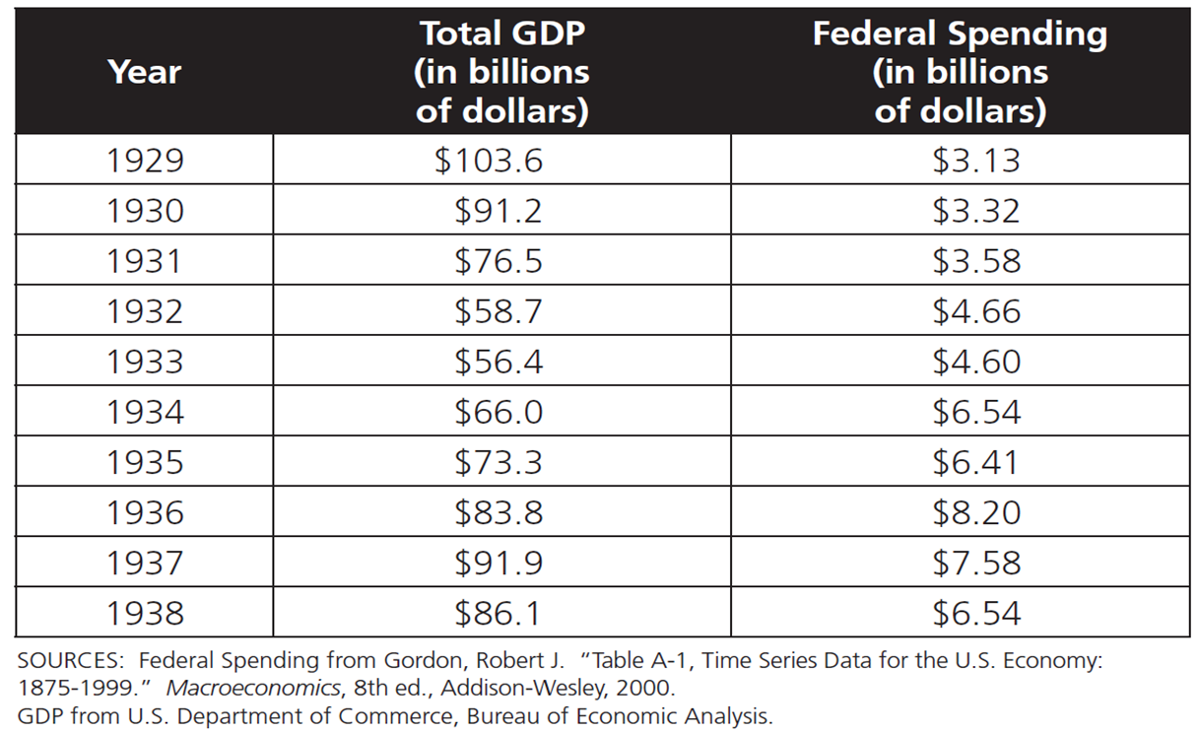

Source 5
During the Great Depression there were many bank failures/suspensions. Bank failures are considered to be the most important reason for the length and depth of the Great Depression. That is, the economy could have survived the other economic downturns of this time, but the bank runs proved too great for the economy to endure.

A bank failure occurs when a bank is unable to meet depositors’ demands for their money. That is, people who deposited money in the bank cannot withdraw money because the bank does not have enough money. If you put your money in a bank today, it is most likely insured, which means that you will get your money back even if the bank fails. The table below shows the number of bank failures/suspensions in the United States from 1929 to 1933.

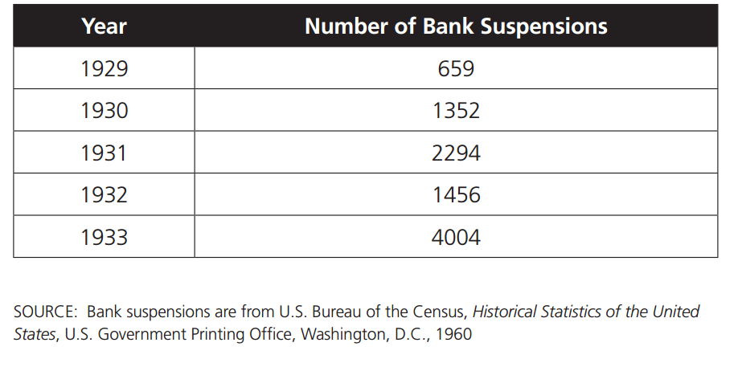

Source 6
During the Great Depression many people were without jobs. The photo below shows a large line of people seeking employment at an employment agency.

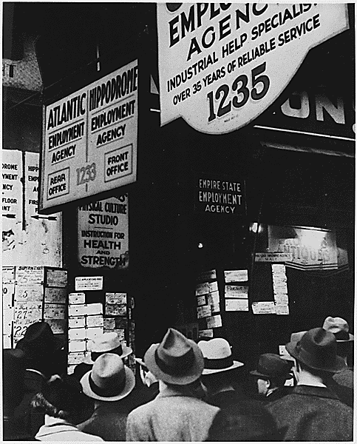
http://history1900s.about.com/library/photos/blygd7.htm

Source 7
During the Great Depression there were many bank failures/suspensions. Bank failures are considered to be the most important reason for the length and depth of the Great Depression. That is, the economy could have survived the other economic downturns of this time, but the bank runs proved too great for the economy to endure.

A bank failure occurs when a bank is unable to meet depositors’ demands for their money. That is, people who deposited money in the bank cannot withdraw money because the bank does not have enough money. The photo below shows a bank run occurring. A bank run occurred when a large number of customers of a bank withdrew their deposits simultaneously due to concerns about the bank's continued existence. Many bank runs forced banks to go out of business.

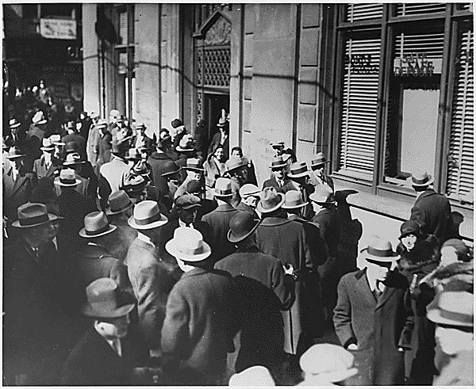
http://history1900s.about.com/library/photos/blygd17.htm

Source 8
Many schools went through hard times during the Great Depression. Some school districts couldn't pay their teachers. One-room grade schools were very common in rural areas. Teenagers sometimes had to quit school to work full time on the family farm. Sometimes young people left home in search of jobs off the farm.

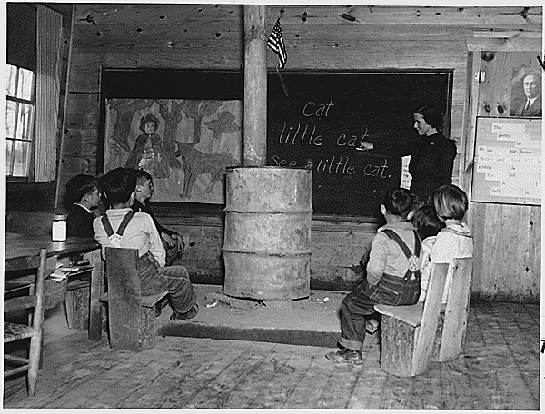
http://history1900s.about.com/library/photos/blygd36.htm

Source 9
Some children helped pick cotton in order to help their families earn income. The photo below shows a young girl picking cotton in Pulaski County, Arkansas. Often schools for African American children did not open until January 1st so as not to interfere with cotton picking.

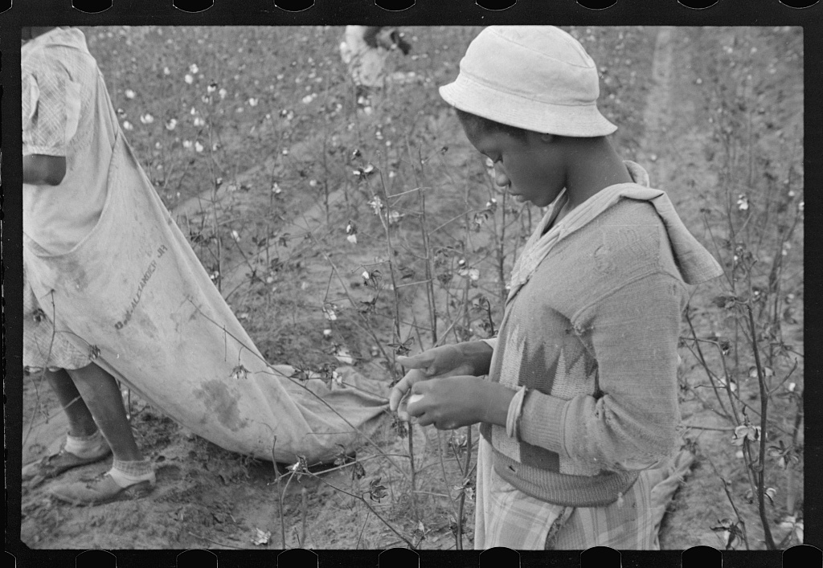

https://www.loc.gov/item/fsa1997017010/PP/
Source 10
Due to the lack of available jobs during the Great Depression, many families found it hard to buy food to feed their families, so many received food through soup kitchens and bread lines.
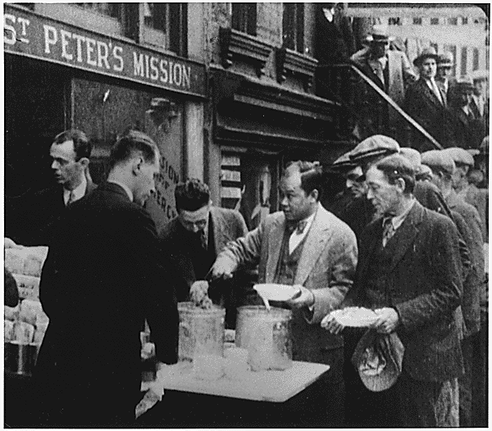
http://history1900s.about.com/library/photos/blygd8.htm

Source 11
The video below includes the first 5 minutes of Franklin D. Roosevelts first fire side chat delivered on March 12, 1933. His use of informal radio addresses to directly communicate his policies to the American public was comforting to many during a time of great national concern.

When President Franklin D. Roosevelt took office in 1933, one in four Americans was out of work nationally, but in some cities and some industries unemployment was well over 50 percent. Equally troubling were the bank panics. Between 1929 and 1931, 4,000 banks closed for good; by 1933 the number rose to more than 9,000, with $2.5 billion in lost deposits.
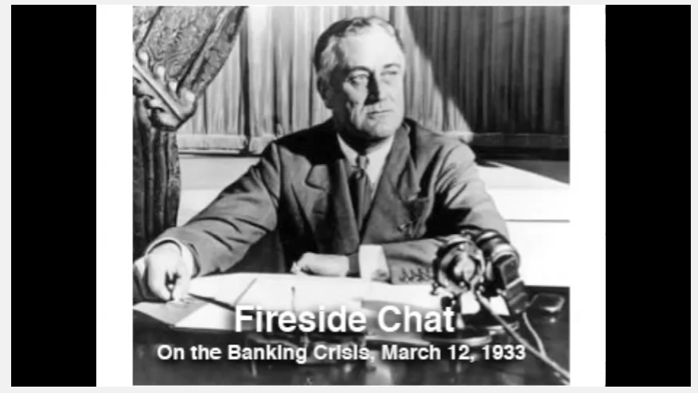

https://www.youtube.com/watch?v=z9CBpbuV3ok

Source 12
The video below includes an excerpt of Franklin D. Roosevelt’s fourth fire side chat. He outlines in clear terms the steps the Government will take to speed economic recovery in America. He describes striking plans for the stabilization of currency, and for mortgage and home relief.
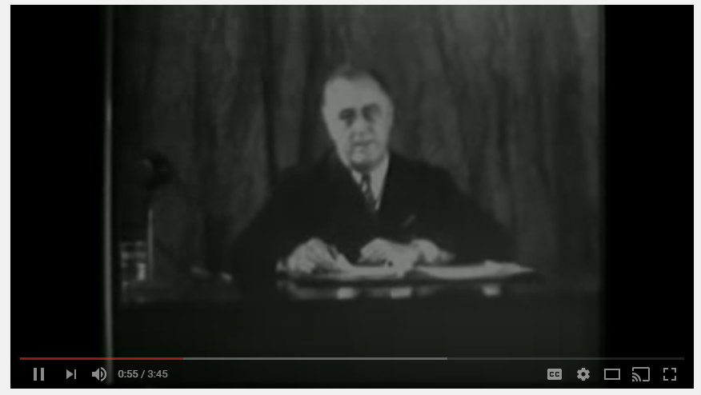
https://www.youtube.com/watch?v=PXY7TkrPPzI

Source 13
During the Great Depression, the Unemployment rate grew to never-before-seen levels. The table below shows the unemployment rate and personal income in the United States during 1929-1933.
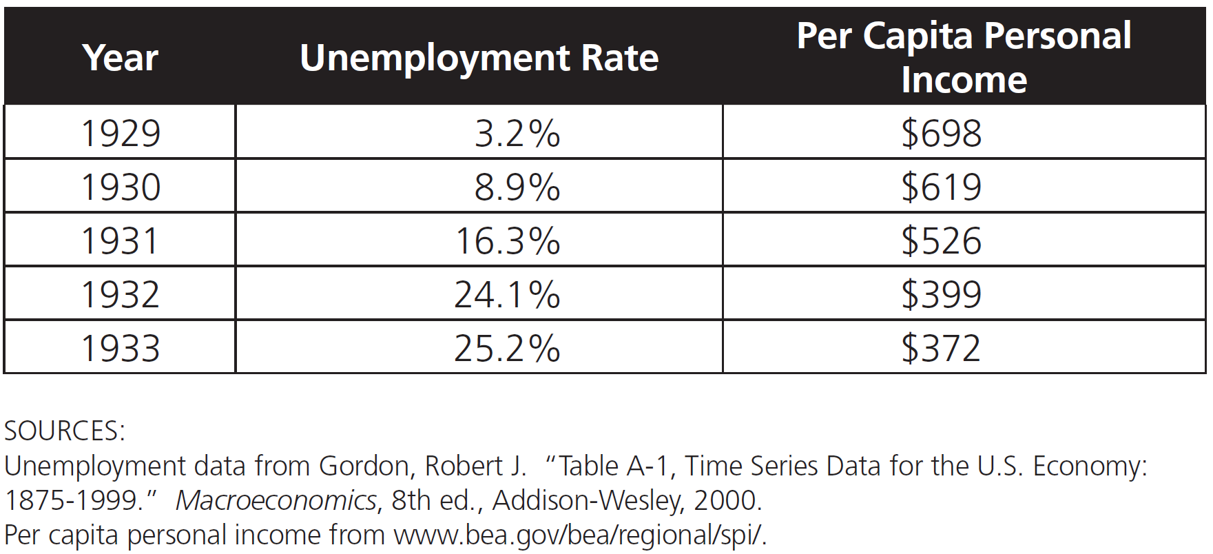

Source 14
The economic hardship of the Great Depression affected everybody, but it was especially harsh for African Americans who were already suffering from unfair employment, housing, and educational practices. In 1935, President Franklin D. Roosevelt created the Works Progress Administration (WPA) to assist with the needs of Americans during the time of economic crisis. The WPA provided jobs to needy men, women, and youth to work mostly on public construction projects. The agency also gave employment opportunities of struggling artists, writers, actors, and musicians. Many of those employed by the WPA were African Americans.

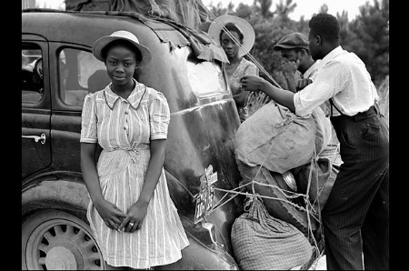

https://rediscovering-black-history.blogs.archives.gov/2014/09/09/we-work-again-african-americans-and-the-federal-work-programs-during-the-great-depression/
RUBRIC FOR PERFORMANCE ASSESSMENT
Task | Beginning  (1-4 points) | Proficient  (5-8 points) | Mastery  (9-10 points)
Analytical use of primary and secondary sources. | The student produced a museum exhibit that was incomplete and contained serious misunderstandings when relating source information to the Great Depression. | The student produced a museum exhibit that was partially complete and made moderately effective connections when relating source information to the Great Depression. | The student produced a museum exhibit that was complete and thoroughly connected relevant, substantial source information to the Great Depression.
Ability to interpret sources to determine characteristics of people, places, or events. | The student did not clearly explain how his/her selected sources illustrated the characteristics of people, places, or events. The student’s explanation was difficult to follow. | The student generally and clearly explained how his/her selected sources illustrated the characteristics of people, places, or events. The student’s explanation was somewhat easy to follow. | The student exceptionally and clearly explained how his/her selected sources illustrated the characteristics of people, places, or events. The student’s explanation was easy to follow.
Determining relationships with multiple causes or effects. | The student’s ideas were unorganized and not expressed clearly. No details and historic references to cause and effects were given. | The student’s ideas were expressed clearly and few ideas are organized. Few details and historic references to causes and effects are made. | The student’s ideas were organized and expressed clearly. There are multiple details and historic references to causes and effects.
Development of final museum exhibit. | The student’s museum exhibit demonstrated an understanding that the Great Depression occurred, but did not explain the economic causes of the Great Depression, the economic impact on Americans during the Great Depression, or the major features of FDR’s New Deal. | The student’s museum exhibit demonstrated an understanding that somewhat explains the economic causes of the Great Depression, the economic impact on Americans during the Great Depression, or the major features of FDR’s New Deal. | The student’s museum exhibit demonstrated an understanding that fully explains the economic causes of the Great Depression, the economic impact on Americans during the Great Depression, or the major features of FDR’s New Deal.

