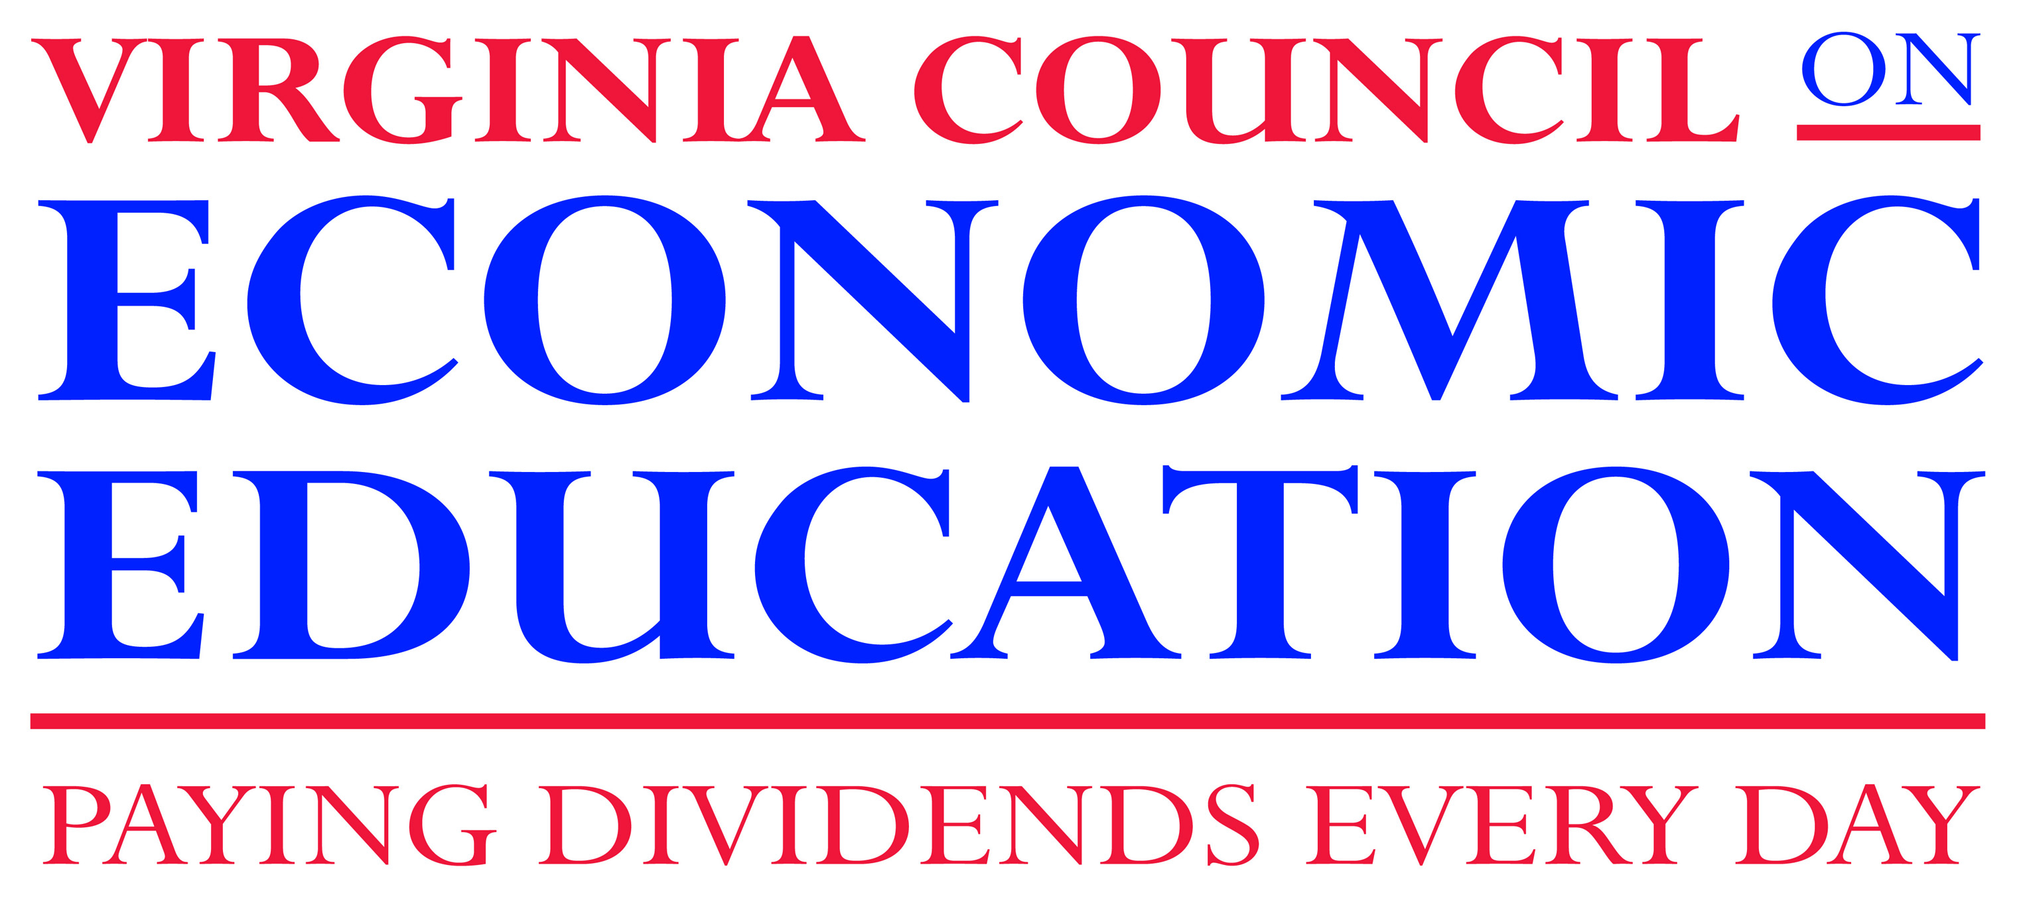
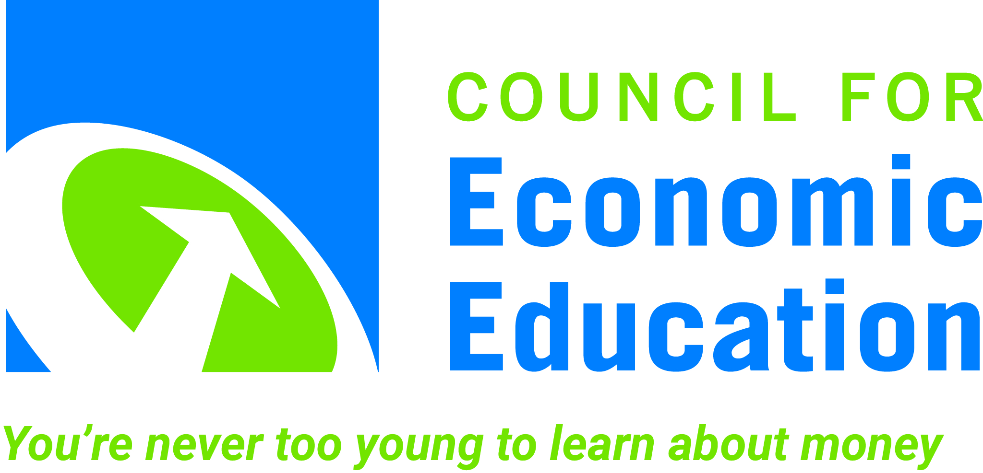

Contact: Judi Crenshaw, Communications & Development Relations Director
Email: jwcrenshaw@vcu.edu
Phone: 804-827-7402
FOR IMMEDIATE RELEASE

Thomas Jefferson High School for Science & Technology Students Win at National Semi-Finals
and Advance to the 17th Annual Council for Economic Education’s
National Economics ChallengeSM

Richmond, Virginia (May 11, 2017) – The Virginia Council on Economic Education is thrilled to announce that the Thomas Jefferson High School for Science & Technology, from Fairfax County, Virginia, placed in the semi-finals and is one of the four teams that will be competing for the championship title in the 17th Annual National Economics Challenge^{SM,} hosted by the Council for Economic Education.

The Thomas Jefferson High School for Science&Technology placed 1st in the Virginia competition’s Adam Smith Division, for advanced placement, international baccalaureate and honors students. They advanced to compete in the National Semi-Finals, a rigorous academic competition against other state winners from across the country, and battled it out to be one of the four highest scoring teams that advance to Finals in New York City.

The National Economics ChallengeSM applies the excitement of an athletic competition to academic excellence, providing students with the opportunity to utilize their economics knowledge and work in teams. The Finals will be held May 20-May 22 in New York City, to include written exams and a critical thinking round, culminating in a “quiz-bowl” round held at the Scandinavia House and hosted by CNBC’s Senior Economics Reporter, Steve Liesman.

"This is a great opportunity for the students to deepen their knowledge of economics and to demonstrate that knowledge in a fun and exciting competition,” says Daniel R. Mortensen Executive Director of Virginia Council on Economic Education. “We’re proud of the team from Thomas Jefferson High School for Science&Technology representing Virginia in the championships at the national level.”

Follow the Council for Economic Education on Twitter @council4econed; and we’ll be live-tweeting the action at #EconChallenge—follow the hashtag for real-time results and to cheer on all the competitors. For additional information visit www.NationalEconomicsChallenge.org.

About Virginia Council on Economic Education

The Virginia Council on Economic Education (VCEE), a public/private partnership and nonprofit organization, provides Virginia’s K-12 students with the economic knowledge and financial skills needed to thrive in our dynamic economy. By providing quality training and up-to-date resources, VCEE partners with teachers and school divisions to help students develop decision-making skills needed to be informed consumers, productive employees or innovative entrepreneurs, thoughtful investors, and reasoned voters. For more information about VCEE, go to http://vcee.org/.

About the Council for Economic Education

The Council for Economic Education is the leading non-profit organization in the United States that focuses on the economic and financial education of students from kindergarten through high school - and we have been doing so for early 70 years. We carry out our mission by educating the educators: providing the curriculum tools, the pedagogical support, and the community of peers that instruct, inspire, and guide. All resources and programs are developed by educators, and delivered by our national network of affiliates. Our goal is to reach and teach every child. Each year CEE’s programs reach more than 55,000 K-12 teachers and over 5 million students across the United States. EconEdLink – our free, online educator gateway for economic and personal finance lessons and resources – attracts more than 1 million unique visitors annually. For further information about the Council for Economic Education go to: http://www.councilforeconed.org.

###

