Whoosh! By Chris Barton
Discussion Questions

Before reading:
Give each student a paperclip or show a paperclip to the class.
Ask students: What job can this little tool do? What problem does it solve? (It holds loose papers together.)
Ask students: Where did the idea for the paperclip come from? (The idea came from an inventor. Everything we use every day was invented or designed by someone who wanted to solve a problem or make something people would enjoy.)
Show the students a picture of a Super Soaker and ask if they know what it is or whether they have ever played with one. Explain that the story you are going to read is about the inventive and hardworking man who created this wonderful toy.

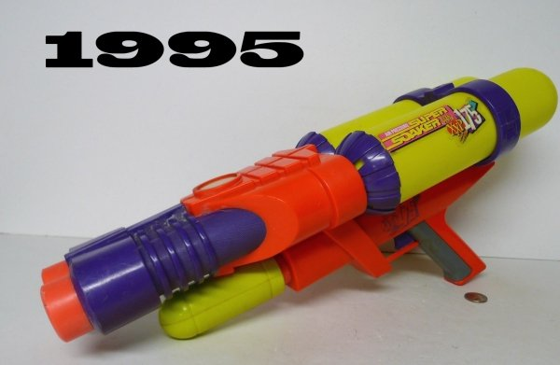
- Scarcity means not having enough of something we want. For Lonnie Johnson what is scarce when he is growing up? (His parents’ house is small and he has 5 siblings, so he has a scarcity of space for his rockets.)
- Resources are needed for building rockets and other inventions. What resources does Lonnie use? (Capital resources - Bolts, screws, and spare parts are some of Lonnie’s resources. Human resources – Lonnie is a human resource needed to build rockets and his other inventions. )
- Lonnie is a human resource with many skills and abilities. What are some of the skills that make him a valuable human resource? (He has many ideas. He can build rockets. He can make rocket fuel. He could build robots from junk.)
- Lonnie was already smart and clever when he finished high school. Why do you think he goes on to college? (He wants to become even more knowledgeable, skilled, and valuable as a human resource. In economic terms, Lonnie is investing in his human capital or investing in himself.)
- Why do you think Lonnie goes to work for NASA—the National Aeronautics and Space Administration? (He wants to earn income so that he can pay for a home, food, clothes and other goods and services he wants. He also really likes the kinds of projects he would be working on at NASA. Note: Income - Payments earned by individuals for selling or renting their productive resources—for work they do. May include salaries, wages, interest and dividends.)
- Why does NASA want to hire Lonnie and pay him wages? (He has skills and knowledge that NASA needs to meet its goals of exploring Jupiter and other areas of space.)
- Lonnie often gets good ideas, and then he gathers resources together. Why does he need these resources? (He wants to experiment and test his ideas, and he cannot do that without resources. Note: The basic kinds of resources used to produce goods and services: land or natural resources, human resources (including labor and entrepreneurship), and capital resources (building and tools.))
- When Lonnie gets older he finally got his own workshop. This workshop contained capital resources, tools and equipment used in the production of other goods. What are some examples of capital resources found in Lonnie’s workshop? (Examples include wrenches, drills, and pliers and the building where he had his workshop.)
- Lonnie invents an entirely new kind of water gun and takes his idea and his prototype to a toy company. Why doesn’t Lonnie just make the toys himself? (It would be very expensive for him, and the toy company has the resources and other things necessary to make the toys on a larger scale. They can buy Lonnie’s idea and use their own equipment—capital resources—and other supplies, and employees—human resources—to make lots of water guns.)
- Lonnie doesn’t have enough money to take all of his ideas and products to market, so Lonnie works with investors. How do investors help Lonnie? (They provide the money that Lonnie needs so that he can get his product to market. That is, make sure that all the things are done so that people will see the product and want to buy it. This includes manufacturing the toy, marketing it, and having it available in stores or other places so people can buy it. Note: Investors – Those who put money someplace with the intention of earning more and making a financial gain. Investment possibilities include stocks, bonds, mutual funds, real estate, and other financial instruments or ventures.)
- Why would investors give money to an inventor like Lonnie? (Investors think Lonnie’s ideas and products are good, and that consumers will want to buy them. His investors will be paid back with interest if Lonnie is successful. Note: Interest - Money paid regularly, at a particular rate, for the use of borrowed money.)
- Investors take a risk when they give money to Lonnie. What is their risk? (They risk losing their money because the product may not be successful—people may not buy it—and the investors won’t get any money from it. Note: Risk - The chance of losing money.)
- What risk does Lonnie take? (He quits his job to focus on inventing. If he isn’t successful in making a product that other people will buy, he won’t get money to buy food, clothing or other things he wants.)
- Lonnie has a lot of the personality traits or qualities that inventors and entrepreneurs need to have. What are some of those traits? (He is willing to take risks. He is persistent; he doesn’t give in even when some people say “No.” He has gotten the education he needs to know what he is doing. He believes in his ideas and in himself. Note: Entrepreneur - One who draws upon his or her skills and initiative to launch a new business venture with the aim of making a profit. Often a risk-taker, inclined to see opportunity when others do not. Lonnie is an inventor - Someone who creates or devises a new process, application, machine, or article of application.)
- Lonnie’s Super Soaker is a big success. Lonnie still doesn’t have a “regular” job. How does Lonnie earn money from this popular toy? (He makes a little bit of money each time a Soaker is sold.)
- After Lonnie’s Super Soaker success, he could have retired, but he kept on inventing instead. Why do you think that is? (He has many more ideas, and he likes to work on them and he wants to solve problems with some of his inventions.)

