At-a-Glance:
Cleo Edison Oliver, Playground Millionaire, By Sundee T. Frazier
Cleo Edison Oliver is sassy, confident, independent, and enterprising. She is ready to take on the world. She is ready for business.
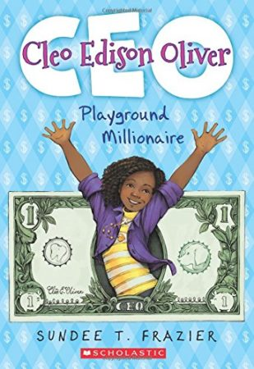
She’s also just a kid – an African-American girl – navigating elementary school. So amid her various enterprising business schemes, this novel is also filled w/ verve and… wordplay!
Cleo will concoct a scheme to sell anything. Avocados. Homemade dogfood. Quinoa cupcakes. Anything.
There’s even a money-making scheme to pull teeth with a Nerf gun – the Extractor Extraordinaire™.
All of which combines to make Cleo Edison Oliver a fun family read and a great vehicle to teach financial literacy. Students can learn with Cleo all the basics, how to turn schemes into action. What are the costs and hurdles? What does one learn about economics – about advertising (Cleo is a whiz at slogans), marketing, distribution and incorporation?
All of it takes place at the playground level so students are sure to be charmed by Cleo’s ambitions – and parents and teachers will be fascinated to see how Cleo can teach basic financial principles. She might even turn some of your students into budding entrepreneurs…

Interested in Registering for Virginia Reads One Book?
The deadline to register your school (fee required) January 31, 2019.
Visit: Virginia Reads One Book to learn more or contact Cathy Plageman, Program Coordinator, cathy.plageman@readtothem.org or (804) 334-5872.
Limited needs-based funding may be available.
Download Classroom Guides from the Virginia Council on Economic Education Here: http://vcee.org/elementary-school/virginia-reads-one-book/

