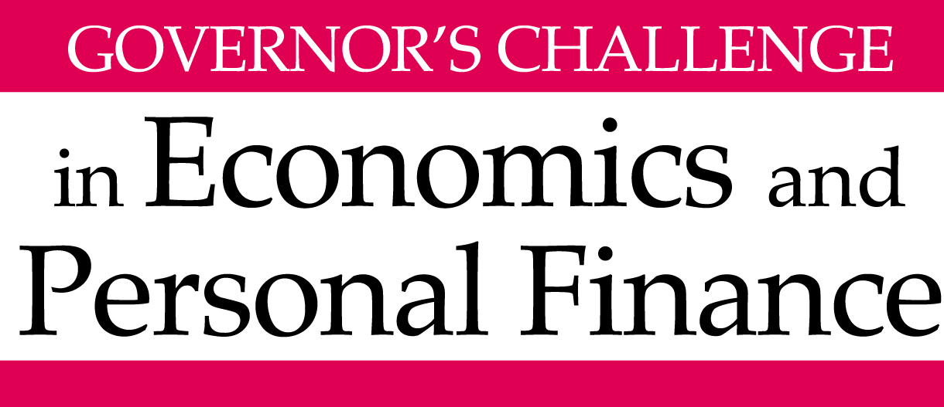

2015 Personal Finance Case Study
12-18-14

Your team focuses on providing comprehensive financial planning for clients. Mr. and Ms. Babbitt heard about your services from a neighbor, who stated that you are great at helping families evaluate various options so they can develop a plan that will help them reach their goals and make intelligent financial choices along the way.

When you first met with the Babbitts, you learned the facts described below and were provided with both the attached balance sheet and budget. Use this information to help the Babbitt family improve their financial condition and reach their financial goals.

PERSONAL INFORMATION
Dale and Mia Babbitt currently reside in Chesapeake, VA, where they have been happily married for one year and 8 months. Both Dale and Mia have children from previous relationships. Dale has twin teenage daughters from his previous marriage of twelve years, which ended in divorce. His daughters, Cecile and Sophia, both age 13, are in the 8th grade. Mia has a 19 year-old daughter, Jessica Cepeda, from her former marriage of 14 years, which also ended in divorce eight years ago. The family also has two Chesapeake Bay Retrievers, Hokie and Pokie, who love the water and taking boat rides.

Dale (age 39) is a nurse at a local hospital, while Mia (age 42) is a paralegal. Both Cecile and Sophia play soccer year round for their middle school and travel teams. Dale thinks Sophia plays simply because she enjoys the social aspect; however, Cecile is a different situation. She has always been the best player on any team she joins and she could earn a scholarship to play at the college level if she continues to play at a high level. Jessica is currently in basic training for the Marine Corps at Parris Island, South Carolina. In addition to the three girls, Dale and Mia welcomed another baby girl, Elizabeth, into their home last month. With this new addition to the family, financial goals and priorities will have to change for the Babbitt’s. Neither Dale nor Mia wish to send their newborn child to daycare, and they would like to avoid incurring more expenses if at all possible. They want either Dale or Mia to stay home until Elizabeth reaches kindergarten.

By working extra hours, Dale could earn up to $10,000 more per year on top of his current annual salary of $70,000. Mia has a stricter 9-5 schedule and currently makes $45,000 per year. In addition, Mia’s sister owns a Christmas tree farm nearby and is always looking for seasonal help. Annually, Mia could increase her income by $5,000 by taking on a job at the farm. As of now they are leaning towards Mia staying home because of her desire to go back to school. If this were the case, Mia would stay home and take night classes. Mia has thought of being a lawyer and this might be an option. If she attends law school and passes the bar exam, she believes she would have a reasonable chance to practice law at the firm where she is currently employed. If so, her income should exceed $80,000 per year.

Dale and Mia are very active in their spare time. The Babbitts, including their two dogs, enjoy going out on Dale’s boat, The Codfather. The boat, a 2003 Sea Ray 320 Sundancer, is valued at $35,000 and the family would prefer to have it around in the future. Before the baby, Mia kept herself busy in her free time. She loved going to the local CrossFit gym. This cost her about $150 per month. She also tried to volunteer at the local animal shelter as much as she could - normally five to ten hours per month. If possible, Mia would love to start the CrossFit workouts again. Dale inherited a stamp collection from his father five years ago He became fascinated with stamps and has since added to the collection. Today, his stamp collection is valued at around $10,000. However, Dale is not interested in selling his collection unless he absolutely must.

The Babbitts maintain two credit cards. On one (Card 1 on Balance Sheet), they maintain a rather large balance at all times because of their spending habits on luxury items. They use the other one (Card 2 on Balance Sheet) to charge their monthly expenses and are religious about paying it off every month.

At minimum your written plan should address the following:
- The main strengths and weaknesses of Babbitt family’s current financial condition.
- Your recommendations for improving upon their current financial situation.
- Discuss the resolution of any conflicts between the clients’ goals, and the ability to satisfy them due to financial or other constraints.
- Identify the extent to which you would advise them to use other professionals to implement any recommendations.

Objectives: (listed in the priority given by the Babbitts, but if you believe a different priority is more appropriate you can recommend it.)
- Fund at least 75% of the education costs for Cecile, Sophia and Elizabeth.
- One of the parents would like to stay at home with Elizabeth until she goes to kindergarten.
- Evaluate Mia’s townhouse situation and decide if they should rent or sell.
- Retire after Elizabeth graduates from college and replace 70% of pre-retirement income.
- Analyze if Dale and Mia should increase their life insurance policies or adjust any end-of-life documents given their divorces and Elizabeth’s birth

ECONOMIC ASSUMPTIONS
The current rate of inflation is 1.7% but the Babbitts would like to use 3% general inflation as a conservative assumption. They are currently in the 25% tax bracket; however, if Mia ends up working as a lawyer, the Babbitts can expect that to increase. Upon retirement, they expect their income to fall into the 15% tax bracket.

REAL ASSETS
Currently, Mia and Dale live together in Dale’s 4-bedroom house valued at $360,000. Before the marriage, Mia and her daughter Jessica were living in a 3-bedroom townhome that is currently on the market for $175,000. While things have been a going slowly for the sale, Mia and Dale feel that the home will soon be sold; however, Mia would not be opposed to renting out the townhome. After skimming the local listings of similar townhomes in her area, Mia determined that she could earn $1,400/month through renting. Mia would require an up-front security deposit equaling one-month rent. Mia would cover any repairs or maintenance on the property. However, Mia does not expect these to rise above $100/month. Finally, the rent does not include the cost of utilities but the tenant would cover those expenses.

There are two vehicles in the household. Dale drives a 2008 Chevrolet Silverado and Mia recently purchased a brand new 2014 Jeep Grand Cherokee for $35,000 just a month before she found out she was pregnant. Mia took out a $27,000, 5-year loan on the vehicle that has a 4.25% interest rate. While she loves her Jeep, she is questioning the economic validity of the purchase since the loan payment is another expense. Additional information pertaining to other personal and financial assets and liabilities can be found in the balance sheet.

EDUCATION PLANNING
Along with paying for Mia’s night classes, the Babbitts have a top priority on ensuring that Cecile, Sophia, and Elizabeth have the opportunity to attend college without being overburdened with debt. Although neither Dale nor Mia have begun saving for the occasion, they would like to contribute the maximum amount to a Virginia 529 plan, if possible. Dale feels that Sophia will want to attend an out-of-state school since she is very outgoing and loves to travel to new areas when they have soccer tournaments. The Babbitts also cannot come to a conclusion on how to handle Cecile. Dale feels that she is going to get a scholarship for soccer, but Mia thinks he is a little ambitious and should consider a more financially secure route. Cecile loves to be home and it is doubtful she will attend an out-of-state college.

Currently, in-state tuition costs $12,000 per year and out-of-state tuition costs $28,000 per year. Room and board for both and in and out-of-state costs $5,000 per year. These costs are expected to increase 3% per year forever. The Babbitts would like to cover at least 75% of the girls’ education costs. Whatever amount is covered, Mia wants to ensure that each daughter receives the same percentage of help relative to the cost of tuition when each child enrolls in college.

INVESTMENTS
Mia has been contributing to her own 401(k) account since she started working at age 22. Her employer matches half of all contributions up to the first 5% of pay. Mia cannot keep her 401(k) account with her current employer if she decides to leave. Additionally, Mia is a huge fan of Notre Dame Football and had a good feeling before the start of the 2012 season. To support her favorite team, she purchased 20 shares of Adidas for $61 in August. Recently, Notre Dame switched sponsors from Adidas to Under Armour. Mia decided to purchase 50 Under Armour shares in January of 2014 for $52.00. Today, she still holds all Adidas and Under Armour shares.

Dale has been funding his own Traditional IRA for a while. However, he has decided to take advantage of his employer’s generous new 401(k) policy which will match his contribution dollar for dollar up to 5% up of his pay.

RETIREMENT
Dale and Mia would like to be financially stable after Elizabeth graduates from college, including having paid off all major debts. They believe that point will be a good time to at least consider retirement. Mia and Dale would like to both retire when Mia turns 65, although Dale would be only 62; and they realize that neither of them would be of “full retirement” age for Social Security benefits. Based on family histories, Dale and Mia believe they will live to 87 and 90, respectively, so they hope to have sufficient retirement income for these life expectancies. Dale and Mia are a laid-back couple, and do not believe they will need much for retirement – around 70% of their pre-retirement income Their dream retirement consists of beach days, continuing hobbies, and visiting their family whenever they can.

INSURANCE COVERAGE
Currently the Babbitts are well covered through the essential plans needed for their family. While Dale has an employer funded life insurance plan, Mia has no plan set up to help the family in the case of her death or disability. Therefore, the Babbitts want to look into the possibility of purchasing some type of life or disability insurance plan for her, but were not sure of the type or amount necessary. In addition to the life plan, the family’s health and auto insurance cover the family to an appropriate level that they believe will keep them well protected.

Life insurance:
- Dale has 2x salary in life insurance ($140,000) through employers group life plan.
- Mia is currently has no life insurance.
Health insurance:
- Dale's employer covers family plan, which includes Dale, Mia, twins and newborn
- Major medical coverage unlimited
- 80/20 co-insurance
- Stop-loss limit: $9,000
- Annual deductible: 1,500
- Jessica has coverage through her military service.
Auto Insurance:
- Split-limit coverage: 100k/300k/100k
- Collision and Comprehensive deductibles: $1,000
- Annual premiums: $2,500

ESTATE
As stated previously, Dale and Mia have been married for less than two years. During this time many significant life events have occurred. For instance, Jessica recently made the decision to defend her country and join the Marines. Also, the Babbitt family just welcomed a new family member into their house with the birth of Elizabeth. Dale and Mia believe they should update their wills from their previous marriages before the responsibilities of caring for a newborn drain all their energy. This means both Dale and Mia’s wills are currently set up to benefit their former spouses.

MISCELLANEOUS EXPENSES
Dale is paying alimony of $325 monthly for no more than the next 5 years.

Case study provided by students Zach Bennedsen, Dennis Elias, Rodger Isom, Jack O’Donnell, Megan Posey, Allen Ropp, members of the Student Financial Planning Association at Virginia Tech, under the guidance of student leaders David Francis and Jessica Brinkley and faculty members Mr. Derek Klock and Dr. Ruth Lytton.
If your team is one of the top scoring teams in the online Personal Finance Division of the
Governor’s Challenge and invited to participate in the statewide Championship on April 17, 2015,
below are some additional directions.

- By Monday, April 13, 2015 at NOON, provide a written report in any format you believe
appropriate that sets forth your recommendations and includes any assumptions and calculations you
believe would be helpful for the Babbitt family/judges. The report cover should include the names of
your financial planning team and your sponsoring teacher, school and school division. E-mail the
report to Sarah Hopkins Finley at shfinley@vcu.edu. If you do not receive an e-mail acknowledging
receipt within 30 minutes, please call Page Ritter to confirm receipt of the report (804-828-1627.)

- MAXIMUM page limit: the report with recommendations may not exceed 10 pages, not
including the cover page. An appendix may also be added with any supporting documentation
and calculations deemed appropriate.

- Visit www.vcee.org for additional details regarding the Championship Challenge on April 17, 2015.
(http://www.vcee.org/Personal_Finance_Case_Study under Governor’s Challenge under Programs/Awards.)

The rubric for judging the written and oral presentations is found on this webpage along with the budget and balance sheet for the Babbitt family.

