“Barbie’s Keepin’ It Real”: How Insurance Affects Your Life

Christine Pedersen
Lesson Targeted to 10th Grade

II. Abstract:

In my Economics and Personal Finance class, my students must study insurance as part of the curriculum. Unfortunately, most 16 year olds do not care very much about insurance and have little concept of the risks they run by being uninsured. To make insurance more relevant and even fun, I created a game using Barbie dolls. The students got around their desks in groups of 5 or fewer players, with each group having a game board, dice, insurance policies, game cards, and a Barbie doll. The concept of the game is the Barbie has been granted her wish to become real, but she has to live in the “real” world for one year and end with both a positive net worth and with a positive tally of “joy points.” Students could choose to buy insurance for Barbie, or not, and as they rolled the dice and moved their Barbie’s around the board, good and bad things happened to Barbie. While each game was played concurrently, I posted the scores of each game, and there was an overall winner on the classroom level. At the end of the class period, students did a reflection in Padlet on what they had learned about insurance by playing the game.

III. Economics Content and Key Concepts:

Insurance – A contract (policy) in which an individual or entity receives financial protection or reimbursement against losses from an insurance company. The company pools clients' risks to make payments more affordable for the insured. (http://www.investopedia.com/terms/i/insurance.asp)

Policy –The insurance contract and all attached endorsements, including type of insurance coverage, the limits paid for particular loss and the amount the insured paid in premium. (http://www.investprogram.org/students/insurance-in-real-life/basic-terminology)

Risk -- Risk exists whenever there is uncertainty about outcome. Facing risks is part of life, and it is the basic problem insurance addresses. (http://www.investprogram.org/students/insurance-in-real-life)

Utility--. In microeconomics, happiness is measured by a concept called utility. The standard unit of measurement that microeconomics uses to measure utility is called the util….[which] has no concrete numerical value like an inch or a centimeter. It is merely an arbitrary, subjective and convenient way to assign value to consumer choices and to measure the consumer utility or utils of one choice against another. http://www.investopedia.com/university/microeconomics/microeconomics2.asp

IV. Economic Standards and Student Learning Outcomes:

The Standard of Learning addressed was EPF.14 (a) The student will demonstrate knowledge of the role of insurance in risk management by a) evaluating insurance as a risk management strategy.

The lesson objectives were:
1) students will know that insurance can only reduce financial risk but not any other kinds of risk--bad haircuts and heartbreaks will still happen!
2) students will understand buying insurance is a paradox -- the best case scenario is not to have to use the insurance you purchase.
3) students will be able to decide when and whether to purchase insurance and will experience the consequences of their decisions.

V. Instructional Process:
At the start of the insurance unit, I made a Google form to collect the students’ ideas of good and bad things that could happen in life, some that would be financial and others that did not involve money. I used the student-generated scenarios to create game cards that Barbie would draw as she rolled the dice and landed on various squares of the game board. The game board is made of posterboard with colored squares of paper that matched the colored cards. On the sample game board, all the spaces are blank; you just draw the color card on which you’ve landed. Teachers can also write in “events” onto the spaces, like in Monopoly (e.g. “someone thanks Barbie for something nice she did: +2 Joy”). See the pictures on this page and next.

I used real Barbie dolls as the game pieces that moved around the board. My high school students got a big kick out of using the actual dolls. The silliness of playing with dolls made the seriousness of the subject matter more fun.

After covering many different types of insurance from auto to life to homeowners, we played the Barbie’s Keepin’ It Real game as a culminating activity.

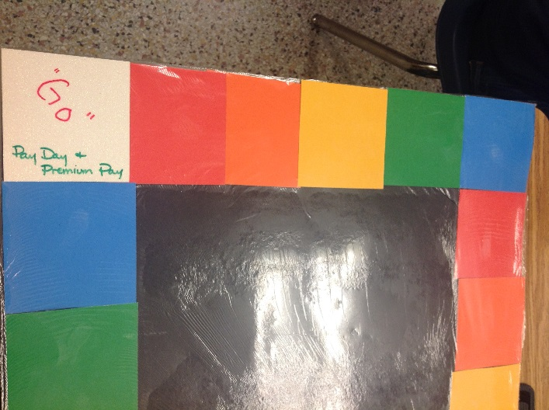
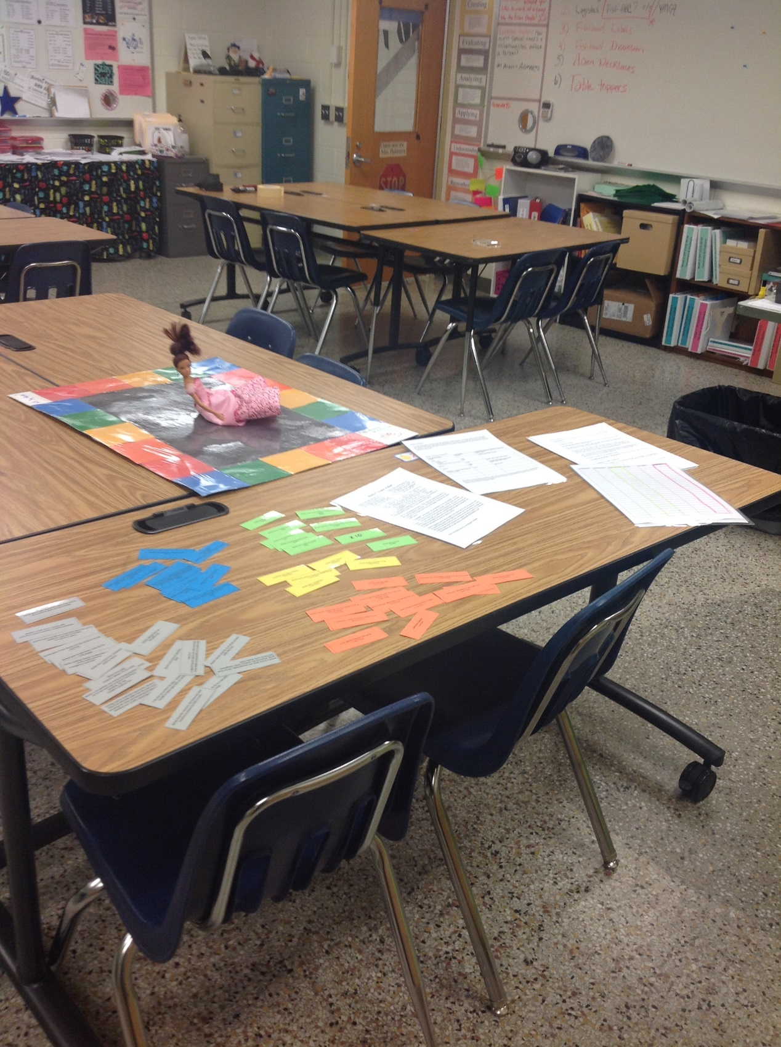

VI. Evaluation of Student Learning:
The completion of the feedback Padlet, along with the student’s participation in the game, revealed the student’s level of understanding and engagement.

Appendix:
A. Resources:
Investopedia.: http://www.investopedia.com/
InVEST : http://www.investprogram.org/
Padlet: https://padlet.com
B. Handouts, Worksheets, and Links:
1) Barbie’s Keepin’ It Real: Game Instructions

2) Google form for collecting the students’ ideas about happy/sad or money-driven life events.
Live Form: http://tinyurl.com/vhs4real
Responses for one class section (Spreadsheet): http://tinyurl.com/response4real
https://docs.google.com/spreadsheets/d/1OllOn3i4mPU10mgx8qxxfqH0apD6rxUVmDjp1Sips3w/edit#gid=37846873
3) Barbie’s Keepin’ It Real Insurance Cards

4) Barbie’s Keepin’ It Real Positive Joy Cards

5) Barbie’s Keeping it Real Negative Joy Cards

6) Barbie’s Keepin’ It Real Positive Money Cards

7) Barbie’s Keepin’ It Real Negative Money Cards

8) Barbie Padlet: Actual student reflections on the game
http://padlet.com/clpedersen/Barbie1
http://padlet.com/clpedersen/Barbie3
http://padlet.com/clpedersen/Barbie4
http://padlet.com/clpedersen/Barbie6

9) Barbie’s Keepin’ It Real Tracker

10) Barbie’s Keepin’ It Real Insurance Options

*****************************************************************************
Student BARBIE GAME INSTRUCTIONS

Barbie’s Keepin’ It Real
Barbie is the doll who has it all—except for one thing. She’s tired of being a toy. Barbie wants to be real! You can help make Barbie’s dream come true. You will help her make decisions and you will keep track of her MONEY and her JOY. If she can end the game with BOTH positive utils (happiness points) and a positive net worth (she owns more than she owes), then Barbie can stay alive and real!
Roll the dice to move Barbie around the board. Every time she passes “GO” it’s PAYDAY and PREMIUM DAY. Write her MONEY points in the DEPOSIT/CREDIT column and/or the PAYMENT/FEE column, keeping track of her current balance in the MONEY BALANCE column. Have Barbie purchase INSURANCE (or not) and keep track of her coverage; you will track her PREMIUMS in the PREMIUM section and pay them in the PAYMENT/FEE column. Track Barbie’s happiness in the JOY column, with a running balance in the JOY BALANCE column. Rely on your teammates for advice!
As a team, you are helping your Barbie. Other teams are helping their Barbies in the same quest for happiness and money. Your Barbie wins or loses on her own terms, but there is an overall winner based on the highest combined total of JOY and MONEY points.
LIFE CHANGERS: can be either a or EVENT or a $+ or $- EVENT. For the $+ or $-, there may or may not be insurance coverage. Just like in the real world, Barbie’s insurance must have been purchased in advance for an event to be covered. Also like in the real world, you will have to decide if Barbie needs the coverage and can afford the coverage. In some cases, you will decide how high her deductible will be which will impact how much her premium will be.
Barbie’s happiness points will be higher if she doesn’t have to use her insurance and her regular money points will be higher if she doesn’t have to pay premiums….but if she has an event that would have been covered, yet she does not have coverage, her happiness points will be reduced by the number you roll on one die. You will need to help Barbie find the right balance to MANAGE HER RISKS in life!

Grab your Barbie and let’s start Keepin’ It Real!

******************************************************************************
Barbie’s Keepin’ It Real Insurance Cards

Barbie has a crack in her windshield.  $500 to replace. | Barbie is on vacation. Her friend is feeding Barbie’s cat for her and trips in Barbie’s apartment, breaking her leg.  $5,000 in medical care.
Barbie’s in an accident that damages a building. She is at fault.  $15,000 liability charge. | Barbie’s credit score reaches 800.  $50 less on auto insurance monthly premium.
Barbie goes to the dentist for her first 6 month cleaning.  $190 visit. | Barbie goes to the dentist for her second 6 month cleaning.  $190 visit.
Barbie’s tooth needs a crown.  $3,500 | Barbie goes to the doctor with the flu.  $75 charge.
Barbie’s doctor sends her to a specialist.  $200 charge. | A pipe bursts in Barbie’s apartment, ruining her big screen TV (bought for $1500) and her computer (bought for $2,000).  $5,000 replacement cost.
Barbie hurts herself on a Saturday bike ride and is unable to work for 4 months.  4 x monthly salary. | Barbie’s pet needs an operation.  $600
A hit-and-run accident damages Barbie’s car.  $4,000 in repairs plus $500 car rental | Barbie’s power goes out unexpectedly. All her food spoils. Replacing the contents of her refrigerator and freezer costs Barbie $360.
Someone breaks into Barbie’s apartment and steals all her shoes. $3,500 replacement cost. | Someone breaks into Barbie’s car, damaging it, and steals her GPS, her car’s stereo system, and even her spare tire!  $1,100 to repair the car and $1,500 replacement cost.
Barbie’s allergies flare up.  $75 office visit. | Barbie needs prescription allergy medicine; the generic brand does not stop her symptoms.  $100 a month.
Barbie’s doctor sends her to an allergy specialist.  $200 office visit. | Barbie needs a medical test and blood work to figure out her allergic reactions.  $800 total charge
While cooking, Barbie accidentally sets the kitchen on fire and burns her arm badly.  Emergency room bill including ambulance ride: $3,000. | During a party at Barbie’s apartment, Barbie’s friend accidentally walks into the patio door, breaking her nose and shattering the glass door.  Medical cost: $1500; replacing door: $1200
Barbie gets a speeding ticket, with a fine of $75. Her premium goes up $20 a month. | Barbie goes to traffic school. Her auto insurance premium is lowered by $20 a month
Barbie shops for insurance. She lowers her total insurance premium by $100 a month. | Barbie goes to an acupuncturist to relieve stress. The price of each visit is $100, but the provider is in her plan.

******************************************************************************
Barbie’s Positive Joy Points

Barbie gets a compliment  2 Joy Points | Barbie gets a random gift  2 Joy Points
Barbie gets accepted to college  3 Joy Points | Someone tells Barbie she looks pretty today  1 Joy Point
Someone says hello to Barbie  1 Joy Point | Barbie does some community service and gives back to her neighborhood  10 Joy Points
Barbie sees a family member she hasn’t seen in a while  3 Joy Points | Someone gives Barbie a hug  4 Joy Points
Someone gives Barbie a piece of candy  1 Joy Point | Someone buys Barbie flowers  4 Joy Points
Barbie accomplishes a goal she set for herself  5 Joy Points | Barbie visited a friend  4 Joy Points
Barbie got a new game to play  3 Joy Points | Barbie spent some time with her pet  4 Joy Points

*****************************************************************************
Negative Joy Point Cards

Barbie did not accomplish a goal she set for herself  -3 Joy Points | Someone said something mean to Barbie  -1 Joy Point
Barbie got suspended from school  -5 Joy Points | Barbie lost something important to her  -3 Joy Points
Someone close to Barbie passed away  -10 Joy Points | Barbie had her hopes up, but the hoped for thing did not happen  -2 Joy Points
A car splashed Barbie with water  -2 Joy Points | Barbie has a bad day  -1 Joy Point
Someone gave Barbie attitude when she was already down  -3 Joy Points | Barbie’s friends talked about her behind her back  -5 Joy Points
Barbie’s power went out  -2 Joy Points | Barbie’s pet got lost  -5 Joy Points
Barbie got bad grades on her report card  -4 Joy Points | Barbie got a bad haircut.  -2 Joy Points

******************************************************************************
Positive Money Cards

Barbie’s investment made money!  $1,000 | Barbie found money in her driveway!  $100
Barbie hit the Lottery  $1,000 | Barbie got a bonus!  $2,000
Barbie won a free cruise, including shopping money  $500 | Barbie found some money!  $20
Barbie got a raise at work!  $100 every paycheck | Barbie won a raffle at a party!  $200
Barbie was the 1millionth customer at Food Lion!
$2,000

*****************************************************************************
Negative Money Points

Barbie’s investment lost money.  -$1,000 | Barbie lost her wallet  -$100
Barbie spent money on the Lottery  -$100 | Barbie forgot to pay her credit card bill  -$50 late charge
Barbie was scammed about a “free cruise”  -$500 | Barbie’s account was hacked, and she had to miss a day of work to sort everything out  -$100
Barbie’s company changed hands, and she lost her job  Skip one paycheck | Barbie bought a new Apple watch  -$350
Barbie owes back taxes  -$2,000 | Barbie made a check out to cash, and then lost the check. Someone legally cashed it.  -$200
Barbie’s is carrying a balance on her maxed out credit card  -$65 finance fee | Barbie took a payday loan at a high interest rate.  -$300
Barbie was the victim of identity theft. She had to pay the maximum credit card fee.  -$50 | Barbie co-signed on a loan for Ken many years ago. Ken recently stopped repaying the loan, so Barbie had to make the last few payments herself.  -$1,000

******************************************************************************
Barbie’s Score Sheet
PAYMENT/FEE | DEPOSIT/CREDIT | MONEY BALANCE | JOY PLUS | JOY MINUS | JOY BALANCE
*************************************************************************************
BARBIE’S PAYCHECK:
Every time Barbie goes around the board, she will get her monthly paycheck. She makes $3,000 a month, take home pay. She pays $700 in rent every month. She pays $300 for a car payment every month. She starts out with $1,000 in her account. You will add and subtract the rest. Be sure to keep a running balance in the money balance column, and track any changes below:
BARBIE’S INSURANCE PREMIUMS:
TYPE OF INSURANCE: | DEDUCTIBLE | PREMIUM (broken into a MONTHLY premium)
Health | $1,000 (per year, not per incident) | $481 a month
Auto  Liability  Comprehensive  Collision  Uninsured/Underinsured motorist | $0  $500  $1,000 | $0 deductible=$3600 a year/$300 a month  $500 deductible =$2400 a year/$200 a month  $1,000 deductible=$1200 a year/$100 a month
Renters | $250  $500 | DELUXE $480 a year/ $40 a month  BASIC $360 a year / $30 a month
Dental | $50 | $600 a year/ $50 a month
Disability – replaces 70% of Barbie’s income ($2,100) |  | $50 a month

Remember, every time Barbie experiences a life event that WOULD HAVE BEEN COVERED by insurance, except Barbie did not choose to get that insurance coverage, she loses the number of JOY POINTS X the roll of one die. This is in addition to the financial loss/MONEY POINTS.

