“Give Adam Smith a High Five!”

Christine Pedersen
Lesson Targeted to 9-12 Grade

II. Abstract:
One of the fundamental concepts my students need to understand in Economics and Personal Finance is the elegant beauty of a free market. To explore Adam Smith’s seminal theories, I first assign my students the famous essay by Leonard E. Read, “I, Pencil” for outside of school reading (or listening), and we then watch the short video in class. Our discussion centers on what it means to have a “free” market, where no one is telling anyone what to do but everyone does what is in their own self-interest. I then present an extremely concentrated version of Adam Smith’s theories as covered in “The Wealth of Nations.” My lesson correlates each of the five concepts that the Virginia Standards of Learning requires to be taught to the four fingers and thumb on an “invisible” hand; the students trace their own hands and write the theories on the indicated digits and palm. To reinforce the concepts in a memorable and fun way, I have my students experience what happens when the ‘invisible hand” bakes chocolate chip cookies. In small groups, my students choose one ingredient from chocolate chip cookies and trace back all the things people do (by personal choice and without a central commanding body) to create the ingredients in a chocolate chip cookie. For the final part of the lesson, the groups share all the inputs into how their ingredient came to be made, and we have some chocolate chip cookies while we wrap up a discussion of the magic of free markets. Homework is student application of the invisible hand theory to their own lives by taking a treasured item and contemplating how the free market made that object available to them, without any coercion or command.

III. Economics Content and Key Concepts:

Free market – A free market is a market economy based on supply and demand with little or no government control. A completely free market is an idealized form of a market economy where buyers and sellers are allowed to transact freely (i.e. buy/sell/trade) based on a mutual agreement on price without state intervention in the form of taxes, subsidies or regulation
http://www.investopedia.com/terms/f/freemarket.asp

Self-interest— Self-interest refers to actions that elicit the most personal benefit. Adam Smith, the father of modern economics, explains that the best economic benefit for all can usually be accomplished when individuals act in their own self-interest. His explanation of the invisible hand reveals that when dozens or even thousands act in their own self-interest, goods and services are created that benefit consumers and producers.
http://www.investopedia.com/terms/s/self-interest.asp

IV. Economic Standards and Student Learning Outcomes:
STANDARD EPF.1f
The student will demonstrate knowledge of basic economics concepts and structures by
f) identifying Adam Smith and describing the characteristics of a market economy.

Students will be able to identify Adam Smith and understand his theories
Students will be able to apply the idea of the invisible hand by showing they understand how a free market encourages people to provide what others want by focusing on what they need to do to get what they themselves want.

V. Instructional Process:
BUILD BACKGROUND:
Previous to the lesson, students read or listen to the essay “I, Pencil” by Leonard E. Read.

HOOK/ATTENTION GETTER: We watch the short video of “I, Pencil” together and have a discussion of what a free market is and why it matters.

DIRECT INSTRUCTION:
The invisible hand is Adam Smith’s most famous theory, but he had many other economic theories that were also very influential.

ESSENTIAL KNOWLEDGE, directly from the Virginia Standards of Learning EPF 1 f
http://www.doe.virginia.gov/testing/sol/frameworks/economics_personal_finance/economics_personal_finance_curriculum_frmwrk.pdf
Adam Smith observed that specialization and division of labor in a pin factory allowed workers to produce many times more pins than if each worker had been working alone.
Smith believed that people, acting in their own self-interest, would work hard and produce what consumers want as if directed by an invisible hand.
Smith argued for trade, saying it opened new markets where surplus goods could be sold and allowed for cheaper goods to be imported.
Smith believed that competition among businesses would keep prices in check.
Smith believed there was a limited but important role for government to do things such as enforce contracts, grant patents and copyrights, and provide public works such as roads.

ACTIVITY:
Students trace their hand on a piece of paper and write the following things, as detailed in the attached handout: PALM- Adam Smith (1723-1790), author of “The Wealth of Nations”, called “The Father of Economics.” THUMB—Trade Opens New Markets, INDEX FINGER –Invisible Hand Theory, MIDDLE FINGER--competition keeps prices in check, RING FINGER – specialization + division of labor=higher productivity, PINKY FINGER – Limited but important role for government.

GROUP WORK/GUIDED PRACTICE:
Just like no one knows how to make a pencil, but the invisible hand still guides everyone to work together and make one—no one knows how to make a chocolate chip cookie, either. So how does the invisible hand manage to get those chocolate chippers made? Let’s explore!

In small groups, students will take one item from the making of a batch of cookies. [Choices include: bag of flour, bag of sugar, a carton of eggs, bottle of vanilla, bag of chocolate chips, a cookie sheet, a spatula, an oven mitt or potholder]. Each group will have 5 minutes to trace all the inputs into creating just that particular item needed to make the cookies. The group speaker will share with the rest of the class how that item’s existence is evidence of the invisible hand at work.

INDIVIDUAL PRACTICE/HOMEWORK: The student will choose an item she or he uses on a regular basis and show how that is evidence of the invisible hand at work. The student will then answer the question: What evidence do YOU see of Adam Smith’s theory of the invisible hand working for you?

VOCABULARY: Economics, consumer, producer, market, market economy, command economy, traditional economy, mixed economy, Adam Smith, figurative language/metaphor.

VI. Evaluation of Student Learning:

Students trace the hand and fill in the fundamentals of Adam Smith’s theories. I’ve included a photograph of the students’ work posted outside of the classroom. The comments students make in the discussion of the chocolate chip cookie activity and also in their homework of where they see the invisible hand at work in their life reveal that students understand the concepts.

Appendix:
A. Resources:
Link to “I, Pencil” text: http://www.econlib.org/library/Essays/rdPncl1.html
Link to “I, Pencil” audio version: https://fee.org/resources/i-pencil-audio-pdf-and-html/
Link to “I, Pencil” movie: http://ipencilmovie.org/
http://www.doe.virginia.gov/testing/sol/frameworks/economics_personal_finance/economics_personal_finance_curriculum_frmwrk.pdf
http://www.investopedia.com/articles/economics/08/adam-smith-economics.asp
http://www.biography.com/people/adam-smith-9486480
View a picture: http://2015people.com/images1/adam-smith-6.jpg

B. Handouts, Worksheets, and Links:

Comprehension Check for “I, Pencil” by Leonard E. Read
1. Are you able to make a pencil on your own? Is anyone?
2. How many people are required to make pencils simple and inexpensive?
3. Is the construction of pencils mandated or voluntary?
4. What is required to keep useful tools like pencils available and inexpensive?

Mrs. Pedersen Economics and Personal Finance WEEK #1
Give Adam Smith a High Five!
1. Trace the outline of your hand on a sheet of paper.

2. On the PALM, write:
Adam Smith (1723 – 1790)
“The Father of Economics”
Author of The Wealth of Nations
3. On the THUMB, write: TRADE OPENS NEW MARKETS!
Smith argued for trade, saying it opened new markets where surplus goods could be sold and allowed for cheaper goods to be imported. He gave TRADE a THUMBS UP.

4. On the INDEX FINGER, write: THE INVISIBLE HAND
Adam Smith believed that people, acting in their own self-interest, would work hard and produce what consumers want as if directed by an invisible hand. This was his #1 idea!

5. On the MIDDLE FINGER, write: COMPETITION KEEPS PRICES IN CHECK
Smith believed that competition among businesses would keep prices in check. This infamous gesture might remind you that it takes at least two to make it meaningful….and you should definitely think twice before raising it, just like businesses in competition have to think long and hard before raising prices.

6. On the RING FINGER, draw a ring that looks like it was made from a pin, and then write:
SPECIALIZATION + DIVISION OF LABOR = HIGHER PRODUCTIVITY
Smith observed that specialization and division of labor in a pin factory allowed workers to produce many times more pins than if each worker had been working alone. This is a great observation: we like it, and we definitely want to put a ring on it!

7. On the PINKY FINGER, write: LIMITED BUT IMPORTANT ROLE FOR GOVERNMENT
Smith believed there was a limited but important role for government to do things such as enforce contracts, grant patents and copyrights, and provide public works such as roads. You probably don’t think of your pinky as important, but try picking things up without it…..like the government, you’d miss it if it were gone!

Interested in knowing more?
http://www.investopedia.com/articles/economics/08/adam-smith-economics.asp
http://www.biography.com/people/adam-smith-9486480
View a picture: http://2015people.com/images1/adam-smith-6.jpg
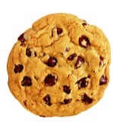The Invisible Hand that Makes Chocolate Chip Cookies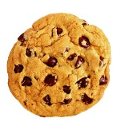
Each team will get one item used in the making of chocolate chip cookies. Your team should first examine the item and decide whether it is an ingredient used to make the chocolate chip cookie dough or a tool used in the process of combining the ingredients or baking the cookie.
Analyze your item. What are its component parts? Where do those parts come from? Who makes them? How did they come to be a part of what you are holding in your hand?
Is there packaging for your item? How did that come to be? Trace all elements back to their source.
Things to consider:
People have to design things like packages. Containers need to be created. Items need to be shipped. Shipped items need to be weighed. Trucks need drivers. Truck drivers need roads, etc. You should trace each element that is needed to make the item used to create a cookie, going as far as you can.
When you have gone as far as you can in analyzing the origins of the item you have, spend a few moments pondering how the existence of this item, at your fingertips any time you have the money to buy it from the store, is a demonstration of Adam Smith’s concept of “The Invisible Hand.”
In your Interactive Notebook, 1) list the component parts of your item, 2) trace back how it came to be available for you to purchase, and 3) explain how its availability to you any time you want to bake chocolate chip cookies is evidence that Smith’s theory was correct.
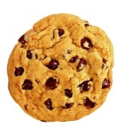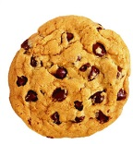
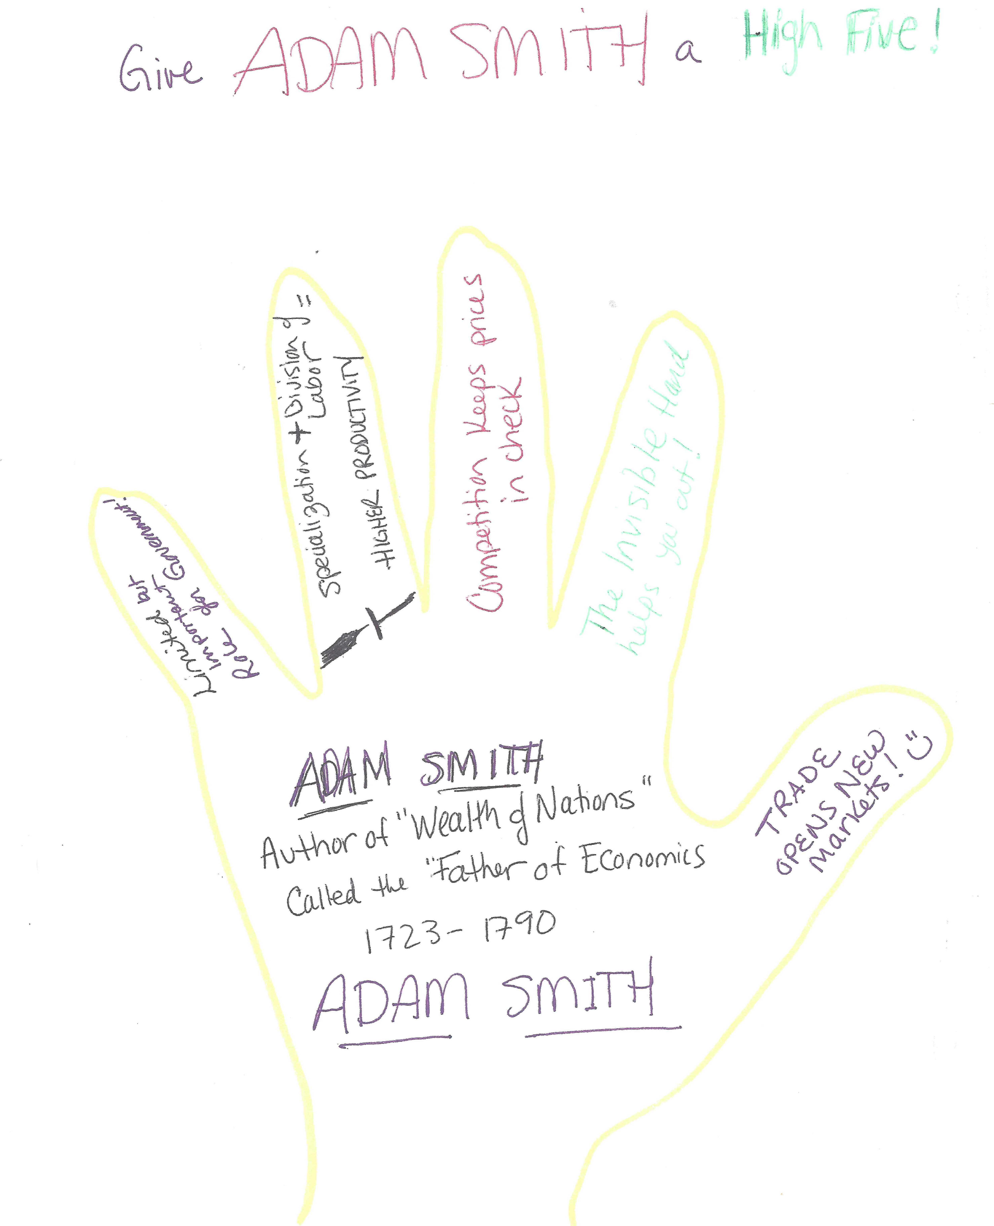

ADDITIONAL ACTIVITY

Visit the website of Otis Spunkmeyer and the Christie Cookie Company. Then, watch the video of the Chocolate Chip Cookie Factory below. Think about all the different “fingers” that Adam Smith writes about in “The Wealth of Nations.” Can you make a connection between what you’ve explored about frozen cookie dough to each of the economic concepts of Adam Smith?

http://www.spunkmeyer.com/About-Us/About-Us/#supply
https://www.christiecookies.com/food-service/flavors

Video: “How It’s Made”
https://www.youtube.com/watch?v=kUlA3cBhApw

[Student answers will vary, but here are some possible answers]
- Trade is good—we couldn’t enjoy the amazing vanilla from beans harvested in Madagascar, Africa without trade!

- Invisible Hand--No one is making these companies create this product. Everyone is working in his or her best interest, for profit or a paycheck—and the result is fresh, tasty cookie dough, ready to bake for your pleasure!

- Competition Keeps Prices in Check—Otis Spunkmeyer and The Christie Cookie Company both make frozen cookie dough for sale so that companies and individuals can bake them fresh at home, and they both also sell their delicious baked cookies and other goodies. Because there is competition in this market, prices are lower than they otherwise would be.

- Specialization—even though many jobs are now done by automation, the video clearly shows specialization. In the packaging station, for example, the box is set up, then lined with plastic, filled with frozen cookies, weighed, seal and labelled—all in distinct processes.

- Limited but Important Role of Government—did you notice that the cookies are run by a metal detector? Did you see that the worker had gloves and a hairnet on? Did you notice that Otis Spunkmeyer complies with the California Supply Chain Transparency Act of 2010? These are just a few ways you can see that the government is protecting consumers of cookies!

