United States History: 1865 to the Present Performance Assessment
Trade and Globalization
Grades 6-7

TEACHER GUIDE

Targeted Content
Economic impact of trade and globalization

Brief Summary of Performance Assessment
The students will assume the roles of business strategist for U.S. based companies and will create a cost/benefit analysis including historic trade data related to participating in international trade. Students will choose the best presentation option for the analysis. Presentation objects should reflect the economic impact of trade and globalization.
Objectives
Students will be able to:
- analyze the economic impact of international trade.
- investigate the economic implications of globalization.
- examine the costs and benefits of international trade.

Students will also demonstrate skills for economic, historical, and/or geographical analysis including:
- USII.1c - interpreting charts, graphs, and pictures to determine characteristics of people, places, or events in United States history;
- USII.1h - using a decision-making model to identify costs and benefits of a specific choice made;
- USII.1j - investigating and researching to develop products orally and in writing

2015 Virginia Standards of Learning
- USII.8e The student will apply social science skills to understand the economic, social, and political transformation of the United States and the world between the end of World War II and the present by evaluating and explaining the impact of international trade and globalization on American life.
Time Required
- 90-150 minutes

Materials Needed
- Student Handout (one copy per student)
- Source Documents (one copy per student)
- Rubric (one copy per student)
- Two copies of student role cards (cut apart so that each student has one card)
- Internet access for each student to view source video
- Video recording devices (iPad, tablet, video camera, smart phone, etc.) for Video Presentation option
- Plain paper for Informational Memorandum option
- Markers, Pens, Color Pencils for Informational Visual option
- Computer with presentation software for PowerPoint option

Internet Resources to Support and Reinforce Learning
Planet Money’s T-Shirt Project, NPR (2013) Grades 6-8
- http://www.npr.org/series/248799434/planet-moneys-t-shirt-project
Earth Pulse: A Visual Guide to Global Trends, National Geographic (2017) Grades 6-12
- http://www.nationalgeographic.com/earthpulse/globalization.html

Suggested Lessons and Resources to Build Prior Knowledge

- “Lesson 6: Trading Connections,” The Wide World of Trade (also available on Virtual Economics 4.5) The lesson and updated visuals can be downloaded from the VCEE Middle School Performance Assessment webpage: http://vcee.org/performance-assessments-2/
- “Lesson 4: Globalization and the U.S. Economy,” Focus: Globalization (also available on Virtual Economics 4.5) The lesson and updated visuals can be downloaded from the VCEE Middle School Performance Assessment webpage: http://vcee.org/performance-assessments-2/

Procedure

- Teach the two suggested lessons listed above before proceeding with the performance assessment. This will help build students’ prior knowledge of international trade and globalization. Tables from “Lesson 4: Globalization and the U.S. Economy” are used in the accompanying source documents.
- Discuss the following background information with students which will give them insights on cost/benefit analysis and their roles as a business strategist.
Cost/Benefit Analysis Background: A process of examining the advantages (benefits) and disadvantages (costs) of each available alternative in arriving at a decision. A benefit can be defined as a monetary or non-monetary gain received because of an action taken or a decision made. A cost can be defined as an amount that must be paid or spent to buy or obtain something and/or the effort, loss or sacrifice necessary to achieve or obtain something. Costs and benefits can be weighted to show a level of importance (i.e. using a scale of 1 to 5 with 5 being the highest). A decision making process involves reaching a conclusion after considering the costs and benefits of alternatives. For videos on applying decision making models, see http://vcee.org/economic-decision-making-ms-and-hs/ on the Virginia Council on Economic Education’s website.
Business Strategist Background: A business strategist preforms a critical and deliberate role for his/her company. Some of his/her job duties include analyzing data, preparing planning documents, evaluating assigned problems, and recommending appropriate solutions to senior management.
- Distribute the following to each student: Student Handout, One Role Card, Rubric, and Source Documents.
- Discuss the students’ role for the performance assessment:
Students’ Task: You are a business strategist for a growing company that is based in the United States. You will refer to your selected role card to become familiar with the specifics of the company such as industry, goods, services, company background, and time period. Also on your role card, you will find a globalization decision-making task given to you from the company president. You should complete the decision-making task by completing a cost/benefit analysis which you will deliver to the company president. Your presentation should include historical data from the source documents. You may select the best method for delivering your cost/benefit analysis from a list of presentation options.

Note to Instructor: Although similar to real companies, the role cards contain information about stylized, fictitious companies. As an extension to the performance assessment, students could research the real company to learn more about its international trade involvement.
- While referring to the student’s tasks which are shown on the Student Handout, instruct the students to look over the Source Documents. (Note: students will need internet access to view the source video)
- Instruct students to choose one item to create for the cost/benefit analysis delivery from the presentation options below. The content of their analysis should be supported by at least two sources. Students must show or refer to the sources they are using to support their analysis. Encourage students to wisely select their sources as they will describe their reasoning for using their sources in writing.

Presentation Options
Oral Presentation – Prepare a 5 minute oral presentation detailing your cost/benefit analysis and recommended decision for the company. Your presentation should include a visual aide. Give your oral presentation in front of the class. | Informational Memorandum – Prepare a memo to the company president detailing your cost/benefit analysis. Give reasons for your final decision based on the outcome of your cost/benefit analysis.
PowerPoint Presentation – Create a 5-slide PowerPoint presentation highlighting the major components of your cost/benefit analysis. One slide should contain your final recommendation to the company’s globalization decision. | Informational Visual – Design an informational visual displaying your detailed cost/benefit analysis. Give supporting reasons for your final decision based on the outcome of your cost/benefit analysis.
Video Presentation – Record a 5 minute presentation detailing your cost/benefit analysis and recommended decision for the company. Your presentation should include a graphic of your cost/benefit analysis.

- Direct students’ attention to the performance assessment Rubric. Encourage students to revisit the rubric while completing their work as a means of self-assessment.
- Once students have completed their work, we encourage you to invite division/school administrators, parents, and local business owners/managers to view the students’ presentations.
Instructional Modifications/Accommodations/Differentiated Instruction
- This performance assessment builds on the prior knowledge from previous lessons conducted by the instructor which could include suggested lessons above. Also, we encourage students to build on prior knowledge from their experiences of purchasing goods produced in other countries and possible international travels.
- Economic vocabulary supports can be found in a glossary available at http://www.econedlink.org/glossary/a
- A rubric is attached. Classroom teachers can decide how and if to count this as a grade. This can be attached to a current assessment or given as a stand-alone assessment. It can also be given over several days and multiple attempts may be made to ensure mastery.
- To accommodate for varying abilities:
  - Sources can be limited to those that are given, or research and gathering of outside sources can be permitted. Recommended site for gathering outside resources: https://www.cia.gov/library/publications/the-world-factbook/.
  - Students can access graphs of economic data at Trading Economics: www.tradingeconomics.com.
  - Students could work in pairs to produce the cost/benefit presentation.
- A variety of writing prompts could be used to enrich the assessment process. Sample writing prompts are listed below:
  - Why are there examples in the data of the U.S. increasing both imports and exports of raw materials at the same time?
  - How can economic interdependence contribute to an increased standard of living?
  - What can happen to the traditions within a culture when globalization takes over?
  - Are there winners and loser in international trade? Give reasons for your answer.
  - What do economists mean when they talk about the "gains from trade"?
  - What are the three main areas of anxiety surrounding globalization?
- To help defray monetary cost associated with this performance assessment, you may wish to ask for donations of art supply and posters from local businesses and/or parent teacher associations.

Business Strategist Role Cards

U.S. Company: Holiday Lodge  Current Year: 1965  Situation: Founded in 1950, Holiday Lodge began building clean family friendly lodging for travelers across the United States. Within the last fifteen years, it has become a well-known chain of lodging across the country. It now has 1,500 locations from coast to coast. Recently, a well-respected entrepreneur from the England contacted the company president about a partnership. The English entrepreneur would like to invest in your company and bring your chain of lodging to the United Kingdom.  Globalization Decision Making Task: Complete a Cost/Benefit Analysis to determine, if your company should accept the offer and begin offering your services in Europe. | U.S. Company: O’Donnie Fast Food Restaurant  Current Year: 1978  Situation: Founded in 1949, the fast food restaurant began with a simple menu that proved successful. Over the past thirty years, it has become a well-known brand in the United States. It is known for its delicious food and excellent quality. Now, in 1978, your company is exploring the possibility of expanding into Mexico and Canada. The company is considering tourist locations in these two countries.  Globalization Decision Making Task: Complete a Cost/Benefit Analysis to determine, if your company should open fast food restaurants in Mexico and Canada.
U.S. Company: Watertown Brass Company  Current Year: 1946  Situation: Founded in 1925, your company produced the majority of all brass products sold in the United States. During World War II, it shifted its manufacturing to brass cartridge clips. Now that the war is over, Watertown Brass Company is resuming its brass products production and experiencing much success in the United States.  Globalization Decision Making Task: Complete a Cost/Benefit Analysis to determine, if your company should begin exporting its brass products to Europe. | U.S. Company: Walton Theme Parks  Current Year: 1982  Situation: The company was founded in 1963. Its first theme park opened in 1968 in California. Five years later, it opened a larger theme park in Florida. Quickly, both parks became a popular family vacation destination. Its merchandise and movie brands are known worldwide. People from around the world frequently travel to both theme park locations. Because of its worldwide attraction, the company is now exploring the possibility of building and opening a theme park in South Korea.  Globalization Decision Making Task: Complete a Cost/Benefit Analysis to determine, if your company should expand to South Korea.

Business Strategist Role Cards (continued)

U.S. Company: The Kola-Kola Company  Current Year: 1947  Situation: Founded in 1900, the company created a soda to be used for medicinal proposes. Within the first 20 years, it become a well-liked beverage across the country and was not just consumed for medicinal proposes. After World War II, the company began to wonder if there could be a global market for its soda.  Globalization Decision Making Task: Complete a Cost/Benefit Analysis to determine, if your company should begin exporting its soda to countries around the world. | U.S. Company: Little Roman Emperors  Current Year: 1970  Situation: Founded in 1950, the company opened its first pizza restaurant near a major league baseball stadium. It quickly become well known for its fast service and great tasting pizza and pasta. Within only 15 years, it had expanded to 20 major U.S. cities. Now, it is exploring the option of opening its first restaurant in Canada.  Globalization Decision Making Task: Complete a Cost/Benefit Analysis to determine, if your company should open a restaurant in Canada.
U.S. Company: IMB, Informational Machines for Business  Current Year: 1948  Situation: Founded in 1915, the company began producing tabulation machines which could calculate math problems more accurately and in less time than humans. The machines were used during World War II for war time calculations. After the war, many U.S. businesses began using the machines for data collection. Now that the war is over, the company is considering exporting its machines to Europe and Asia.  Globalization Decision Making Task: Complete a Cost/Benefit Analysis to determine, if your company should begin exporting its tabulation machines to Europe and Asia. | U.S. Company: Henry Car Company  Current Year: 1959  Situation: Founded in 1910, the company’s goal was to invent a “horseless” carriage. It achieved that goal. The demand for this new form of transportation rapidly grew across the country. The company’s factory operated around the clock to build cars to meet the customer’s demand. However, during World War II, it halted its civilian car production in the United States to produce military equipment. Through its manufacturing expertise, it built a staggering number of automobiles, planes, tanks, aircraft engines and other material for the war effort. The majority of its war time employees were women. Now, that the war is over, the company is considering exporting its automobiles to Europe and South America.  Globalization Decision Making Task: Complete a Cost/Benefit Analysis to determine, if your company should begin exporting its automobiles to Europe and South America.

Business Strategist Role Cards (continued)

U.S. Company: 5N  Current Year: 1946  Situation: Founded in 1906, the manufacturing company developed several products out of multiple mistakes. It became known for its sandpaper and masking tape. During World War II, it diverted into defense materials. It also became known for developing new products as innovative solutions for its customers’ problems. After World War II, it began producing reflective road signs. With much reconstruction occurring around the world, it began to consider exporting its goods and services.  Globalization Decision Making Task: Complete a Cost/Benefit Analysis to determine, if your company should begin exporting its goods and services globally. | U.S. Company: Inform  Current Year: 1971  Situation: Founded in 1970. The information technology company began developing and producing innovative small metal RAM (random access memory) for U.S. computer companies. Soon the company was approached by technology companies in Germany and England expressing interest in purchasing the company’s products.  Globalization Decision Making Task: Complete a Cost/Benefit Analysis to determine, if your company should begin exporting its products to Germany and England.
U.S. Company: Hotair  Current Year: 1965  Situation: Founded in 1960 the company began offering hair care and personal products. Its hair dryer changed the way people dried wet hair. Through hard work and dedication, the company began increasing its product line. Soon retail companies in France, Italy, Australia, and South Africa began contacting the company about placing product orders.  Globalization Decision Making Task: Complete a Cost/Benefit Analysis to determine, if your company should begin exporting its goods to France, Italy, Australia, and South Africa. | U.S. Company: Danny’s  Current Year: 1968  Situation: Founded in 1952 as a breakfast restaurant, it prided itself on serving the best cup of coffee with the best service possible. Its unique business plan involved serving breakfast 24/7. It did offer other diner style lunch and dinner sections, but it was well known for its breakfast menu. During its first 15 years, it grew to locations in 35 states. Now, it has an opportunity to open its first restaurant in Mexico.  Globalization Decision Making Task: Complete a Cost/Benefit Analysis to determine, if your company should open a restaurant in Mexico.

Trade and Globalization
Performance Assessment

STUDENT HANDOUT

Goal
To create a cost/benefit analysis including historic trade data related to participating in international trade. Students will choose the best presentation option for the analysis. Presentation objects should reflect the economic impact of trade and globalization.

Role
You are a business strategist for a growing company based in the United States. You will refer to your selected role card to become familiar with the specifics of the company such as industry, goods, services, company background, and time period. Also on your role card, you will find a globalization decision making task given to you from the company president. You should complete the decision making task by completing a cost/benefit analysis which you will deliver to the company president. Your presentation should include historical data from the source documents. You may select the best method for delivering your cost/benefit analysis from a list of presentation options.
Audience
Fellow students, division/school administration, parents, and local business owners/managers.

Situation
A business strategist preforms a critical and deliberate role for his/her company. Some of his/her job duties include analyzing data, preparing planning documents, evaluating assigned problems, and recommending appropriate solutions to senior management. A business strategist can use a cost/benefit analysis to examine the advantages (benefits) and disadvantages (costs) of a business decision. Costs and benefits can be weighted to show a level of importance (i.e. using a scale of 1 to 5 with 5 being the highest). A decision making process can involve reaching a conclusion after considering the costs and benefits of alternatives.

Products or Performances
Presentation Options
Oral Presentation – Prepare a 5 minute oral presentation detailing your cost/benefit analysis and recommended decision for the company. Your presentation should include a visual aide. Give your oral presentation in front of the class. | Informational Memorandum – Prepare a memo to the company president detailing your cost/benefit analysis. Give reasons for your final decision based on the outcome of your cost/benefit analysis.
PowerPoint Presentation – Create a 5-slide PowerPoint presentation highlighting the major components of your cost/benefit analysis. One slide should contain your final recommendation to the company’s globalization decision. | Informational Visual – Design an informational visual displaying your detailed cost/benefit analysis. Give supporting reasons for your final decision based on the outcome of your cost/benefit analysis.
Video Presentation – Record a 5 minute presentation detailing your cost/benefit analysis and recommended decision for the company. Your presentation should include a graphic of your cost/benefit analysis.

Task:
- Look at your Role Card and become familiar with your company’s industry, goods, services, company background, and time period. Also, review the globalization decision making task given to you from the company president.
- Look over your items that you have discovered through your research (attached source materials).
- Analyze the source material and create a cost/benefit analysis using the given cost/benefit outline.
- From the presentation options above, choose one item to create for the cost/benefit analysis delivery. The content of your analysis should be supported by at least two sources. You must show or refer to the sources you are using to support your analysis. Select your sources wisely as you will describe your reasoning for using the sources in writing below.

Reasons for using source:
_____________________________________________________________________________________________________________________________________________________________________________________________________________________________________________________________________________________________________________________________________________________________________________________________________________________________________________________________________________________________________________________________________________________________________________________________________________________________________________________________________________________________________________
Reasons for using source:
___________________________________________________________________________________________________________________________________________________________________________________________________________________________________________________________________________________________________________________________________________________________________________________________________________________________________________________________________________________________________________________________________________________________________________________________________________________________________________________________________________________________________________
Cost/Benefit Analysis
Should your company engage in international trade?

Identify the choice to be made:

Costs of the choice | Level of importance  (1-5) | Benefits of the choice | Level of importance  (1-5)
Total: |  | Total:
Your decision:

Source 1

Exports are goods and services produced in one nation and sold in other nations.

Imports are goods and services bought from sellers in another nation.

The table below is from the updated Visual 3 of “Lesson 4: Globalization and the U.S. Economy.” This lesson can be found on Virtual Economics 4.5 or Focus: Globalization from the Council on Economic Education. The lesson and updated visuals can also be downloaded from the VCEE Middle School Performance Assessment webpage: http://vcee.org/performance-assessments-2/

Value of U.S. Exports and Imports (in 2016 dollars)
Year | Exports | Imports
1890 | $ 472,192,078 | $ 427,048,424
1900 | 830,636,216 | 554,154,728
1950 | 830,705,779 | 700,831,195
1970 | 1,341,374,143 | 1,246,006,825
2005 | 1,133,981,541,219 | 2,111,467,516,641
2016 | $1,471,000,000,000 | $2,205,000,000,000
Source: Bureau of the Census. Historical Statistics of the United States Colonial Times to 1970, Bicentennial Edition, Part 2. CIA Factbook: www.cia.gov/dia/publications/factbook. Nominal data for 1890, 1900, 1950, and 1970 were converted to 2016 dollars using the U.S. Inflation Calculator, http://www.westegg.com/inflation/.

Source 2

Exports are goods and services produced in one nation and sold in other nations.

Gross Domestic Product (GDP) is the market value of all final goods and services produced in a country in a calendar year.

The table below is from the updated Visual 3 of “Lesson 4: Globalization and the U.S. Economy.” This lesson can be found on Virtual Economics 4.5 or Focus: Globalization from the Council on Economic Education. The lesson and updated visuals can also be downloaded from the VCEE Middle School Performance Assessment webpage: http://vcee.org/performance-assessments-2/

U.S. Merchandise Exports as Percentages of Total Output, and Tradable
Output, United States, 1889–2016
 | Merchandise Exports
Year | Percentage of GDP/GNP | Percentage of Goods Output
1889 | 5.6 | 14.3
1913 | 6.1 | 13.2
1929 | 5.2 | 13.9
1950 | 3.6 | 8.9
1960 | 3.8 | 11.0
1970 | 4.2 | 14.1
1980 | 8.3 | 29.2
1990 | 7.0 | 31.4
2000 | 7.7 | 41.3
2016 | 7.9 | 52.4
Source: Douglas Irwin, “The United States in a New Global Economy? A Century’s Perspective.” American Economic Review, May 1996. James Gerber. International Economics, Third Edition, p 5, Pearson Addison Wesley, 2005. 2016 data, CIA Factbook: www.cia.gov/dia/publications/factbook , 2016 data, Census https://www.census.gov/economic-indicators/index.php

Source 3

Exports are goods and services produced in one nation and sold in other nations.

Commodities Market is the market for the purchase and sale of commodity (a basic product, usually, but not always, agricultural or mineral) futures, contracts for the sale and delivery of commodities at some future time.

The table below is from the updated Visual 4 of “Lesson 4: Globalization and the U.S. Economy.” This lesson can be found on Virtual Economics 4.5 or Focus: Globalization from the Council on Economic Education. The lesson and updated visuals can also be downloaded from the VCEE Middle School Performance Assessment webpage: http://vcee.org/performance-assessments-2/

Commodity Composition of U.S. Trade, 1890 vs. 1990 vs. 2016
 | 1890 | 1990 | 2016
 | Percentage of Exports
Agricultural  Goods | 42.2 | 11.5 | 9.2
Raw  Materials | 36.6 | 11.6 | 26.8
Manufactured Goods | 21.2 | 77.0 | 64
Total | 100.0 | 100.0 | 100.0

Source: Douglas Irwin, “The United States in a New Global Economy? A Century’s Perspective,”
American Economic Review, May 1996. 2016 data, CIA Factbook: www.cia.gov/dia/publications/factbook

Source 4

Imports are goods and services bought from sellers in another nation.

Commodities Market is the market for the purchase and sale of commodity (a basic product, usually, but not always, agricultural or mineral) futures, contracts for the sale and delivery of commodities at some future time.

The table below is from the updated Visual 4 of “Lesson 4: Globalization and the U.S. Economy.” This lesson can be found on Virtual Economics 4.5 or Focus: Globalization from the Council on Economic Education. The lesson and updated visuals can also be downloaded from the VCEE Middle School Performance Assessment webpage: http://vcee.org/performance-assessments-2/

Commodity Composition of U.S. Trade, 1890 vs. 1990 vs. 2016
 | 1890 | 1990 | 2016
 | Percentage of Imports
Agricultural  Goods | 33.1 | 5.6 | 4.9
Raw  Materials | 22.8 | 14.8 | 32.9
Manufactured Goods | 44.1 | 79.6 | 62.2
Total | 100.0 | 100.0 | 100.0

Source: Douglas Irwin, “The United States in a New Global Economy? A Century’s Perspective,”
American Economic Review, May 1996. 2016 data, CIA Factbook: www.cia.gov/dia/publications/factbook

Source 5

The table below is from Visual 5 of “Lesson 4: Globalization and the U.S. Economy.” This lesson can be found on Virtual Economics 4.5 or Focus: Globalization from the Council on Economic Education. The lesson can also be downloaded from the VCEE Middle School Performance Assessment webpage: http://vcee.org/performance-assessments-2/

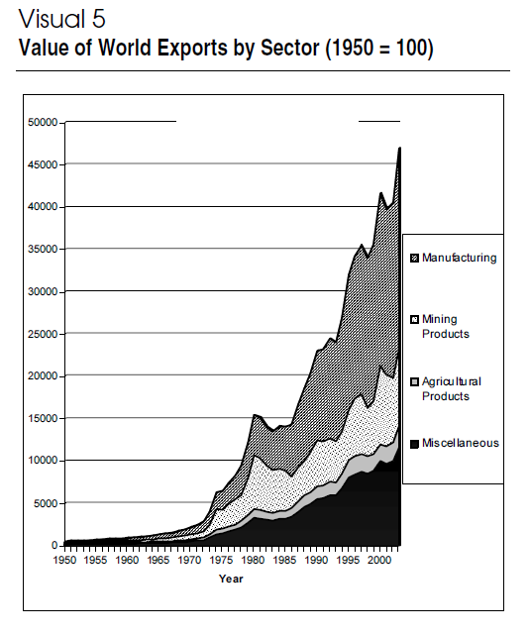

Source 6

The table below shows the top U.S. trading partners ranked by 2016 export values. It also shows the export values for 2014, 2015, and % change.

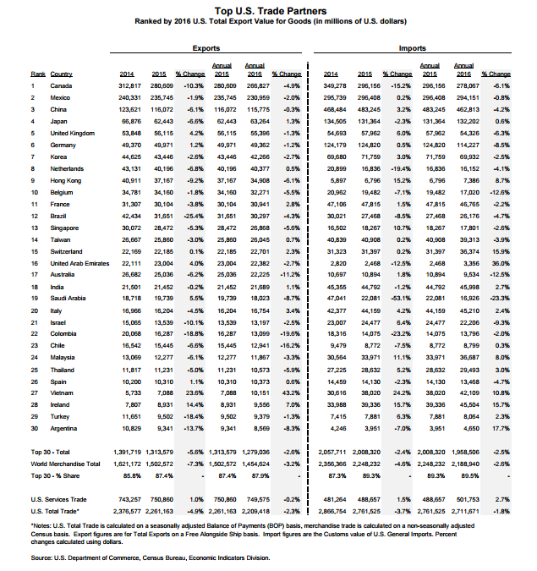
http://www.trade.gov/mas/ian/build/groups/public/@tg_ian/documents/webcontent/tg_ian_003364.pdf

Source 7

The table below shows the top U.S. trading partners ranked by 2016 import values. It also shows the import values for 2014, 2015, and % change.

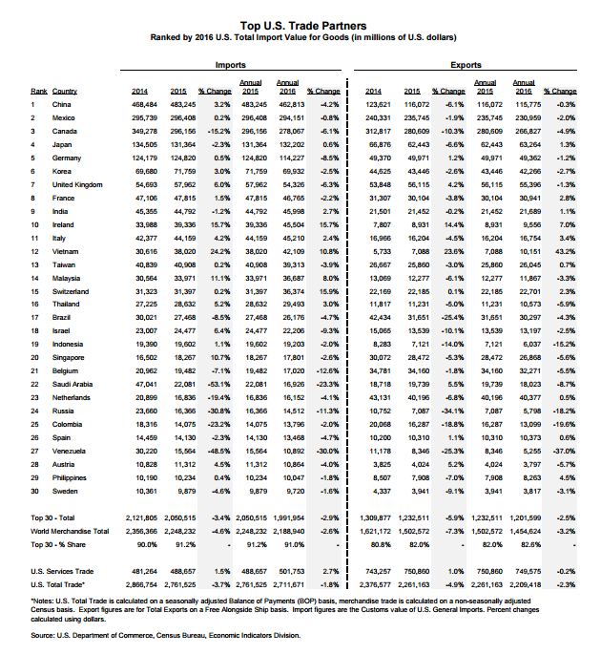
http://www.trade.gov/mas/ian/build/groups/public/@tg_ian/documents/webcontent/tg_ian_003364.pdf

Source 8

The table below is from Visual 6 of “Lesson 4: Globalization and the U.S. Economy.” This lesson can be found on Virtual Economics 4.5 or Focus: Globalization from the Council on Economic Education. The lesson can also be downloaded from the VCEE Middle School Performance Assessment webpage: http://vcee.org/performance-assessments-2/

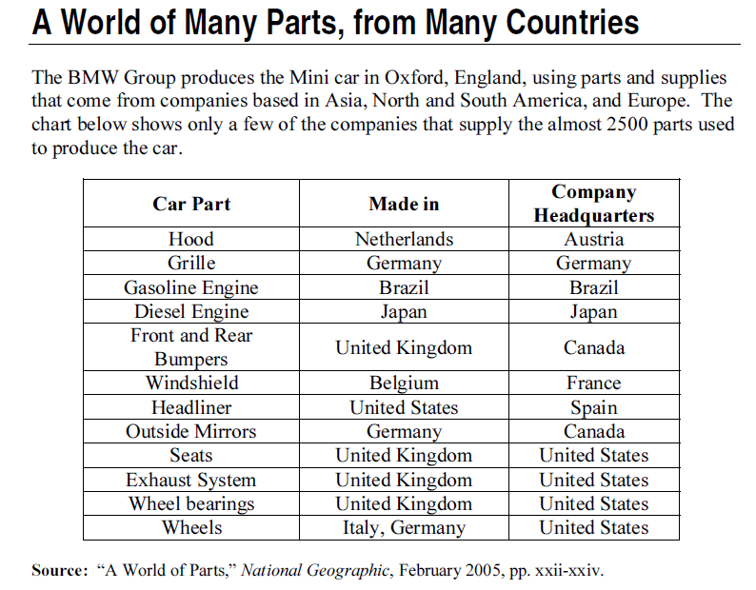

Source 9

A tariff is a tax on an imported good or service. (May also be known as: duty, import tax and import tariff.)

Economic correspondent Paul Solman reports on an American-born product hit hard by globalization: the surfboard. In Southern California, U.S.-based manufacturers fear they will soon be wiped out by competing, foreign companies due to discrepancies in labor costs and duty taxes. Record date: March 21, 2013. Run time: 10:52 http://www.econedlink.org/tool/281/Making-Sen$e-with-Paul-Solman-Is-Globalization-Wiping-Out-American-Surfboard-Industry

RUBRIC FOR PERFORMANCE ASSESSMENT
Task | Beginning  (1-4 points) | Proficient  (5-8 points) | Mastery  (9-10 points)
Evaluate and explain the impact of international trade and globalization on American life. | The student made reference to international trade and globalization, but did not give an explanation or evaluation of the effect of international trade and globalization on American life. | The student gave an explanation of what international trade and globalization are, but did not evaluate the effect on American life. | The student gave a full explanation and evaluation of the effect of international trade and globalization on American life.
Analyze and interpret sources to determine meaning of data and events related to international trade and globalization. | The student’s product contained incomplete interpretations and serious misunderstandings when relating source data to international trade and globalization. | The student’s product contained partially complete interpretations and made moderately effective connections when relating source data to international trade and globalization. | The student’s product contained complete interpretations and thorough connections of relevant source data to international trade and globalization.
Identifying the costs and benefits of a situation to make an informed decision. | The student identified unrelated costs and benefits for the decision making scenario. No details and historic references were given. | The student identified applicable costs and benefits for the decision making scenario. Ideas were expressed clearly, but few ideas are organized. Few details and historic references were made. | The student identified relevant costs and benefits for evaluating the decision making scenario. Ideas were organized and expressed clearly. There are multiple details and historic references made.
Development of final cost/benefit analysis presentation. | The student’s cost/benefit analysis demonstrated an understanding that it is a decision making tool, but did not make a final decision. | The student’s cost/benefit analysis demonstrated an understanding that it is a decision making tool used to evaluate a choice, and made a choice that was somewhat related to the costs and benefits that were identified. | The student’s cost/benefit analysis demonstrated an understanding that it is a decision making tool used to evaluate a choice, and made a choice that was clearly related to the costs and benefits that were identified.

