THE HARRISONBURG-ROCKINGHAM CHAMBER OF COMMERCE
AND HARRISONBURG ROTARY CLUB
2016-2017 AWARDS PROGRAM FOR THE TEACHING OF ECONOMICS
JMU CENTER FOR ECONOMIC EDUCATION

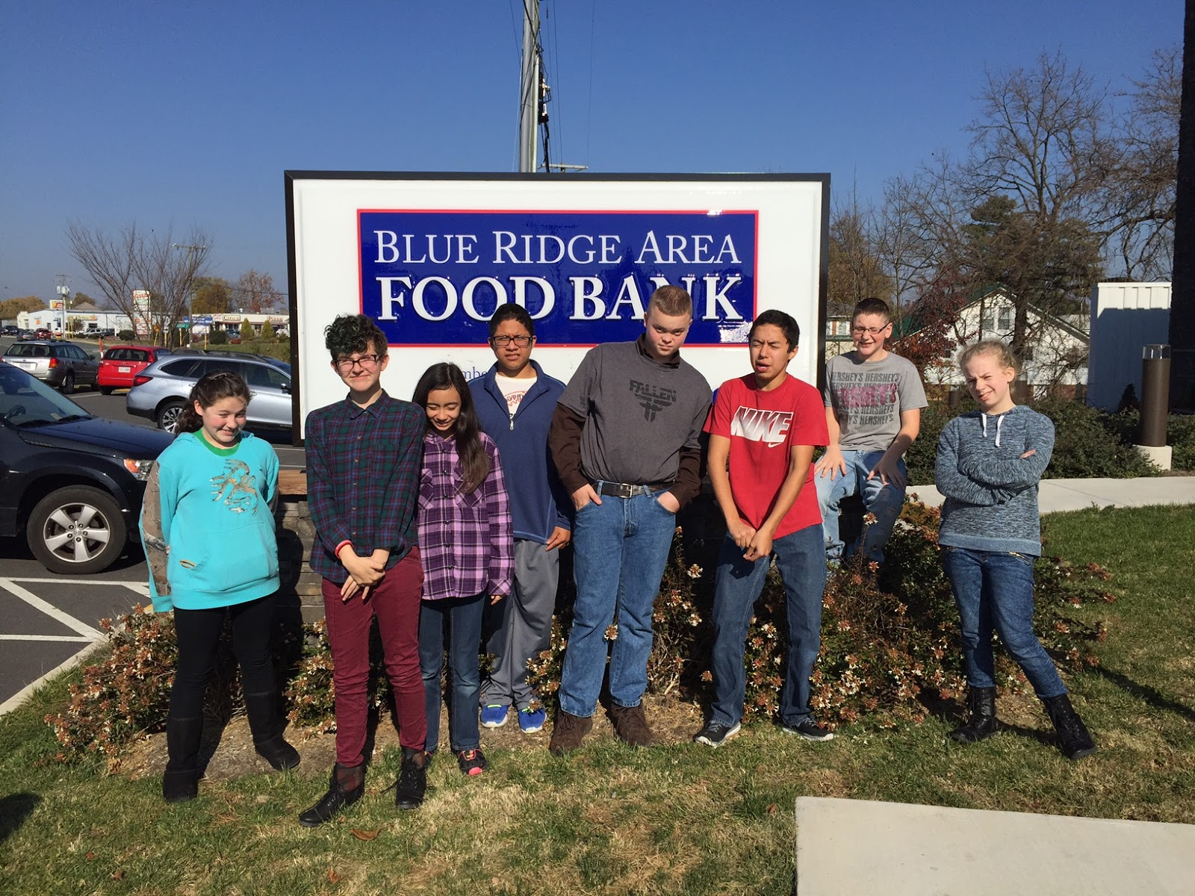
Nora S. Fletcher
“Poverty in America:
Addressing Disparities through Action”
2017
7th grade Multiculturalism Interdisciplinary Class
J. Frank Hillyard Middle School

THE HARRISONBURG-ROCKINGHAM CHAMBER OF COMMERCE
AND HARRISONBURG ROTARY CLUB
2014-2015 AWARDS PROGRAM FOR THE TEACHING OF ECONOMICS
JMU CENTER FOR ECONOMIC EDUCATION

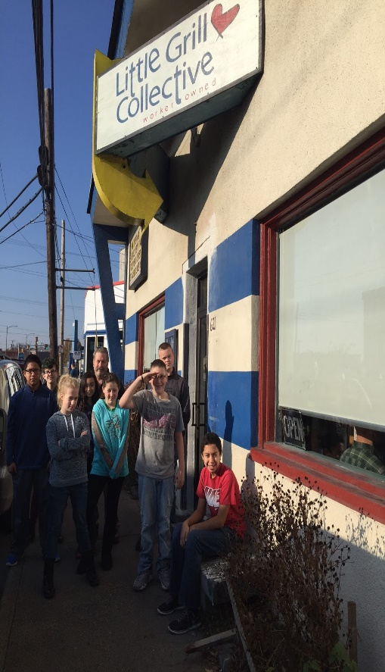
I. Description
The unit, Poverty in America: Addressing Disparities through Action is designed to give students a hands on approach to exploring poverty in their area. Students investigate trends in poverty and reasons people become impoverished. They also address the needs of our area through an action research project and visit to the local food bank. Students also learn about small business and worker owned collectives with a visit to a local restaurant.

Eight seventh grade Multiculturalism students participated in this unit which took place in the Fall of 2016 at J. Frank Hillyard Middle School in Rockingham County, Virginia. In all, JFHMS has 714 students enrolled with 41.34% being served in our free and reduced lunch program. The students that participated in this unit came from diverse backgrounds including two Hispanic, one Asian and five white students from varied socioeconomic backgrounds.

Multiculturalism is an elective class available for 6th and 7th grade students at J. Frank Hillyard. Through this course, students tackle such complex concepts as racism, poverty, intolerance, bullying, building connections, empathy and social action. Students learn tolerance and acceptance through hands on lessons and coursework focused on building knowledge of marginalized groups. Each unit of study within the Multiculturalism frame-work focuses on a different community building topic throughout the semester. Some units that have been taught in this course involve such topics as: The American Civil Rights Movement, The Holocaust, Bullying and Self-Esteem building, Workers’ Rights, Poverty, Environmental Sustainability and more. Each year, I take time getting to know the students in my class before choosing a topic that will best meet their needs. This unit in particular seemed to meet the needs of the students in my classroom and building this year.

I chose this topic in my first year teaching here at J. Frank Hillyard Middle School after attending a county wide in-service on poverty in our area. As stated previously, J. Frank Hillyard serves 41.3 % of students in their free and reduced lunch program. Of the 714 students this year, nearly half are struggling to make ends meet in their own homes at the end of the day. This economics-based unit creates an opportunity for students to learn about the diversity of income in America. Students engage in research, writing, speaking, discussion and action as they raise awareness and collect goods for impoverished peers and neighbors. Through this lesson, students gained a greater awareness of their voice, their ability to make choices and make change for others.

II. Abstract

J. Frank Hillyard Middle School is set in a beautiful rural community in the Shenandoah Valley. While the 714 students come from a range of economic backgrounds, nearly half of our school population struggles with economic distress at home. Students struggle to have enough to eat, to have the foundation blocks for learning and to simply navigate daily middle school life. I wanted to create a unit for students to explore ways in which they can end the cycle of generational poverty and make choices that will change their future. And for those students not struggling with poverty, I wanted to create a unit for students to learn empathy and ways to provide goods for those less fortunate. This unit is a coming together of all social classes to take action for others.

The guiding questions during the unit are: How does poverty affect me, my family, my school and my community? How can I, as a 7th grade student, make decisions and take actions to end the cycle of poverty and assist those in their fight to meet the basic needs for their families?

Students begin their learning by researching the facts about poverty in America as well as the needs of people in our area. Learning continues as students dispel common stereotypes about poverty and how people become impoverished. Students are awed at the fact that the group most affected by poverty is children.

Students continue to break down the statistical evidence and find that economic disparity does not affect every race or ethnicity equally. They discuss and debate the reasons why African Americans and Hispanics in our country are disproportionately affected by poverty.

They then create an action project and come up with incentives to create a successful food drive. Students present their ideas to a panel including the Hawks News Team and the principals of the school before moving forward. Students used their Chromebooks (laptops) to create a rap song about participating in the food drive, to create a brochure promoting the drive and to research all about poverty in our area. All facts, raps, and brochures premiered on our very own “News” at our school! A link to our rap video can be found here: https://www.youtube.com/watch?v=3YPoJUesNBA&index=31&list=PL70qSne8BPhOhiu8R5Xv1k6k1_D-8oiCQ at 1:20 minutes in :)

Students also created posters, covered boxes with wrapping paper, delivered the boxes and collected cans weekly as they kept track of the weekly progress of their drive. The students had a goal of collecting 500 items. They surpassed their goal and collected over 1500 pounds of food for local families. Our food drive poster can be seen on the next page.

Mrs. Fletcher’s 7th grade Cultural Studies Class
Is hosting
The 1st Annual
“Can we get some cans up in here?”
Food Drive
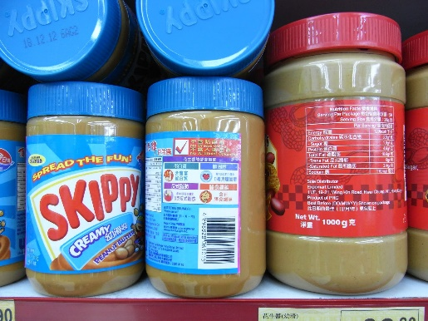
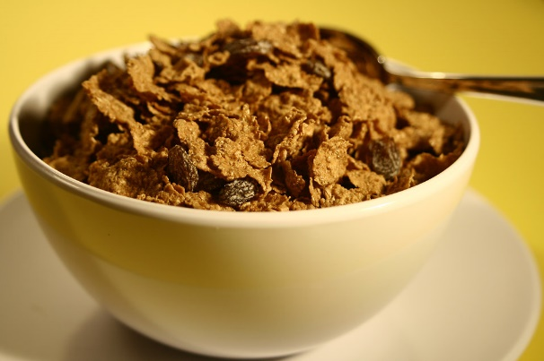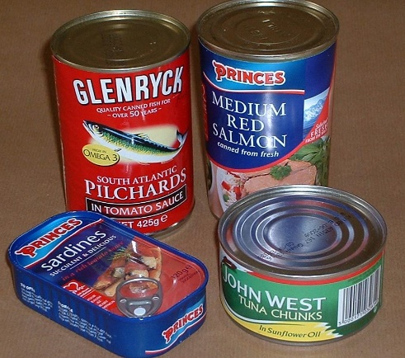
October 31st-November 11th
Turn in cans to your PRIDE teacher
1 item = surprise on your locker
5 items = 10 talons
10 items = Entry into a Pj/movie/popcorn event
15 or more items = tickets to be entered to win 1 of 2 awesome Emoji pillows!
The PRIDE that brings in the most gets to walk to 7-11 to get a SLURPEE
As a culminating event to the learning, students actively participate and serve as leaders in a school wide food drive collection and delivery to the local area food bank in Verona, VA after a visit to collective owned “Little Grill Restaurant.”

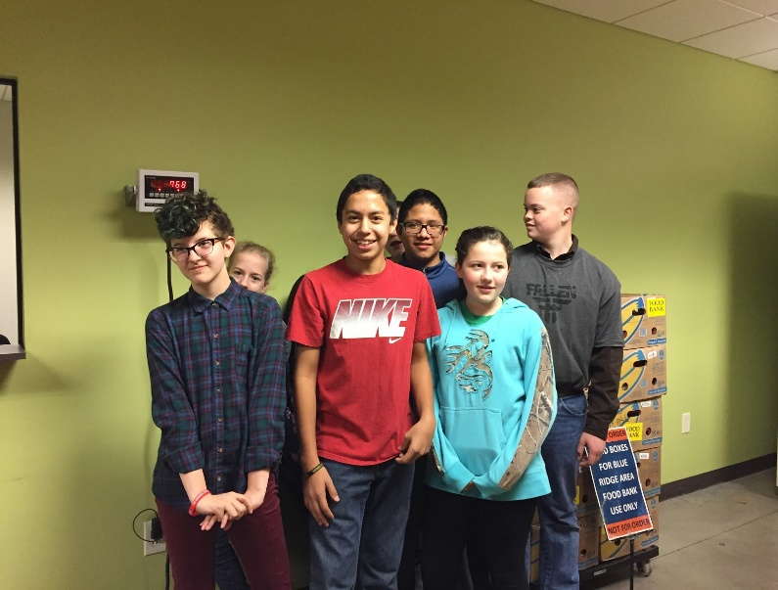
(Students weighing themselves at the Blue Ridge Area Food Bank)
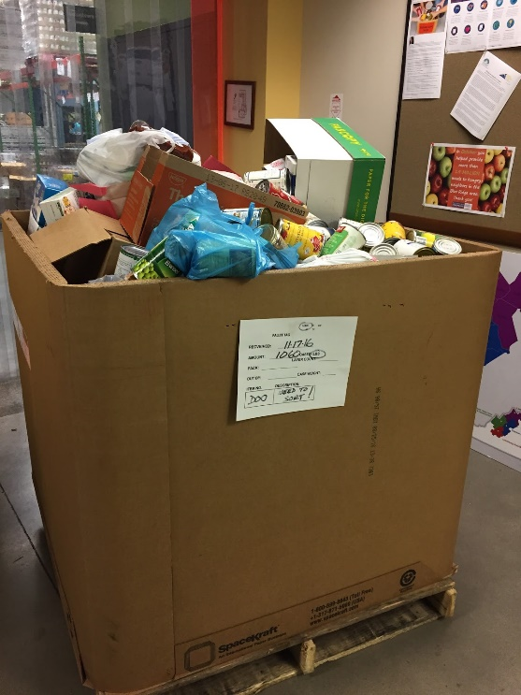
(Students weighed LESS than the food they donated!)

Note: If you want to skip ahead and see the finished product, all work can be found in the Appendix

III. Economic Content and Key Concepts
List of vocabulary terms:
- Scarcity
- Opportunity Cost
- Choices
- Poverty
- Disparity
- Unemployment
- Underemployment
- Competition
- Incentives
- Stereotypes
- Preconceived ideas
- Rural poverty
- Food bank
- Empathy

As this course is not a traditional economics course, I did not approach this project as a strictly economics activity. Rather, I wanted to use the economic ideas of disparity, poverty, student choice making, competition and social action to help students learn empathy, compassion and the power they have over their own circumstances.

With that said, economically this project is about the awareness of poverty and disparity as well as student choice and competition. To create a successful food drive, students had to create incentives for students to participate. They created a competition between pride classes and created motivational videos to persuade students to take part in the drive. Students had to research the needs of our community to advertise the most needed products. Students learned firsthand the effects poverty has on local community members and created both a personal path to improvement of circumstances as well as the circumstances of others. Finally, students learned compassion for others as they learned that poverty does not affect all people equally and children do not choose their circumstances when they are born into a family that struggles to make ends meet.

Students not only learned the values of competition and motivation to sell an idea or product but also they learned the values of making positive choices to change their own circumstances and the circumstances of others. Students were visited by two women who grew up in poverty and changed their circumstances with hard-work, creating connections and education. They learned that relationships can help or hinder your progress to success and how to tune in to people who will encourage you and dismiss those that will discourage you. Students learned that in some countries, like India, children do not have the opportunities to change their social class circumstances the way that they do in the United States. They learned that giving into peer pressures for drugs, alcohol, or early pregnancy can make earning potential drop significantly. They learned that some people have very limited resources in case of emergency like a natural disaster and others have learned to save for just that reason. Students learned that while being born into poverty is not a choice, taking education seriously and working hard this year and in years to come can give them the tools they need to make their situations better for the future. Finally, they learned that giving can be an extremely rewarding and memorable experience. I truly believe that the lights that glittered in the eyes of the students when they learned that they had donated over 1500 meals to their local community will never dim.

IV. Economic Standards and Student Learning Objectives
This unit covers content from the following Middle School standards:
Civics and Economics
CE. 1
B. Practicing service to the school and/or community
F. Examining how personal choices about education, training, skill-development and careers impact earnings.
- create and explain maps, diagrams, tables, charts, graphs, and spreadsheets
- analyze political cartoons, political advertisements, pictures, and other graphic media
- distinguish between relevant and irrelevant information
- review information for accuracy, separating fact from opinion
- identify a problem, weigh the expected costs and benefits and possible consequences of proposed solutions, and recommend solutions, using a decision-making model
- formulate an informed, carefully reasoned position on a community issue
- select and defend positions in writing, discussion, and debate
CE.11 The student will demonstrate knowledge of how economic decisions are made in the marketplace by
- applying the concepts of scarcity, resources, choice, opportunity cost, price, incentives, supply and demand, production, and consumption
- describing the characteristics of the United States economy, including limited government, private property, profit, and competition
CE.12 The student will demonstrate knowledge of the structure and operation of the United States economy by
- describing the types of business organizations and the role of entrepreneurship
CE.13 The student will demonstrate knowledge of the role of government in the United States economy by
- examining competition in the marketplace

English Grade 6
6.1 The student will participate in and contribute to small-group activities.
a) Communicate as leader and contributor
b) Evaluate own contributions to discussions
c) Summarize and evaluate group activities
d) Analyze the effectiveness of participant interactions

6.2 The student will present, listen critically, and express opinion in oral presentations
a) Distinguish between fact and opinion
b) Compare and contrast viewpoints
c) Present a convincing argument
e) Use language and vocabulary appropriate to audience, topic, and
purpose

6.3 The student will understand the elements of media literacy
c) Craft and publish audience-specific media messages

English Grade 7

7.1 The student will participate in and contribute to conversations, group discussions, and oral presentations
a) Communicate ideas and information orally in an organized and succinct manner
b) Ask probing questions to seek elaboration and clarification of ideas
c) Make statements to communicate agreement or tactful disagreement with others’ ideas
d) Use language and style appropriate to audience, topic, and purpose
e) Use a variety of strategies to listen actively

7.3 The student will understand the elements of media literacy
- Identify persuasive/informative techniques used in non-print media including television, radio, video, and Internet
e. Craft and publish audience-specific media messages
7.7 The student will write in a variety of forms with an emphasis on exposition, narration, and persuasion
- Identify intended audience
- use a variety of prewriting strategies including graphic organizers to generate and organize ideas
k. Use computer technology to plan, draft, revise, edit, and publish writing
7.9 The student will apply knowledge of appropriate reference materials to produce a research product
- Collect and organize information from multiple sources including online, print and media
- Use technology as a tool to research, organize, evaluate, and communicate information

Computer Technology Standards of Learning Grades 6-8
C/T6-8.1 Demonstrate an operational knowledge of various technologies
- Use various types of technology devices to perform learning tasks. Demonstrate the ability to perform specific tasks using technology, including organizing, analyzing, and presenting date; formatting and presenting text and graphic information; and capturing and manipulating images
C/T6-8.5 Demonstrate digital citizenship by actively participating in positive activities for personal and community well-being
b. Explore the potential of the Internet as a means of personal learning and the respectful exchange of ideas and products. Participate in the creation of digital projects that involve others working together toward a common goal
C/T6-8.6 Understand the nature of information in a global society and how the characteristics of various media may influence others
- develop communication projects using various types of media
- Use search strategies to retrieve information. Identify indicators that a digital sources is likely to be reliable
C/T6-8.13 Communicate effectively with others in collaborative learning situations
- use technology tools for individual and collaborative writing, communication, and publishing activities. Use various technology resources to develop written and media-based report and projects
C/T6-8.14 Apply knowledge and skills to generate innovative ideas, products, processes, and solutions.
- Organize and display knowledge and understanding in ways that others can view, use, and assess.
- use digital resources and technology to enhance original oral and written presentations

Math-6 & 7
The student will solve single-step and multistep practical problems, using proportional
Reasoning.
Additionally, this unit also presents material that would apply to the following High School Standards:

Economics and Personal Finance
EPF.1 The student will demonstrate knowledge of basic economic concepts and structures by
describing how consumers, businesses, and government decision makers face scarcity of resources and must make trade-offs and incur opportunity costs
explaining that choices often have long-term unintended consequences
describing how effective decision making requires comparing the additional costs (marginal costs) and additional benefits (marginal benefits)

EPF.2 The student will demonstrate knowledge of the role of producers and consumers in a market economy by
describing how consumers, producers, workers, savers, investors, and citizens respond to incentives;
explaining how businesses respond to consumer sovereignty;
describing how increased productivity affects costs of production and standard of living.
describing the effects of competition on producers, sellers, and consumers

EPF.4 The student will demonstrate knowledge that many factors affect income by
examining the market value of a worker’s skills and knowledge
identifying the impact of human capital on production costs

EPF.11 The student will demonstrate knowledge of planning for living and leisure expenses by
calculating the cost of utilities, services, maintenance, and other housing expenses; and
evaluating discretionary spending decisions

EPF.15 The student will demonstrate knowledge of income earning and reporting by
examining how personal choices about education, training, skill development, and careers impact earnings;
investigating employee benefits and incentives
EPF.17 The student will demonstrate knowledge of personal financial planning by
identifying short-term and long-term personal financial goals;
identifying anticipated and unanticipated income and expenses;
developing a personal budget;
investigating the effects of government actions and economic conditions on personal financial planning; and
explaining how economics influences a personal financial plan

Materials
- Lesson pages attached to this packet.
- Current real estate magazine for your area
- Current car sales flyers for your area
- Current prices for food in your area etc.
- Find 1-2 speakers who are willing to come into your classroom to talk about their experiences with poverty.

Time Frame
1-12 class periods & 2 week food drive
** order of lessons may vary depending on visitors schedule as well as food drive needs!**

Instructional Process
*All corresponding pages can be found in the appendix portion

Lesson 1: Pre-test and advertisement
- Students fill out a pre-assessment about their preconceived ideas about poverty in America.
- Discuss and tell students the facts
- Students choose one of the facts and create
- A way to display the information visually
- Think of a way to alleviate the problem in a no cost way
- Display images/present

Lesson 2: The Poverty Line
- Students analyze the 2014 (update as available) government guidelines for poverty
- Students discuss and answer questions about the minimum wage.
- Students talk about reasons people live in poverty
- Students create a cost of living calculator to evaluate their own monthly living needs
- Students take a stance on the question “Individuals are responsible for living in poverty. They have no one to blame but themselves.” and commence in a structured debate with classmates.

Lesson 3: Reasons People Live in Poverty
- Discuss major reasons for poverty in America. Discuss the difference between unemployment and underemployment.
- Play traditional musical chairs- discuss
- Burden some players with difficulties (shoes tied, blindfolded, waiting until being told to enter the game etc.) and play the game again
- Discuss how people with disabilities, of color, of different genders, family circumstances etc. have a hard time getting/keeping a job
- Answer and discuss the larger question- “Why don’t people simply untie their shoelaces?”

Lesson 4: Visitors * Appendix 8, 9
- Prior to the lesson, have students come up with ideas about what the speaker will act and sound like. Have them guess their gender and age etc.
- Invite 1-2 speakers to come to your classroom to discuss their experiences with poverty. I try to focus on speakers that have had the ability to make choices that affected their future for the positive.
- Have students reflect and write a structured thank you letter to your speakers.

Lesson 5: Underemployment and Unemployment by race and ethnicity
- Review the meaning of underemployment. Have students guess which jobs on the list would qualify. (Hint...they all do!) Discuss why these workers would be underemployed. Added bonus: discuss gender wage gaps.
- Students reflect on the ways that their parents or families are already giving them a leg up in the world or how they are going to have to work even harder to get where they want to be.
- Analyze the teaching tolerance race and ethnicity unemployment rates. (These are provided on the teacher tolerance website for free use by teachers)
- Discuss all based on the makeup of your school community.

Lesson 6: Poverty and Natural Disasters
- Students preview vocabulary
- Students read the Scholastic News article about the Disaster in Haiti in 2010 (Update articles as they become available)
- Discuss the UN and the responses of the red cross and how poverty is affected by natural disasters

Lesson 7: Writing
- Students choose a picture from the list and write a story about the people’s lives. They may write an article or a story about the person/people pictured. Their story should attempt to dispel stereotypes and also inform.

Lesson 8: Debate
- Students read a fictional application for a scholarship. They choose one person to award the scholarship to. Students write out their arguments and then have a classroom debate.
- Discuss the idea of forgiveness, second chances and the importance of being open to people from diverse backgrounds.
- If interested- you may come up with ideas about how the people they have chosen used the money and what they became. I made all of mine positive!

Lesson 9: Conclusion
- Students choose one of 5 final products to demonstrate their learning. These can be adapted and changed to meet your needs.
- Final test worth 15 points as a culmination of fact learning and retention

Lesson 10: Community food drive and field trip
- Students come up with an incentive based program to encourage their peers to participate in a food drive
- Student create flyers, commercials and present their ideas to the school
- Students collect canned goods
- Students deliver food to the Blue Ridge Area food bank and tour the facility
- Students eat at the Little Grill Collective and learn about worked owned business.

Lesson 11: Extension: Possible sleep out activity (was used in years past!)
- Students present their final projects at a “sleep out”

Assessment
Students will be evaluated throughout the learning process as they participate in group discussions and daily work. Students will be formally assessed in their writing lesson and final project. Rubrics can be created based on the class needs and objectives. Additionally, they will be given participation credits during each discussion/worksheet lesson.

Students will be assessed behaviorally during the canned food collection and field trip process. They will also self-assess at the conclusion of the unit as they are asked to discuss the growth that they experienced through their learning.

Closure
Lesson objectives are reinforced throughout the unit through discussion, writing, debate, research and action. Students are constantly assessed in their learning process as they participate in the lessons and active planning. Students conclude their unit with a visit to the local food bank. They are able to see the results of their hard-work and learning about poverty in their community. Students learn community economics through hands on experience and information seeking. Students feel empowered to make good choices as they journey into adulthood and also learn the power of reaching out to help others.

Appendix

Resources used are all included in the following pages.
Websites used:
teachingtolerance.org
Dosomething.org
https://www.healthcare.gov/glossary/federal-poverty-level-FPL/

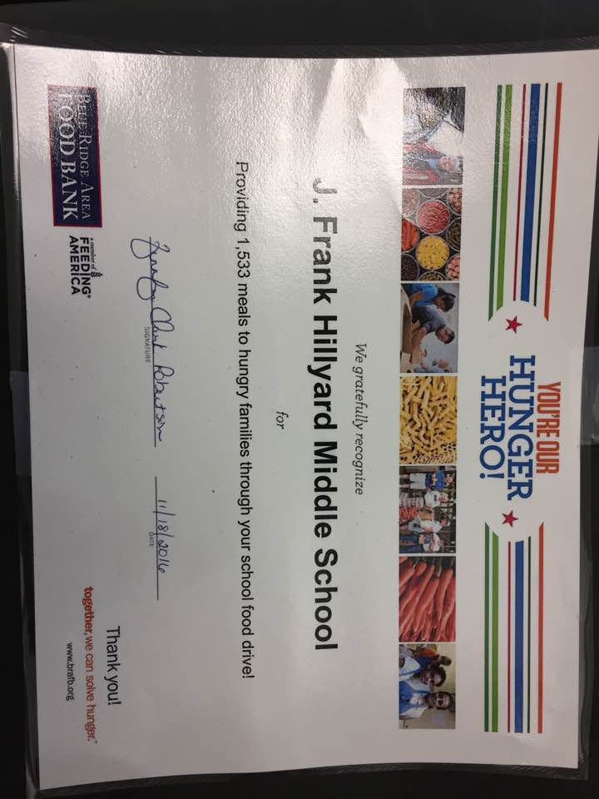

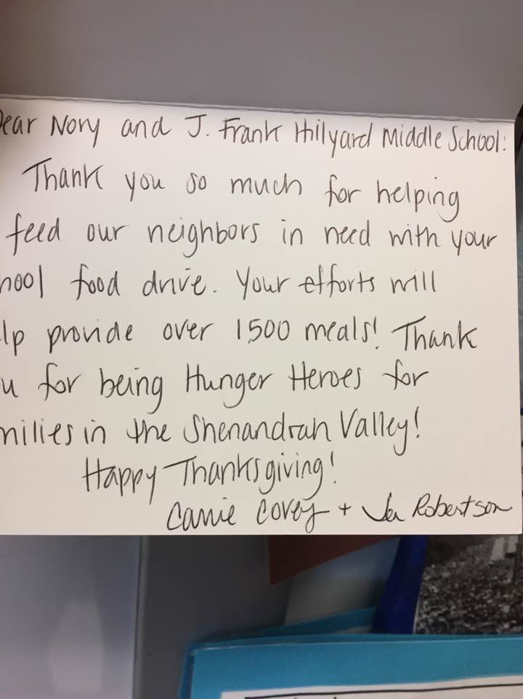

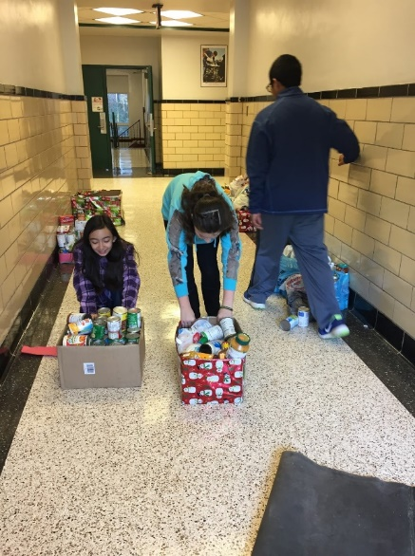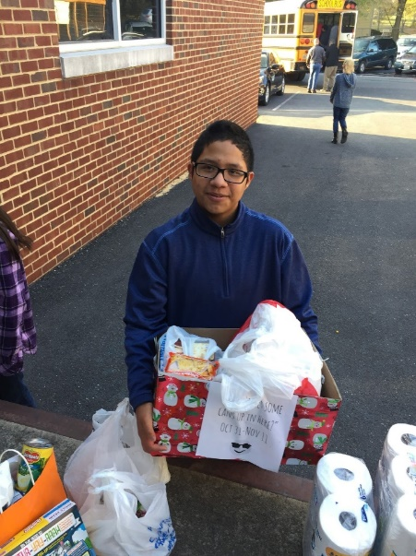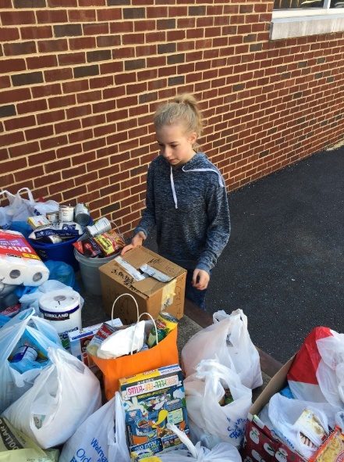

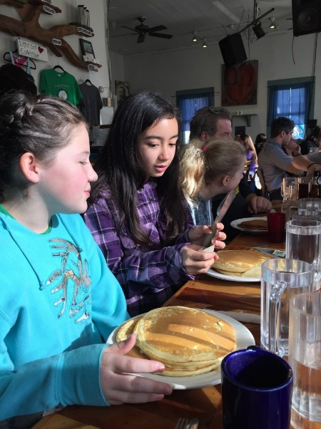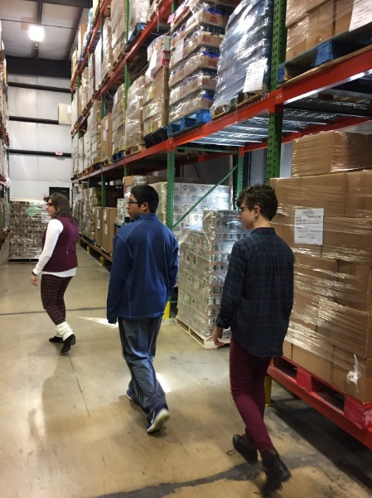

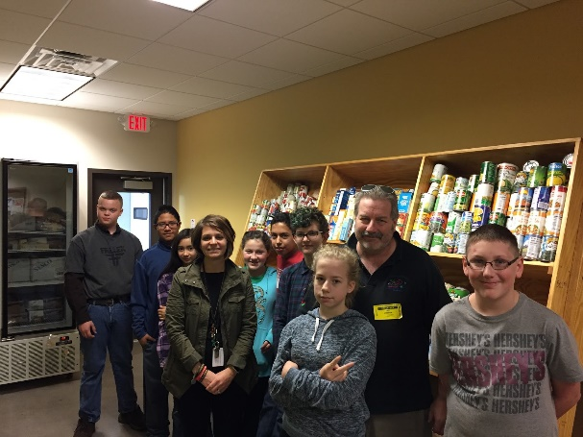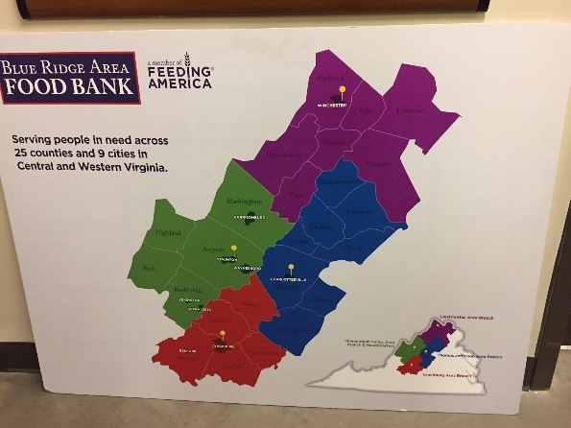

Lesson 1: Pre-test and advertisement
Poverty {Pov-ur-tee}
(noun- the condition of lacking sufficient money or goods to meet basic human needs such as food, shelter, clothing)

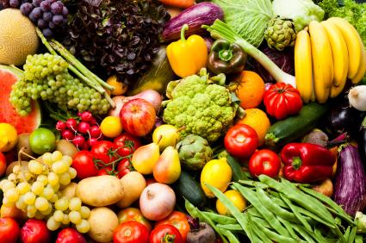

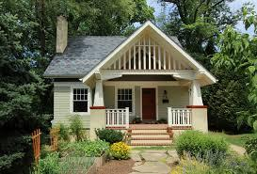

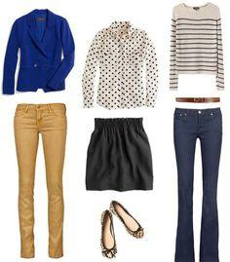

Lesson 1: Pre-test and advertisement
What does it mean to live in Poverty??
“pre-test”
What are your ideas??

- How much money do you think a family of 4 needs to earn in one year to be ABOVE the poverty line?

$10,000 $15,000 $20,000 $25,000 $30,000

- In 2011, how many Americans do you think were living in poverty?
100 500 1000 10,000 50,000 100,000 1 million
5 million more than 40 million

- Who do you think misses school more: children in poverty or children above the
line? Why do you think they miss more?

- How much more likely is it that a student in poverty will drop out of high school
than a student not living in poverty?

1 time 3 times 5 times 7 times 10 times

- What percentage of kindergarten students living in poverty are not ready for
school? (meaning they probably haven’t been read aloud to, taught how to follow
rules etc.)

5 % 10 % 15 % 25 % 35% 40 % 50 % 100%

- True or False: Children living in poverty are more likely than their peers to have
mental disabilities or other developmental delays

- What percentage of students living in poverty enroll in 4 year colleges after high
school?

Less than 10% less than 20% less than 30%

- Which group(s) are more likely to experience poverty?

White Hispanic African American Asian American

Lesson 1: Pre-test and advertisement
Facts about Poverty in America today
- What is the "Poverty Line," anyway? According to the 2011 U.S. Census Bureau, it is a family of 4 (2 adults, 2 children under 18) that earns less than $23,021.
- More than 30 million children are growing up in poverty. In one low-income community, there was only one book for every 300 children.
- In 2011, nearly 46.2 million Americans were living in poverty.
- Children living in poverty have a higher number of absenteeism or leave school all together because they are more likely to have to work or care for family members.
- Dropout rates of 16 to 24-years-old students who come from low income families are seven times more likely to drop out than those from families with higher incomes.
- A higher percentage of young adults (31%) without a high school diploma live in poverty, compared to the 24% of young people who finished high school.
- 40% of children living in poverty aren’t prepared for primary schooling.
- Children that live below the poverty line are 1.3 times more likely to have developmental delays or learning disabilities than those who don’t live in poverty.
- By the end of the 4th grade, in some cases, African-American, Hispanic and low-income students are already 2 years behind grade level. By the time they reach the 12th grade they can be up to 4 years behind.
- The nation’s lowest-performing high schools produce 58% of all African-American dropouts and 50% of all Hispanic dropouts, compared to 22% of all white dropouts.
- Less than 30% of students in the bottom quarter of incomes enroll in a 4 year school. Among that group – less than 50% graduate.

Choose one of the facts above and come up with a public service advertisement that:
- Gives the information in an interesting way
- Explains what it means in 7th grade words
- Offers a solution/campaign to change this fact!
- Complete this in the space below!
-------------------------------------------------------------------------------------

Lesson 2: The Poverty Line
What is the Poverty line?

What does it mean to live in poverty? What kinds of jobs might you have and still live in poverty? Today we will be exploring these questions!

2014 POVERTY GUIDELINES FOR THE 48 CONTIGUOUS STATES
AND THE DISTRICT OF COLUMBIA
Persons in family/household | Poverty guideline
For families/households with more than 8 persons, add $4,060 for each additional person.
1 | $11,670
2 | 15,730
3 | 19,790
4 | 23,850
5 | 27,910
6 | 31,970
7 | 36,030
8 | 40,090

Answer the questions below!

- If you are a single person living and working in Virginia today, how much would you be making and be living in poverty? ____________________
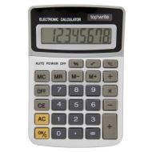
- In Virginia, the current minimum wage is $7.25/hour. If a person worked 40 hours per week (That is 8 hours a day, 5 days a week) how much money would they make in 1 week? $_________
- If that same person worked EVERY day, EVERY week of the year (52 weeks in one year) how much would they make in 1 year? $_____________
- Would that person be living in poverty? Yes No
- Do you think most people are able to work EVERY day, EVERY week of the year? Why or why not? How might that change your answer to number 4?
- Imagine that same person was a single parent of one small child. Would that family be in poverty? (look at your chart again) Yes No
- What if that person had 3 small children? Would that family be in poverty? (look at your chart again) Yes No
But WHY!?? What are some reasons that YOU think people live in poverty?

Lesson 2: The Poverty Line

List them below:
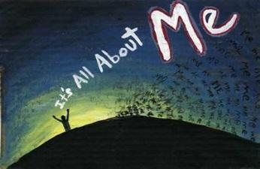
Agree or Disagree: Individuals are responsible for living in poverty. They have no one to blame but themselves. (In the space below write AT LEAST 4 sentences telling how you feel about this statement and why!)

Now turn to your partner and tell them what you’ve written and why! How do your thoughts compare with your partner’s thoughts?

- We agree completely
- We somewhat agree because….
- We somewhat disagree because…
- We totally disagree because…

Lesson 3: Reasons People Live in Poverty
Reasons people live in Poverty

Many factors contribute to poverty. Many, if not all, of them-such as low quality education, lack of adequate food and healthcare, and geographic location-can be traced to the legacy of discrimination that plagues people of color in the United States.

Among the factors that often contribute to poverty are unemployment and underemployment. Put simply, many people live in poverty because they are unable to find a job that pays a living wage-or to find a job at all. To be sure, not everyone who is unemployed lives in poverty but in this lesson you will look at how unemployment and underemployment often contribute to poverty.

- Play musical chairs

Why couldn’t everyone sit down when the music stopped?

Think of the game as representing the job market in the United States. If the chairs symbolize jobs and the players symbolize job seekers, what can you say about the job market in the United States?

- Play musical chairs again (with a twist)

Unemployment doesn’t affect everyone equally. Some people have a harder time getting work than others. Think back to your game of musical chairs (with a twist). What happened to the people with their laces tied?

Think of the game as an analogy for the job market. With a partner discuss who you think the people with their laces tied represent. In other words, which job seekers do you think have the hardest time finding a job?

Why do you think these groups have the hardest time?

Think about the students with their shoelaces tied. Think about the shoelaces as representing obstacles that make it difficult for some people to get jobs. What are some of the obstacles that the shoelaces represent?

What are the factors that prevent some people from getting better jobs?
1.
2.
3.
4.
5.
Why don’t people simply “untie their shoelaces”?

Lesson 4: Visitors
Visitors attend 7th grade Multiculturalism
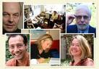
We have invited several visitors to come talk to you about poverty and their experiences with it. Please answer the “preview” questions today and we will answer the “reflection” questions after the visit. I know you will be an amazing audience.

PREVIEW

- What do you expect the visitors to look and sound like?

- What do you think they will say was the hardest thing about growing up or witnessing poverty?

- Come up with several reasons why the visitors might have grown up in poverty.

REFLECTION

- What did the visitors say was the MAIN thing to keep in mind to help you have choices when you grow up?

- What did they think was the hardest part about growing up in poverty?

3. Did the visitors surprise you? If yes, how?

Lesson 5: Underemployment and Unemployment by race and ethnicity
Let’s talk about Underemployment

- Underemployment refers to an employment situation that is insufficient in some important way for the worker, relative to a standard.

Circle the jobs below that you THINK offer minimum wage compensation

Cashier at Wal-Mart
Taco Bell food service worker
Day-care provider
Certified nursing assistant
Emergency Medical Technician
Automotive service technician
Income tax preparer
Seasonal employee (Lifeguard, Ski Patrol etc.)
Waiter or Waitress
Pharmacy Technician
Preschool Teacher
Amusement Ride operator
Line Cook at a restaurant
Nanny
Taxi Drivers
Food and Street Vendors
Trash Removal Service Workers
Add your own ideas:

Lesson 5: Underemployment and Unemployment by race and ethnicity
Answer the following questions:

- Can you have a job and live in poverty? Why or why not?

- Do you think some people work more than one job to stay out of poverty? Why or why not?

- Do you think you can be hard-working and live in poverty? Why or why not

As students, you may often find yourselves short of money. You might not have enough to go to a Friday night basketball game. You might also be worrying about the amount of money it will take to continue your education. But you may have something on your side to help you achieve future success. As a class we are going to make a list of what those helpful somethings might be!

How might your life be different if you did not have those somethings?

Lesson 6: Poverty and Natural Disasters
Poverty and Natural Disasters
(This lesson is about the earthquake in Haiti and poverty)
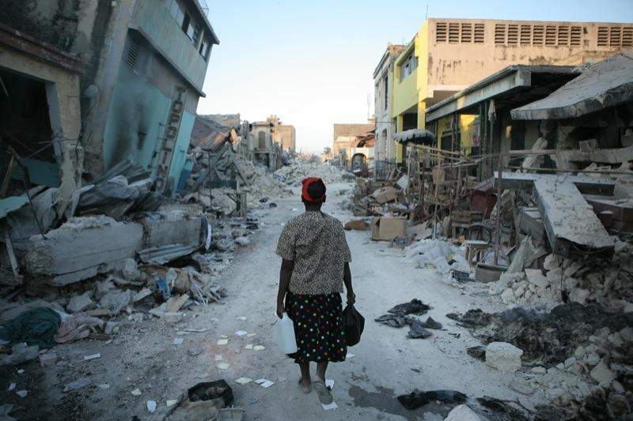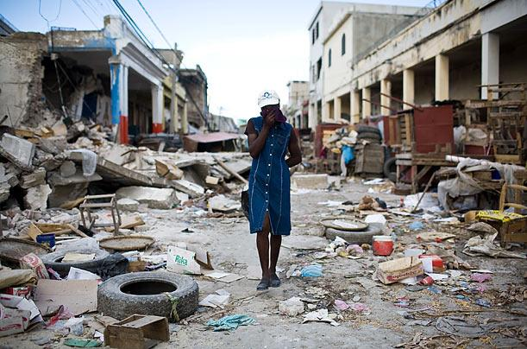
Poverty (noun) The United Nations defines people in poverty as those who live on less than $ 2 a day. United States guidelines for 2009 define poverty as a family of 4 living on $22,050 or less per year (or $62 per day). That amount is updated every year, and the government agencies use it to determine eligibility for certain government programs.

Extreme Poverty (noun) The United Nations defines people in extreme poverty as those living on less than $1 per day.

Areas of concentrated poverty (noun) Areas in the United States where 40 % or more of the population lives in poverty.
Do you think earthquakes and poverty are connected? Write down your hypothesis so you can check back later!

Read the information on the next page about the Earthquake in Haiti.

Lesson 6: Poverty and Natural Disasters

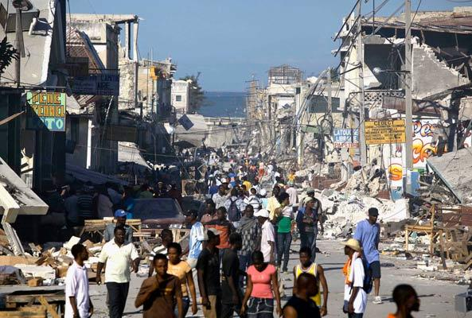
Earthquake survivors walk amidst collapsed buildings and rubble in downtown Port-Au-Prince, Haiti. (Photo: Julie Jacobson/AP Images)
Disaster in Haiti
An island neighbor of the U.S. struggles after a devastating earthquake
By Jill Lederman | January 15 , 2010
Map: Jim McMahon 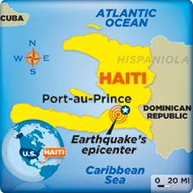
Fast Facts About Haiti
Location: Shares the island of Hispaniola with the Dominican Republic Size: Slightly smaller than the state of Maryland
Major Languages: French and Creole
Population: 9 million; 38 percent are kids under 15
Economy: Haiti is the poorest nation in the Western Hemisphere. Most people live on less than $2 a day.

Lesson 6: Poverty and Natural Disasters
People in the nation of Haiti are struggling to recover after a powerful earthquake caused massive destruction there.
Tens of thousands of people in the Caribbean nation were killed, and many more were injured. The Presidential Palace, which is like the White House here in the U.S., was among the many government buildings that collapsed. Hospitals were destroyed, as were countless homes. The disaster added more suffering to people already struggling to cope with everyday life. Haiti is one of the poorest nations in the world.
International aid groups are rushing to provide food, water, and medical aid to Haiti. People worldwide are donating money to help. Many nations, including the U.S., are sending aid as well as money. The U.S. is sending troops to help with rescue and relief efforts, and to police the streets. “This is a time when we are reminded of the common humanity that we all share,” U.S. President Barack Obama said.

Worst Earthquake in Caribbean in Centuries
The earthquake’s epicenter—the point on the Earth’s surface directly above where it happened—was about 10 miles from Haiti’s capital, Port-au-Prince. Experts say it was the worst earthquake in the region in more than 200 years.
The earthquake had a magnitude of 7.0 on the Richter scale, which is very high. More than 30 aftershocks, or smaller earthquakes, came after the big quake.
What Caused the Quake?
The earthquake in Haiti occurred on a long fault, or crack in the Earth’s surface, that goes across the island. This underground crack separates two giant tectonic plates, or slabs of rock that make up Earth’s outer layer. Along the fault, the plates slowly grind past one another in opposite directions. But this movement isn’t smooth. The plates’ edges get stuck for long periods of time. Eventually, they may suddenly jerk free. That sudden movement is what triggers an earthquake.
Worries About Loved Ones
Some Americans have a special concern about the situation in Haiti—family and friends. Hundreds of thousands of people in the U.S. are from Haiti. They are anxiously seeking news of loved ones. And like other Americans, they are working to help Haiti recover from this disaster.

Lesson 6: Poverty and Natural Disasters
Answer the questions below about the article
- How many people were killed in the quake?
- Name 3 types of buildings that were destroyed in the earthquake.
  - A. B. C.
- True or False: Haiti is one of the poorest nations in the world
- What was the magnitude of the quake? Is that very high?
- What caused the earthquake?
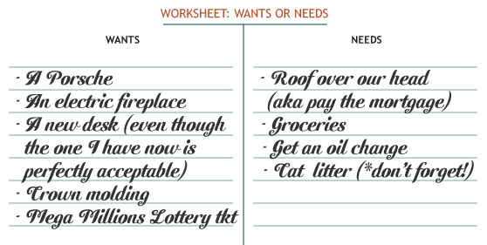

You make your own list!

Wants | Needs

What do you think the people of Haiti lost? Their wants or their needs?

How do natural disasters affect poverty?

Lesson 7: Writing
What does it look like to live in poverty?
Choose one of the pictures and answer the questions!

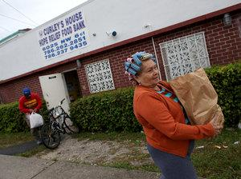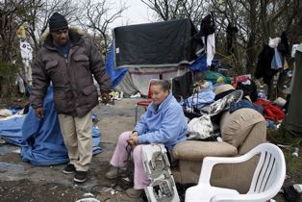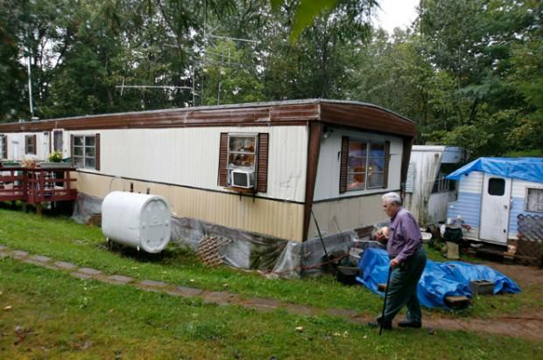

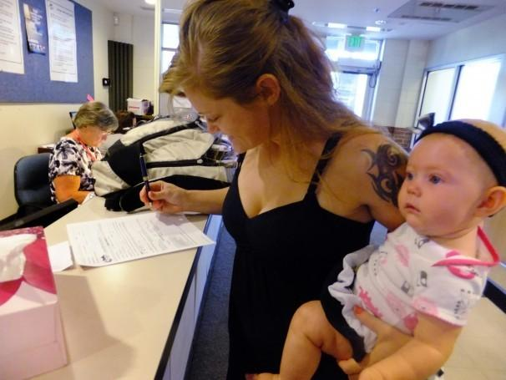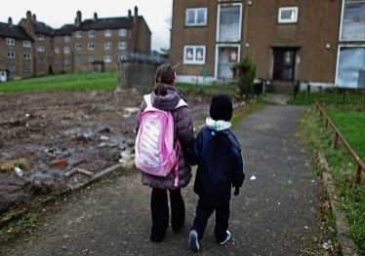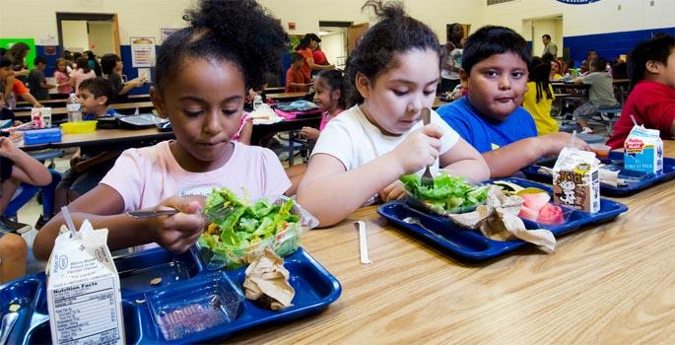

- Which picture did you choose?

- Now make a list of the fine details of this photograph.

Now answer these hypothetical questions about your photo.

- Where do you think this photo was taken?

- Who are the subjects of this photo?

- How do the subjects look? What are they wearing?

- What other items do you see in this photo?

- What seems to be the overall mood of this photo?

Lesson 7: Writing

Choose one of the following writing pieces to complete a story about your photograph.

- Use your list and the answers to your questions to create a fictional story about your photograph. Make sure all of the fine details that appear in this photo are also mentioned in your story. Consider the following when crafting your story:

*How do we treat people who live in poverty?

*What stereotypes might someone have about the people in this photo?

*How can your story defy (go against) those stereotypes?

- Write an article exposing the poverty in your own community. Consider the following when writing your article:

*Are there areas in your neighborhood or town where people are living in poverty? What do you notice about these areas?

*What stereotypes do others have about the people in those areas?

*What do you believe is at the center of the issue of poverty in your town?
Your writing will be worth 100 points!

Lesson 8: Debate
Debate time!
Who will you choose to receive the scholarship? Imagine that you are now grown, have been to college and have a successful career. You now want to give back to your community by donating money for a scholarship to help those less fortunate. It is your job to decide who gets the money this year. Read the following descriptions of those in need and decide who should receive the scholarship. You may work in a group but you must agree on your decision and come up with factors to support your idea as well as to denounce the others.

- A white 23 year old male has just been released from a 6 month stay in the state prison for drug use and distribution. He wants to turn his life around by going to a technical college to become a mechanic. He is asking for your help.

- A single African American female aged 19 has a baby. She did not finish high school but just worked hard and received her GED. She wants to go back to night school to become a nurse.

- An overweight white female aged 35 has been living in poverty since she was born. She and her husband both work in the fast food industry for minimum wage. Her husband is an alcoholic and is less than nice to her most nights. She wants to go back to college to become an informational technologist and to become an independent female who can finally leave the abusive relationship behind.

- An Asian American male aged 19 wants to move out of the city and change his circumstances. He and his parents grew up living on WIC and food stamps. The young man left his home life to join a gang where he was supported and had enough to eat. He is now realizing that the gang is not the right life either. He wants to get the scholarship so he can become a writer and leave the gang.

- A poverty stricken Mexican American female aged 27 has been diagnosed with HIV. She wants to go to college to become an important government official.

- An African American male aged 21 just returned from a 2 year duty tour in Iraq. He has a number of medical bills as well as a need for shelter. He hopes to go to college to become a math teacher.

I choose: ___________________________ because:

Lesson 8: Debate
To inform students after debate:

- If you chose the white male mechanic, he went to develop mechanical technology which is used to transport organs to people who are dying of terminal diseases.

- If you chose the African American nurse, she has gone on to develop a successful career and made a wonderful home for her daughter who later became an award winning movie producer about giving back to those in need.

- If you chose the overweight female, she went on to develop computer software that intercepts terrorist communications.

- If you chose the gang member, he went on to write extremely popular children’s books that teach kids how to stay away from drugs and violence. Children in tons of countries read his books and are inspired to live in peace.

- If you chose the Mexican American female who wanted to be a part of the government, she went on to become a world renowned AIDS research advocate who saved millions of lives from the deadly disease. She died at a young age but her legacy lives on.

- If you chose the veteran, he went on to become a really successful mathematician and developed a theory that changed the idea of economics so that poverty can be reduced in the United States.

Lesson 9: Conclusion
Name:
Class period: red or blue

Now that we have learned about poverty it is time for you to show off what you know! After appropriate research you will choose one of the menu items below to be presented at the end of next week. Do your best!

- Write a poem that explores facts, feelings and solutions to poverty. You may use personal experiences, fictional ones but your ideas must be grounded in reality. Your poem should be at least 3 stanzas long and should be well thought out. Be creative in your display of the poem.

- Create a picture or word collage that explores the feelings, roots and effects of poverty. They may be hand drawn, computer generated or cut from magazines. You must also include a one page written description about what you have learned and why you created the collage that you did.

- Write a play that teaches other about the roots and effects of poverty in the United States today. Write your play in the form of a script. Your play should be no less than three pages long. Be sure to write a short description of the play at the beginning and name all characters involved. You may even asked friends to help you perform it. What costumes will you use? Where will it be set? Think of a creative way to display your script.

- Create a brochure that encourages others to become knowledgeable about poverty. Include important facts and information. Make suggestions for others to help fight against poverty. Include real information about where people can donate in Woodstock and how they can get involved with their school. Be sure to use color and be creative!

- Create a recipe book that includes the ingredients for making a difference. A dash of good will and a pound of knowledge can go a long way to reducing the number of children living in poverty. You must write at least 3 recipes. One that tells the facts, one that shows feelings and one that makes suggestions for change. Think of a creative way to display your recipes.

- Create a website or power point presentation that examines the roots and effects of poverty. Use good details and make suggestions for change. What will you include? Will you have it set to music? Be creative in your presentation of the material we have learned.

- Create a set of diary entries from your personal experience or a fictional one. Have a person living in poverty examine the things that they struggle through. Will they be made fun of in school? Will they feel bad when others are able to join ski club but they simply do not have the money? Will they be able to turn their lives around? How? You should have at least 5 diary entries and it should be displayed in a creative way.

- Create your own project that is of equal weight and difficulty to those described. This must be approved by Mrs. Fletcher before you begin work on it!

You will be graded on the following:

10 pts Turned in on time
10 pts Includes all elements of the project chosen
10 pts Demonstrates knowledge and research of poverty
10pts Neatness/grammar/spelling
10 pts Clear presentation
--------
50 pts total

TURN THIS PAPER IN WITH YOUR PROJECT!!! DON’T LOSE IT!

Lesson 9: Conclusion

Name:
Date:
Class period:

What is poverty?

Please answer all questions to the best of your ability! You may write your answers on the adjoining page if you need more space!

- Some people think that poverty means people are just lazy. Do you agree or disagree with this statement and why?

- What percentage of people in poverty are women?

- Name 3 things that we would have to pay for in school that a person in poverty would have difficulty paying for
A.
B.
C.

- According to the Poverty movie we watched “Among the people: facing poverty in
America” what is the key to ending poverty?

- Which person did you think should receive the scholarship in our debate discussion? Why?

- Name at least 3 causes for poverty and 3 ways we can help someone in poverty

- What do you think is the most important thing you learned about poverty from this unit?

- List 3 facts you remember here!

1.)

2.)

3.)

Lesson 10: Community food drive and field trip
** Possible extension activity from years past! **

Dear 7th grade parents,

Hi! I want to thank you first for having such cool kids! I truly enjoy having each and every one of them in my 7th grade Multiculturalism related arts classes.

This 6 week marking period we are studying the roots and effects of poverty. As a culminating project students will be asked to create a research project or paper to be presented at our “sleep out” on Saturday, November 17th from 5-9 p.m. The sleep out will be a simulation of extreme poverty that can be found throughout the United States. Students will bring a large refrigerator or another box and their warm clothes to spend 4 hours on the PMMS football field. At the “sleep out” students will present their projects, have a lesson about poverty and help organize clothing, toys or other food items that are brought in as donations. You will be responsible for dropping off and picking up your son/daughter on time.

If you would like to have your child participate please fill out the form by November 12th. If they are unable to attend or would rather not they will present their projects in class as an alternative. Thank you for your support!
--------------------------------------------------------------------------------------
My son/daughter __________________________

____ will attend the sleep out and will bring one of the following to donate:

______ A bag of used clothing _____ lightly used toys or books
_______ $ 20 ______ canned goods

____ will not attend the sleep out

Parents name(s) ___________________________________

Email address _____________________________________

Phone number(s)____________________________________

Thanks so much! Mrs. Fletcher

Student work

