South River Elementary Breakfast Cart

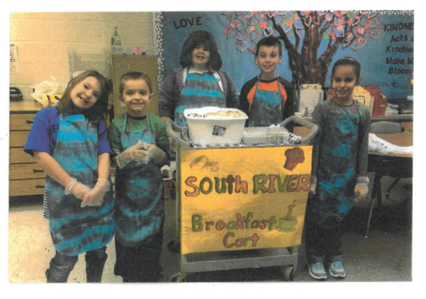

5th Graders
Learning about Making and Saving Money

South River Elementary Breakfast Cart

Introduction
Name: Emily Hartman
Grade Level: Grades K-5 Special Education, Intellectual Disabilities
Abstract: This year-long activity focused on standards addressing money, savings, goods & services, and fractions. The students were required to measure some of the ingredients to prepare two of the items that we sold on the SRES Breakfast Cart this school year

Background
I am a special education teacher of students with Intellectual Disabilities. My students require a lot of exposure, with repeated re-teachings and practice in order to acquire and generalize a skill. I feel that learning how to count and use money is one of the most important skills that I can teach them. In addition to this, the ability to use their social skills so that they may apply their money skills in the real world is essential. I find that the ability to run a business within our school, the South River Breakfast Cart, combines those two very functional skills in a meaningful way for my students with Intellectual Disabilities.
I find that my students are easily distracted and often difficult to engage. The Breakfast Cart provided a real-world example of why learning how to count money and interact socially is so important. With the Breakfast Cart business, the students took more interest in learning how to count money and give change, it really mattered to them!
Overall the students loved the experience, and felt a sense of pride while running the business. It is clear that the students feel a greater sense of self-esteem and pride because of the SRES Breakfast Cart. Teachers view our students in a different light, as they have developed a business that provides a service to them. Our students have learned job skills that will prove extremely useful as they progress through their lives. Their money skills have increased as they see a new reality in the importance of being able to count money. The students’ verbal and social skills increase as they practice the interaction that comes with selling items to customers. Parents tell me that their children go home and talk about the Breakfast Cart and how much they have learned from it. Overall it has been an enjoyable, very educational experience that we would like to continue on for many years to come.

Summary
Our class ran a business called the “South River Breakfast Cart” throughout the course of the 2016-2017 school year. Our business included special education students in grades Kindergarten through 5th grade, with a total of 6 students. We ran the breakfast cart a total of 3 times this school year. Each time the students decided what they wanted to offer, and helped to prepare the food being sold that day. Two of the three times that we ran the Breakfast Cart, the items being sold required the students to use their measuring skills for preparation of the food. The students then walked the cart around the school and sold the items to staff members, taking their money, counting it, and giving change as needed.
Of course there was much preparation that needed to be done ahead of time. We read the book: “One Hen: How One Small Loan Made a Big Difference”. The imaginative pictures engaged the students, kept them interested, and able to discuss the book. They enjoyed seeing how the child in the story took a little bit of money and created a big business, and they were able to make the connection to our class creating a business that could change our school. We completed lessons from the EconEdLink.org website. The students particularly enjoyed the interactive Smart Board portion of the lessons. This enjoyment of the lessons really made the material stick, and to this day the students continue to reference information learned through those lessons. The students had to practice reading money amounts, as the amounts that the staff members owed was written on a spreadsheet. They also needed to practice counting money and giving change to prepare for the big day.
After running the cart, we would always discuss what the students liked most about it, and what they felt they could improve upon next time. Unfailingly, the students always desired to improve their money skills before the next time that we ran the cart. This was the real evidence of the success of the Breakfast Cart – the students developed an internal desire to learn how to count money!
We used some of the profit money at the end of the year to have an awards ceremony and celebration. This was the finale to a discussion we had throughout the year about how you need to work to earn money to be able to buy things.

Economic Objectives

SOLs Covered in Lesson Plan:
(SOL K.7)
ASOL: HS-E2 The student will:
b) explain that people work to earn money to buy things they want.

(SOL 1.9)
ASOL: HS-E4 The student will recognize that people save money for the future to purchase goods and services

(SOL 3.5)
ASOL: 3M-NSCE 5 The student will:
b) Count by tens using money

(SOL 3.7)
ASOL: 3M-NSCE 7 The student will:
a) differentiate between whole, half and fourth

(SOL 3.8)
ASOL: 3M-MG 1 The student will:
- identify coins (penny, nickel, dime, quarter) and their values

(SOL 5.6)
ASOL: 5M-NSCE 4 The student will:
a) differentiate between halves, fourths and eighths

b) explain that people work to earn money to buy things they want.

*

Materials
- The book, One Hen: How One Small Loan Made a Big Difference by Katie Smith Milway
- Technology device to complete EconEdLink.org lessons
- Cart
- Money box (with initial money to create and give change)
- Breakfast Cart sign with “logo” to place on the cart
- Materials to be sold
- Paper/plastic products necessary for items (plates, napkins, forks)
- Spreadsheet with pre-orders and amounts owed (found in appendix)
Plastic gloves
- Aprons
- Hair ties for girls to pull hair back
- 2 written responses for reflection/evaluation (attached)
- Breakfast Cart money spreadsheet

Time Frame
The unit should be completed over the course of a school year. It is amazing how the students grow and feel more comfortable interacting with staff over that time period. Depending on the ages and ability level of the students, I typically aim to run the Cart anywhere from 3 times during the year, to once a month.
Each time the Breakfast Cart runs it takes about 2 to 2 ½ hours to prepare food, run the cart, and clean up/count profit afterward.

Procedure
I. Engage the students in the idea behind the project:
A. Read “One Hen: How One Small Loan Made a Big Difference”. Discuss how the child in the story took a little bit of money and created a big business, make the connection to our creating a business that provides goods and services to our school.
B. Complete lessons from the EconEdLink.org website. Sample worksheets and activities can be found in the appendix.
https://www.econedlink.org/teacher-lesson/910/One-Hen-How-One-Small-Loan-Made-Big-Difference

II. Prepare to run the Cart:
A. Develop a logo for your business. Have the students help to create and color a sign with the logo to place on the cart.
B. Create a staff survey to determine what food items would be of interest. Have students helped to create, distribute, and compile the results of this survey.
C. Practice counting coins and giving change. Particularly focus on using the amounts of money that you will be dealing with the most while running the cart; the amounts the students should decided as a class to charge for the food/drink items.
D. Talk about the verbal/social interaction that will come with the business. Discuss manners, and how to thank customers for their business.
E. Discuss sanitary practices when you are packaging and selling food items to customers. Talk about washing hands, wearing gloves, not putting hands on noses/mouths, and packing food items in clean bags so as not to pick up germs along the way.
F. Create a “staff” uniform. An apron of matching colors (and/or school colors) would be appropriate.
G. Teacher should take pre-orders from staff so the Breakfast Cart workers will only stop at classes choosing to participate, therefore not disturbing teachers/classes who did not want to participate

III. Running the Cart
A. Review sanitary practices: Put aprons and plastic gloves on. Girls pull hair back.
B. Prepare the food item to be sold. Use measurement tools to mix specific amounts if needed.
C. Place your logo on the cart
D. Place your money box on the cart
E. Place the teacher developed spreadsheet of staff pre-orders on the cart
F. Have the students walk the cart around the school, stopping at teachers/classes on the spreadsheet. Take turns letting students push the cart, hand out the food, take the money and give change. It is important for this turn taking to be methodic and teacher dictated, as the students get so excited about the whole process that they fight over who gets to do what job.

IV. Clean up/Closure
A. Put all food items away
B. Put all materials where they came from
C. Have the students help to count the money and subtract the cost of food materials to determine profit. Keep track of purchase cost and profit on a spreadsheet. Put it on the Smart Board and complete it as a class.
D. Have a class discussion to reflect on how the students felt the project went. Have students complete a written response as they are able. (sample found in appendix)
E. Have the students complete a math response sheet (sample found in appendix). This assesses their ability to count the money most often used in our Breakfast Cart: quarters. Edit it to adequately assess the coins you used.
E. Reflect on concepts learned: Engage the students in the Goods and Services EconEdLink.org computer activity. https://www.econedlink.org/tool/101/Goods-Services Determine what goods and services you were providing.
F. Review the “One Hen: How One Small Loan Made a Big Difference” story. Determine what should be done with the profit from the Breakfast Cart. (Encourage the students to roll the profit over so that they can run the Breakfast Cart again).
G. Review the concept that people need to save money for the future to buy goods. Set a goal for what the students want to do with some of the profit money at the end of the year.

Evaluation
There are two written evaluation methods attached that allow the students to demonstrate their money skills as well as reflect on the business. Most of the evaluation is completed through teacher observation and discussion. I found that the students became actively engaged with learning how to count money, and therefore learned the skill much better than they would have sitting at a table counting plastic money and completing a worksheet. They also learned about goods and services with real world examples that they could relate to, which is everything to my students. Each time that we ran the Breakfast Cart I could see pride in the faces of my students, and that is simply priceless for these young folks. The South River Breakfast Cart business provided the students valuable economic lessons and also an everlasting sense of pride and accomplishment.

Appendix
Student Worksheets
Order Forms
One Hen Enrichment Activities

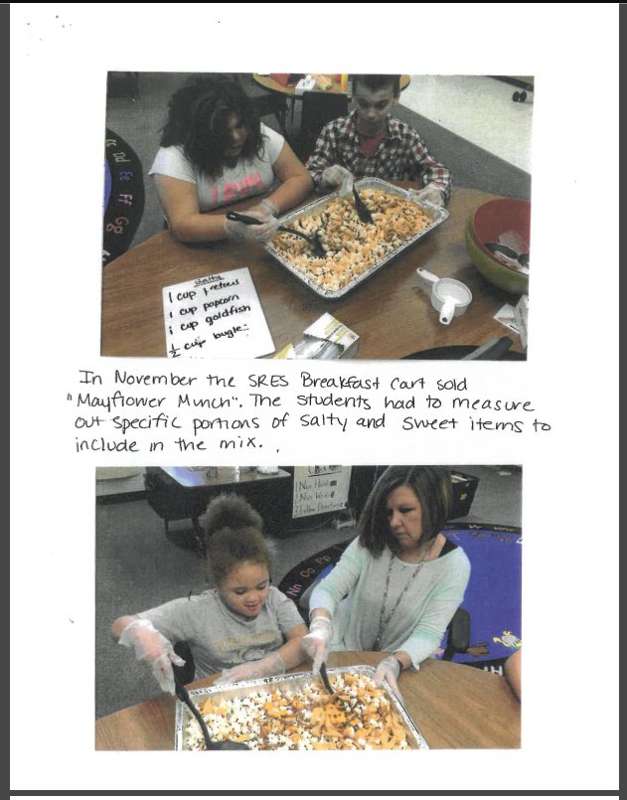

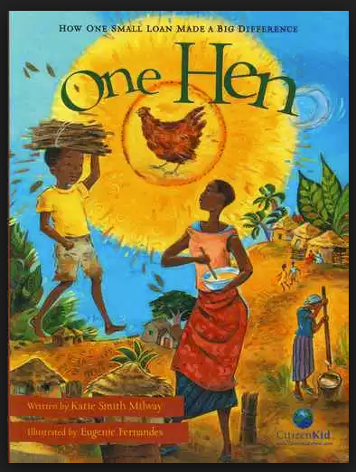

Student Writing Response Activity Sheet

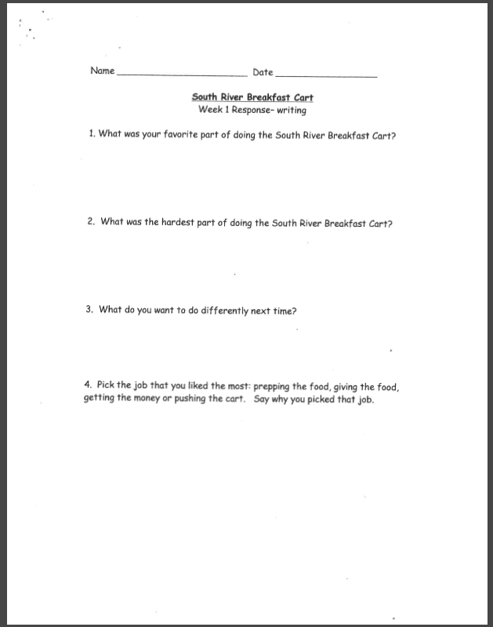

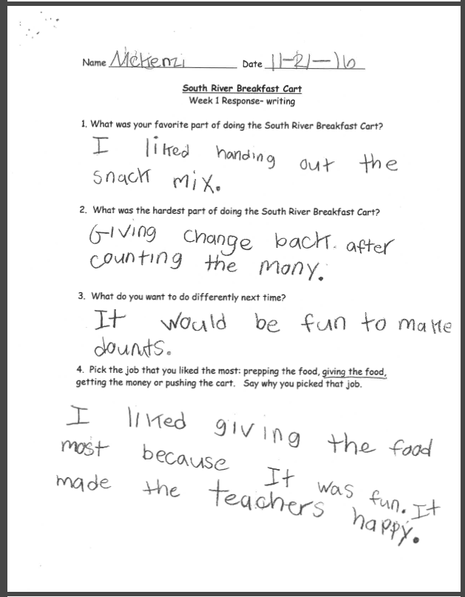

Student Math Response Activity Sheet

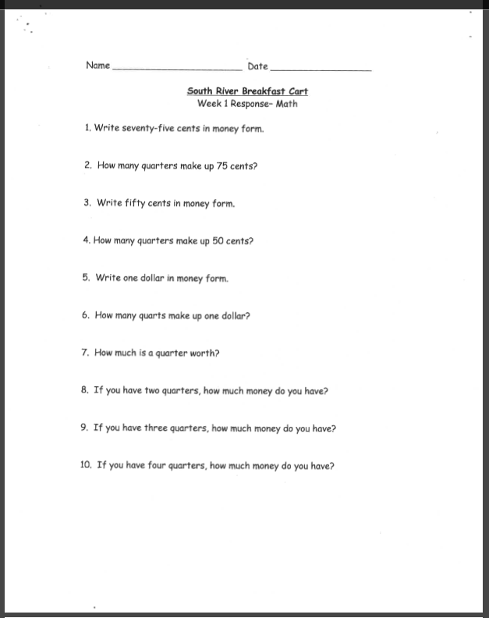
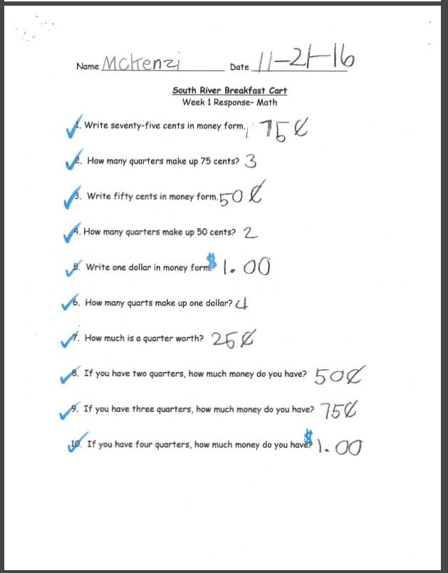

Student Math Response Activity Sheet

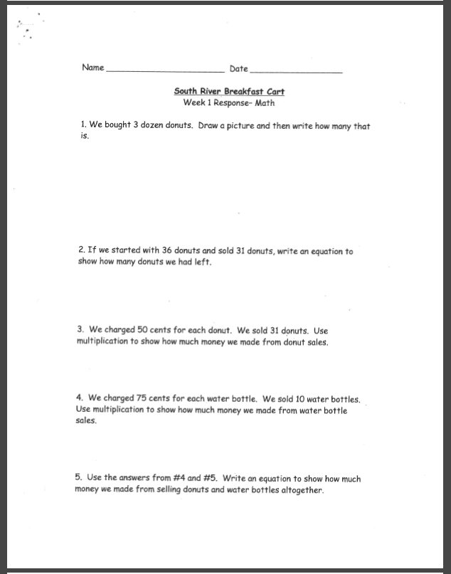

Order & Sales Record Sheets

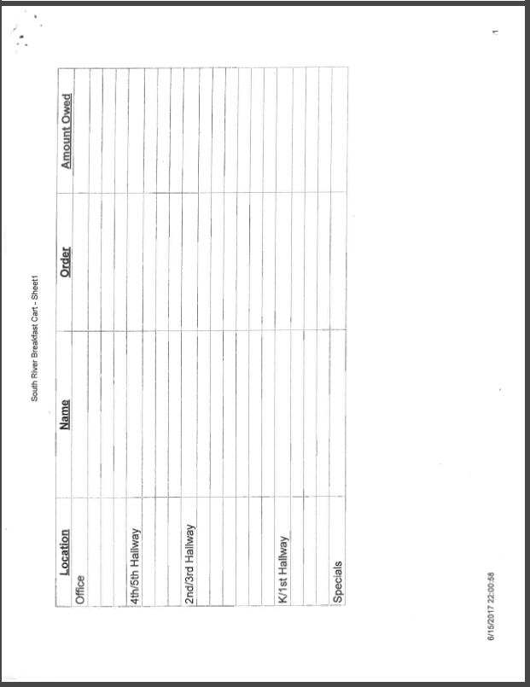

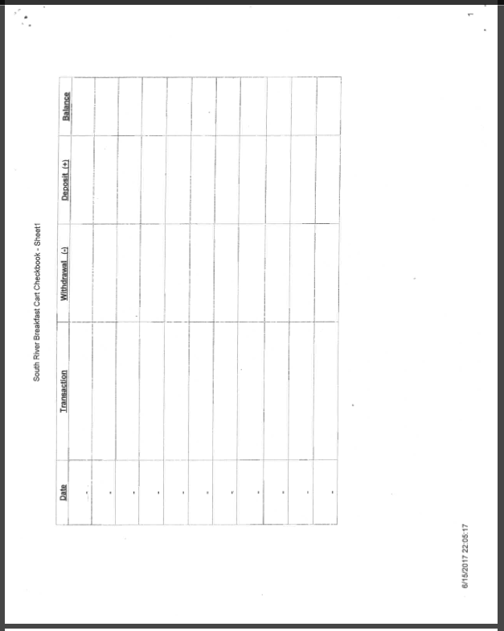

One Hen: How on Small Loan Made Big Difference
Activity Sheets found at:
https://www.econedlink.org/teacher-lesson/910/One-Hen-How-One-Small-Loan-Made-Big-Difference

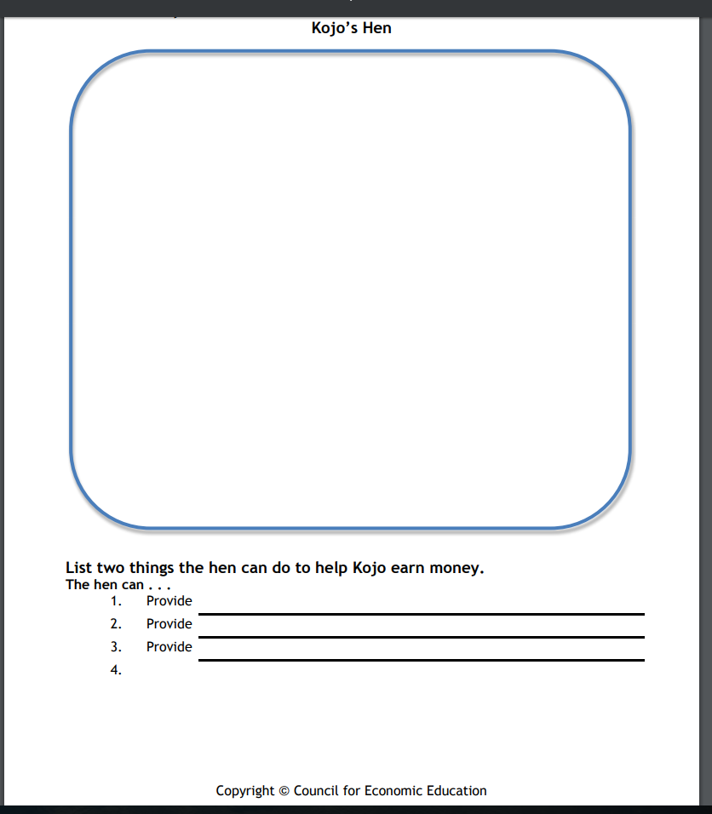

Opporuntiy Cost
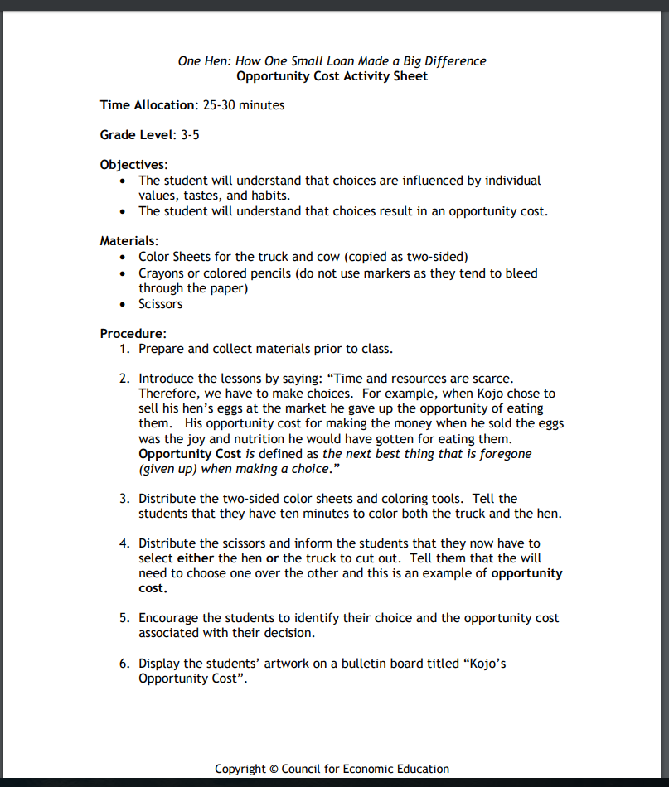

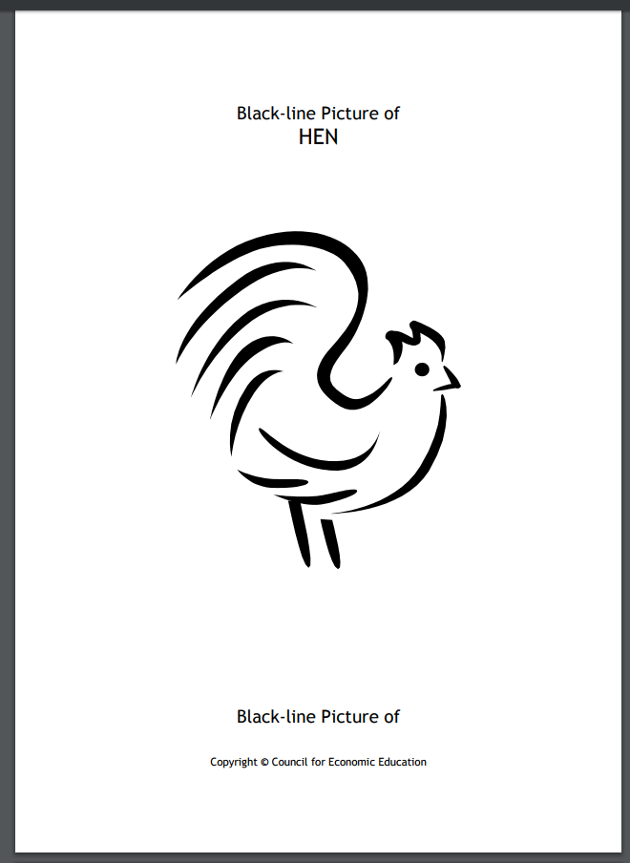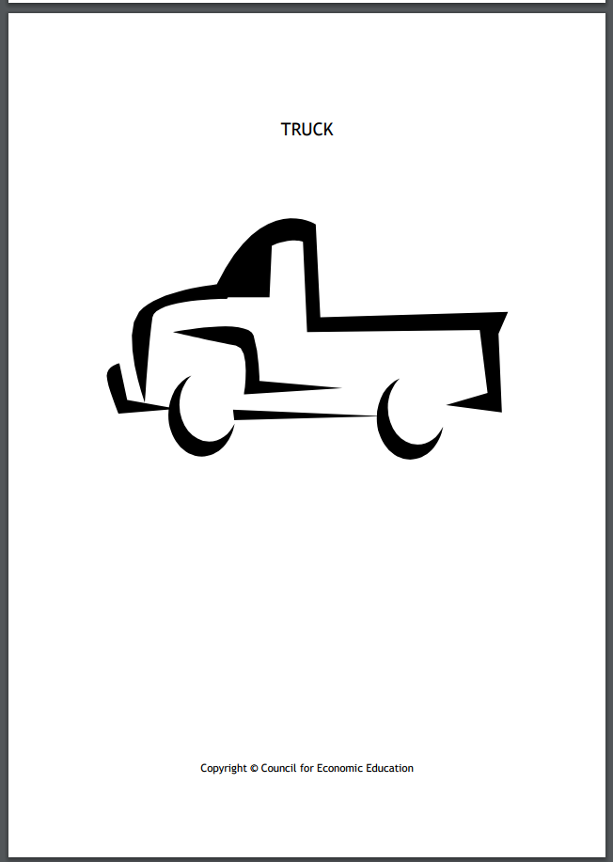

Vocabulary
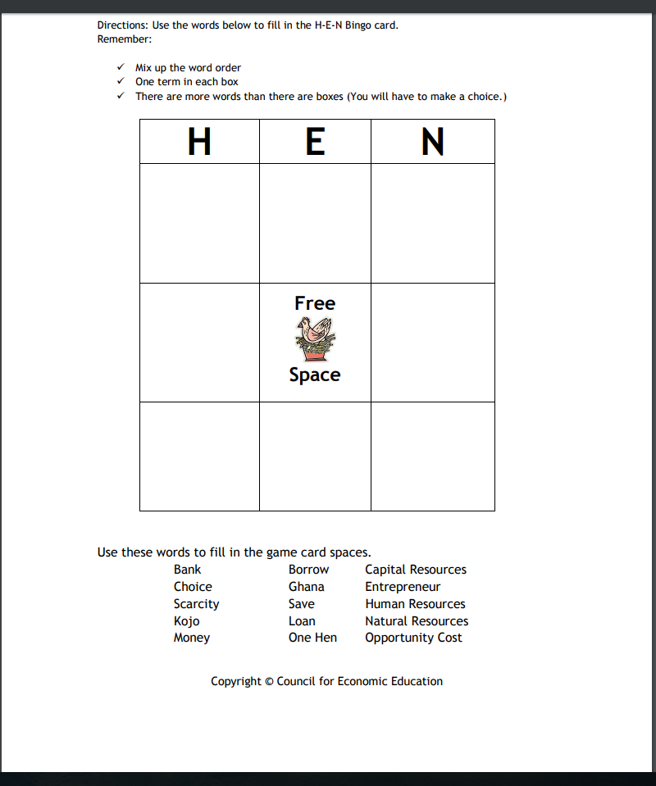
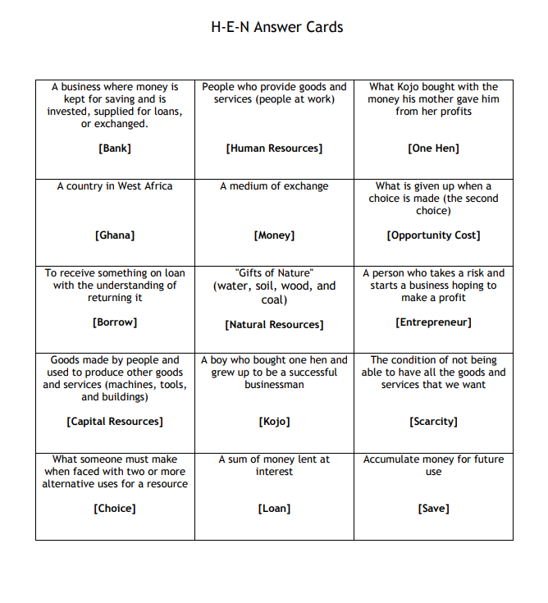

Crossword Concepts
