2018 Virginia Council on Economic Education
Economic Educator Lesson Plan Winner
Submitted by: Lisa Taylor, Leesville Road Elementary School, Campbell County
Grade Level Target: Grade 2/3

Surviving the Heat: A Lesson in Life
By: Lisa Taylor

ABSTRACT

The value of a good or service most certainly depends on supply and demand and that can change in an instant. Surviving the Heat: A Lesson in Life poses a realistic situation that provides meaningful learning experiences for students. As goods and resources become scarce, students will have to weigh opportunity costs in order to make good economic choices. Students will barter for essentials and experience the increase and decrease in value of a good as the supply and demand for it changes. Students will be able to reflect upon their own experience and gain knowledge through peer discussion that will allow them to make better economic choices in the future when faced with unexpected situations.

Providing real life learning opportunities in which students apply knowledge of economic concepts through decision making is an effective approach to economic literacy and lays a foundation for financial literacy as students grow into adulthood. As teachers of economics, it is our ultimate duty to prepare students to be good decision makers and give them the knowledge and tools to plan for the future. It’s important to provide students, even at the elementary level, opportunities to make choices, reflect on the outcomes of those choices, and think about ways to improve decision making skills in future situations.

ECONOMIC CONTENT AND KEY CONCEPTS

goods – things that people make or use to satisfy needs and wants
barter – the exchange of goods and services without the use of money
specialization – when people focus on the production of selected goods and services.
economic choice - - the choice of or decision among alternatives or possibilities
opportunity cost – The next best choice that is given up when an economic choice is made
scarcity – limited resources
supply – the amount of goods/resources available to consumers
demand – the consumer’s need or desire for a good

Students will barter various goods. Each student will specialize in one area and must trade to get the other items needed or wanted. Students will have to make economic choices, weighing the possible opportunity cost in order to make the best choice. Students will experience scarcity when there isn’t enough of a good to meet the demand. There may be an excessive supply of a good or it may not be in demand so the value will decrease. There may be not be a large enough supply of some goods or it may be in high demand, which will make the value increase.

ECONOMIC STANDARDS AND STUDENT LEARNING OUTCOMES

Learning Objectives | Activities | VA SOLs
- Students will choose the goods  - that would be most helpful to  - them. | Students will list brainstorm the goods they will  want to acquire during the discussion section of  the lesson. Then they will list those goods in the  “planning” section of the activity sheet. | K.9a The student will  recognize that people  make choices because  they cannot have  everything they want
Students will barter to try to  acquire what they want/need. | Students will trade their specialized goods with classmates to acquire the other goods they want or  need. There will be goods that are easy to acquire  and there will be some that are difficult to get. If something is scarce, students may need to trade  multiple items to acquire a valuable good. | 1.8 The student will  explain that people  make choices because  they cannot have  everything they want.  2.8 The student will  distinguish between the  use of barter and the  use of money in the  exchange for goods and  services.  3.9 The student will  recognize that because  people and regions  cannot produce  everything they  want, they specialize in  what they do best and  trade for the rest.
- Students will make economic  - choices and identify the  - opportunity cost. | During the bartering activity, students will  encounter situations in which they have to bargain  with their classmates to make a deal both students  agree upon. Since students cannot have everything  they want, they must decide which items they want  more than others. Students will write an example of  a choice they made and the opportunity cost.  Students will share those experiences in a  culminating discussion. | 3.10 The student will  Identify examples of  making an economic  choice and will explain  the idea of opportunity  cost (what is given up  when making a choice).
- Students will reflect on the  - outcome of their choices and  - think about how they might  - make better economic choices  - in the future. | Students will have to make difficult choices during  the bartering activity. Students will be happy with  some of those choices. Students will be asked to  think about the goods they were unable to acquire  and write about the choices they would make if they were able to trade again. If the teacher chooses,  there is an option to repeat the learning experience  so that students can make different choices to  attempt a more desired outcome. Students will share their insights with their classmates during the culminating group discussion.
- Students will be able to  - describe how scarcity or  - abundance changes the value  - of a good. | Because some students will be assigned more  valuable items, those goods will become scarce.  Students who want to obtain those items will have  to give up more of their supply in order to acquire  them. | 2.9 The student will explain  that scarcity requires people  to make choices about  producing and consuming  goods and services.

INSTRUCTIONAL PROCESS

Surviving the Heat – A Lesson in Life – TEACHER GUIDE
Time required: 90 minutes
LESSON DELIVERY SUGGESTIONS
Option 1: One 90-minute session
Option 2: Two 45-minute sessions (the situation, planning, bartering in one lesson and writing, reflecting, discussion in another lesson)
Option 3: Three 30-minute sessions (the situation, planning, and bartering in one lesson, writing in one lesson, reflection and discussion in another lesson)
MATERIALS:
- A copy of Surviving the Heat: A Lesson in Life for each student (two pages)
- A copy of supplies (projectible or copies for students to share to brainstorm)
- 10 copies of the supplies sheet. Cut the items out and place like items together. These are the goods you will assign to your students.
DIRECTIONS
Step 1: Introduce the situation. Project or provide paper copies for students. Discuss some difficulties students might experience in a power outage in very hot weather. (ex – If you do not have power, what will happen to all of the food in your refrigerator? It will be very hot so how will you keep cool? There is no electricity so what will you do for entertainment?)
Step 2: Assign the goods. Assign every student a good by passing out 10 pictures of the same good from the “supplies” sheet.
Step 3: Prepare students to make a plan. Show students a copy the supply sheet so they can see all of the goods that are available. Talk about a few of the goods and how they are used (generator, solar power radio, etc.) Have students think about these things:
- How will you survive the heat? What will you eat/drink?
- Will you lose all your food or will you find a way to save it?
- What will you do during the next three days to pass the time?
Explain to students that they must have at least one of each of the following:
___ food ___ a source of light
___ water ___ some form of entertainment to pass the time

Have students briefly create a “wish list” on the Surviving the Heat paper to prompt them to think about what they might want to attain while bartering.
Step 4: Students barter. Allow students about 10-15 minutes to barter for the items that will help them survive the heat. Have students use the checklist on the Surviving the Heat paper to make sure they have everything required.
Step 5: Students write. In the “Your Story” section of the Surviving the Heat paper, allow students to briefly write how he or she survived the heat.
Step 6: Students share. Students can learn a lot from listening to their peers’ experiences so this is an important part of the lesson. In order to keep students engaged in the sharing process, you may want to divide students into groups of 3-5. Have each student share his or her experience with the small group. As students are sharing, listen for creative ideas or problems that were encountered. Gather together as a large group and have a few students share their successes, creativity, or hardships.
Step 7: In the “Your Knowledge” section, have students write about (or orally discuss) the different economic choices they might make if they had a chance to do this activity again.
Step 8: Final Discussion:
- Have students share some of the different economic choices they would make is given another opportunity. Ask students to identify their opportunity costs (what they would give up to get what they wanted).
- Were there any items that were more valuable than others? Were there items that were worth very little? Why?
- If the situation was a snow storm in the middle of January instead, would any items become more or less valuable? Do you think any items would be scarce in a snowstorm?

EVALUATION OF STUDENT LEARNING

Students can be observed bartering to obtain the goods they want or need.

Students will list the goods they plan to acquire to demonstrate their planning. (Surviving the Heat sheet, page 1)

Students will describe how they used the goods they attained. (Surviving the Heat, page 2 “My Story”)

Students will reflect upon their learning by writing how they would make better economic choices in the future. (Surviving the Heat, page 2 “My Knowledge”)

Students will explain during the culminating discussion what one example of an opportunity cost they encountered during the bartering activity.

Name ___________________________________________
Surviving the Heat – A Lesson in Life
The Situation: It is a hot July evening. A thunderstorm blows through with gusts of wind up to 60 mph. Trees are uprooted and power lines are knocked down. Suddenly, the power goes off. The power company says that it will take three days to restore all power. The water from the faucet is brown and is not safe to drink. You just went to the grocery store earlier that day and have a refrigerator full of groceries that will soon spoil unless you find a way to keep them cool. The temperature tonight will be 80 degrees. Tomorrow it is predicted to be 105 degrees. Luckily, you are in the production business and have a supply of a certain good. You can trade your good for other goods to help you survive comfortably.
_____________________________________________________________________
My Wish List
___ water
___ food
___ light
___ entertainment
other things:
My Plan: Take a look around at all of the goods that different people in your community have and think about the goods that would be useful to you. Make a list of things you’d like to have.
Things to think about:
- How will you survive the heat?
- What will you eat and drink?
- Will you lose all your refrigerated food or will you find a way to save it?
- What will you do during the next three days to pass the time?
_____________________________________________________________________
Bartering:
Things you must have:
___ food
___ water
___ a source of light
___ some form of entertainment to pass the time (You may be creative and invent something.)

My Story: How were your goods used to survive the heat. Describe your experience.

My Knowledge: What would you do differently after thinking about your experience and listening to your classmates’ stories?

Were there any items that were more valuable than others? Were there items that were worth very little? Why?

SUPPLIES
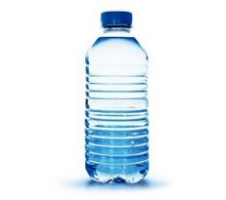  This Photo by Unknown Author is licensed under CC BY-NC-ND  WATER | 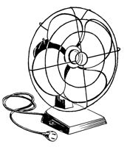  FAN  (need generator) | NOODLES | 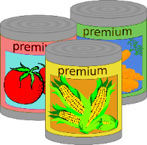  CANNED FOOD  (need can opener)
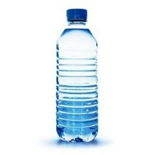  This Photo by Unknown Author is licensed under CC BY-NC-ND  WATER | This Photo by Unknown Author is licensed under CC BY-NC-ND  BOOKS | 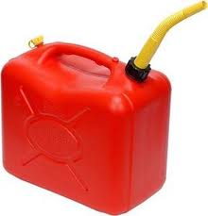  GAS | 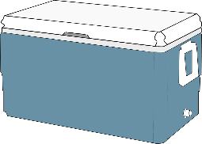  COOLER  (needs ice – you can keep all of the food in your fridge if you have this)
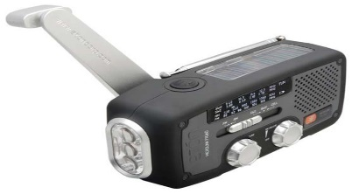  This Photo by Unknown Author is licensed under CC BY-NC-SA  SOLAR POWERED RADIO | 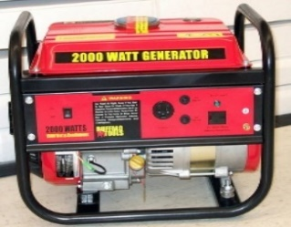  GENERATOR  (needs gas – you can power the fan, refrigerator) | 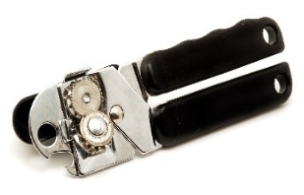  CAN OPENER | 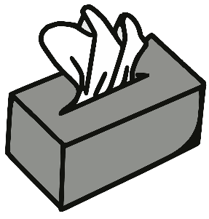  BABY WIPES
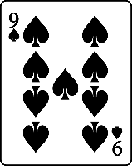  CARDS | BALL | 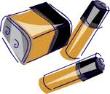  BATTERIES  (for flashlight and radio) | 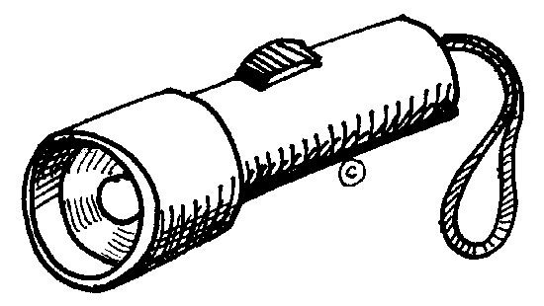  FLASHLIGHT  (needs batteries)
CANDLE | 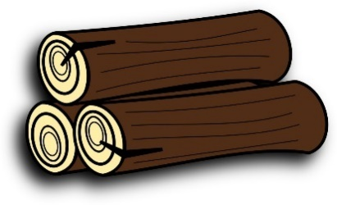  LOGS | HAND FAN | ICE
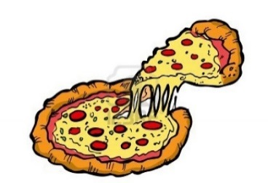  PIZZA | RADIO  (needs batteries) | LEMONADE | 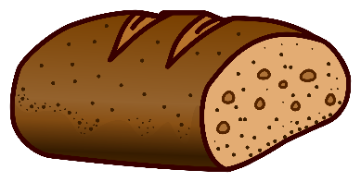  BREAD
* image of solar powered radio and generator have creative common licenses, author unknown

