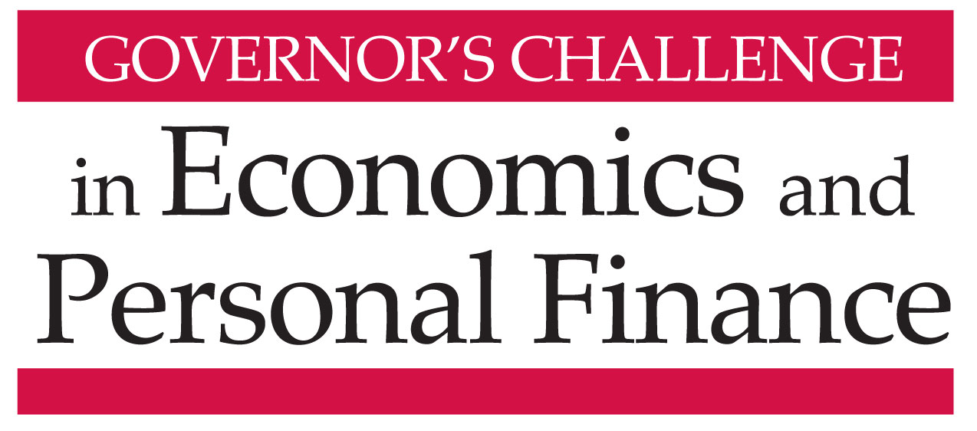

Capital One – West Creek Building Town Center
Thursday, April 11, 2019

AGENDA

9:00-9:30am Registration and refreshments in The Gallery - Teams then report to their rooms

9:30-11:25 Personal Finance Challenge – Forum Room (24A) (also 23E)
Host: Sarah Finley, Director of Programs, Virginia Council on Economic Education

Group 1 – Room 23B
Host: Rebecca Booth, Director, Center for Economic Education at University of Lynchburg
Judges:
- Omar Kemp, Foresters Financial Services
- Mark Newfield, CFP®, Newfield Financial Solutions
- Joey Stemmle, CFP®, Financial Advisor, Riverstone Wealth Advisory Group
Time keeper: Mark Barrett, BB&T Scott & Stringfellow

Group 2- Room 23D
Host: Dr. Cheryl Ayers, Co-Director, Virginia Tech Center for Economic Education
Judges:
- John McFarland, CFP®, Retired, Financial Planning, VCU School of Business
- William Moore, CFP®, Wealth Management Advisor, Executive Benefits Strategies
- Jerry Varela, CFP®, Trainer, PIEtech
Time keeper: Dr. Tricia Jacobs, CTE Coordinator for Curriculum and Instruction, VDOE

9:30-11:20 Adam Smith Economics Challenge – Rooms 22A/B
Hosts: Dr. Stephen Day, Director, VCU Center for Economic Education
John Kruggel, Associate Director of Program, JMU Center for Economic Education

9:30-11:20 David Ricardo Economics Challenge –Rooms 21C/D
Hosts: Ruth Cookson, Director, ODU Center for Economic Education
Kate Scott, Associate Director, GMU Center for Economic Education

11:30-12:20pm David Ricardo Division – Rooms 22CDE
Welcome and announce winning teams: Daniel Mortensen, Executive Director, VCEE
Online Regional Winners Recognized: The Honorable Atif Qarni, Secretary of Education, Office of the Governor

Quiz Master: Judy Pahren, Senior Vice President, Capital One
Judges:
- Nicholas Haltom, Director, Economic Education, Federal Reserve Bank of Richmond
- Dr. Fletcher Mangum, Managing Partner, Magnum Economics, LLC
- Dr. Edward Millner, Professor, Department of Economics, VCU School of Business

Presentation of Awards: The Honorable Atif Qarni, Secretary of Education, Office of the Governor

12:20-12:50 Lunch: Students: Food in The Gallery/registration area. Seating for:
Adam Smith & Personal Finance Group #1 students in 22A/B;
David Ricardo and Personal Finance Group #2 students in 21C/D
Teachers and adult guests have lunch in the Forum Room in 24A
Thanks to Virginia Lottery for sponsoring Teachers’ Luncheon

12:50 TAKE YOUR SEATS FOR CONTINUATION OF CHAMPIONSHIP ROUNDS
in Rooms 22CDE

12:55-1:40 Personal Finance Division
Online Regional Winners Recognized: Gena Keller, Assistant Superintendent for Learning, Virginia Department of Education

Championship Round
Master of Ceremony: Judy Pahren, Senior Vice President, Capital One
Judges:
- Wendell B. Fuller, CFP®, NAPFA-Registered Financial Advisor, Fuller Wealth Advisors
- Oscarlyn Elder, Group Managing Director, Mid-Atlantic and Northeast Investment Solutions Group, SunTrust
- Judith Sams, Business & Information Technology Specialist, VA Dept. of Education

1:40-2:30 Adam Smith Division
Online Regional Winners Recognized: Stephanie R. Peters, President & CEO, Virginia Society of CPAs, and Chair, VCEE Board of Directors

Championship Round
Quiz Master: Dr. Carol Scotese, Chair, Department of Economics, VCU School of Business

Judges:
- Nicholas Haltom, Director, Economic Education, Federal Reserve Bank of Richmond
- Dr. Fletcher Mangum, Managing Partner, Magnum Economics, LLC

Presentation of Adam Smith and Personal Finance Awards: Stephanie R. Peters, President & CEO, Virginia Society of CPAs, and Chair, VCEE Board of Directors

2:30pm Adjourn

We gratefully acknowledge financial support for the Governor’s Challenge provided by:

