John Deere, That’s Who!

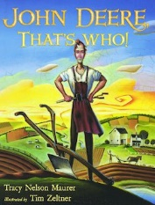

Book Synopsis: In the 1830s a young blacksmith living in Vermont is having a run of bad luck. Deciding to get a new start he moves to Illinois and uses his skills to invent a steel plow that helped farmers cultivate the rich, thick soil.

Lesson
John Deere Makes a Decision

Introduction: After John Deere’s forge burns down for the second time, he has a decision to make. Should he rebuild or move on and try his luck in another location.

Time: 25-30 minutes

Grade Level: 3-5

Materials:
- Book – John Deere, That’s Who by Tracy Nelson Maurer
- Visual- Economic Concepts
- Visual- Decision-Making Grid
- Activity Sheet- Decision-Making Grid
- Writing Tools

Objectives
- Students will review the definitions for the economic concepts: benefit, cost, consumer, producer, goods, services, choice, and opportunity cost.
- Students will use a decision-making model to reach a decision by weighing the costs and benefits of their options.
- Students will develop skills using the decision-making model in order to improve their ability to make reasoned decisions.

Virginia Standards of Learning – History and Social Science
K-3.1h | The student will demonstrate skills for historical thinking, geographical analysis,  economic decision making, and responsible citizenship by using a decision-making model to  make informed decisions.
K.9 | The student will  a) recognize that people make choices because they cannot have everything they want; and  b) explain that people work to earn money to buy the things they want.
1.7 | The student will explain the difference between goods and services and describe how people are consumers and producers of goods and services.
1.8 | The student will explain that people make choices because they cannot have everything they want.
2.8 | The student will describe natural resources (water, soil, wood, and coal), human resources (people at work), and capital resources (machines, tools, and buildings).
2.10 | The student will explain that scarcity (limited resources) requires people to make choices about producing and consuming goods and services.
3.10 | The student will identify examples of making an economic choice and will explain the idea of opportunity cost (what is given up when making a choice).

Procedure:
- Prepare and collect materials prior to class.
- Introduce the lesson asking the students if they have ever heard of John Deere. Explain that the story they are about to hear takes place in the 1830s and is about a decision John Deere make when he was a young blacksmith working in Vermont.
- Read the book John Deere, That’s Who to the class. This takes between 4-5 minutes.
- Review the listed economic concepts on Visual 1 with the students. These terms have connections to the story.
- Explain that all decisions have costs and benefits and that John Deere experienced some positive and some negative things when he moved to Illinois. Did he make the right choice? If he and his family had created a cost-benefit decision grid before spending moving his business, would he still have left Vermont?
- Display Visual 2. Solicit suggestions from the students concerning the costs and benefits of making and selling lemonade and record them on the Cost-Benefit Decision Grid visual. Accept all reasonable suggestions.

Possible Student Suggestions

Benefits of moving to Illionis | Costs of moving to Illionis
☺ It might be a good thing to get new costomers.  ☺ There would be fewer blacksmiths there and less competition  ☺ You are a good blacksmith so starting at a new location might be good for business  ☺ You have to pay off a debt so you have to work  ☺ It will be interesting to solve new problems in a creative way | ☹ You will miss your family  ☹ Your success depends on other people being able to be successful  ☹ The weather could be terrible.  ☹ Many other blacksmiths might have the same idea and there would be too much competition.  ☹ There may be no customers  ☹ You may not make enough money to pay off your dept

- Ask the students to use the information they have suggested on the Cost-Benefit Decision Grid to help them decide, if they were John Deere, if they would move to Illinois. Take a class vote and record the most popular choice in the Decision box.
- Distribute the activity sheet and writing tools. Instruct students to complete a Cost-Benefit Decision Grid based on another situation from the story. (Students may work in pairs or small groups.) Decision Examples: Should John Deere build a new forge after the first one burns down? Should John Deere bring his family with him to Illinois as he is starting his business? Should John Deere continue being a blacksmith?
- Allow students to share their completed Cost-Benefit Decision Grids including their final decision with the class.
- Conclude the lesson by reminding the students that all choices have costs and benefits. Often, we will make better decisions if we stop and think about our costs and benefits before we choose what to do.

Extension Activity:
“Dig into More Facts about John Deere and his Company” is found in the back of the book. This bulleted list of interesting facts contains details about the subject that the students will find fascinating. Encourage students to research an entrepreneur of their own and create a list of five or more facts about this person. Some early American entrepreneurs include: P.T. Barnum, Andrew Carnegie, George Eastman, Thomas Edison, Henry Ford, Benjamin Franklin, Madam C.J. Walker, and George Westinghouse.

Visual 1
John Deere, That’s Who
Economic Concepts

Benefit- A benefit is what satisfies your wants.
A benefit is the positive effect of a decision. ☺

Cost- A cost is what you give up when you decide to do something. A cost is the negative effect of a decision.

Consumer- A person who uses or buys goods and services is a consumer.

Producer - A person who makes goods or provides services is a producer.

Goods - Things people make or use to satisfy wants are goods.

Services - Activities that satisfy people’s wants are services.

Choice (or Economic Choice) - You cannot have all the goods and services you want, so you must choose some things and give up others. A choice is the decision you make among alternatives or possibilities.

Opportunity Cost - The next best choice that is given up when you make a decision is your opportunity cost.

Visual 2
John Deere Makes a Decision
Cost-Benefit Decision Grid
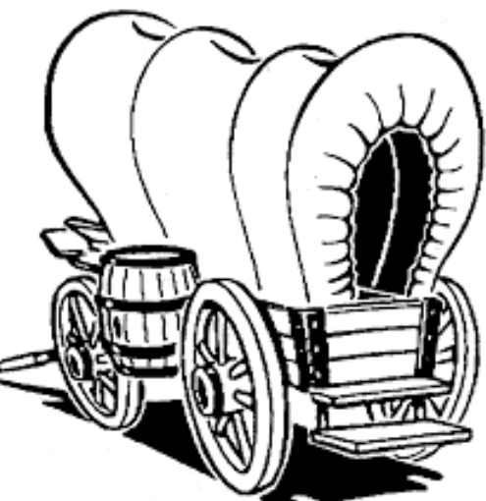

Problem: Should John Deere leave Vermont and move to Illinois to start a new business

☺  Benefits of moving to Illinois  A benefit is what satisfies your wants | ☹   Costs of moving to Illinois  A cost is what you give up when you decide to do something
☺  ☺  ☺  ☺ | ☹  ☹  ☹  ☹

Decision:

Activity Sheet-

Cost-Benefit Decision Grid

Problem:

☺  Benefits ______________________  A benefit is what satisfies your wants | ☹   Costs ________________________  A cost is what you give up when you decide to do something
☺  ☺  ☺  ☺ | ☹  ☹  ☹  ☹

Decision:

