Spend It!
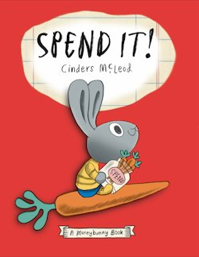
Lesson
Opportunity Cost
BOOK SYNOPSIS: In Bunnyland, Sonny gets three whole carrots for his weekly allowance. He wants to buy everything with it! But he soon discovers his money won't go that far, and his mom tells him he needs to make some choices. Even though this doesn't sound like much fun, Sonny soon learns what’s really important and how to make an informed decision.

INTRODUCTION: In this activity, students learn the hard lesson of making a choice. Just like Sonny, they will have to make a decision, thus giving up other possible choices,

TIME REQUIRED: 25-30 minutes.

OBJECTIVE:
- The student will be introduced to the concept of opportunity cost: “In a choice, the benefit expected form the highest valued alternative forgone; or what you give up when you make a choice.”

MATERIALS:
- Book Spend It! By Cinders McLeod
- Prepared color sheets (duplicated front-to-back)
- Crayons or colored pencils
- Scissors

ECONOMIC CONCEPTS:
Because we cannot have everything we want (scarcity), we must make choices. Each time we make a choice, we give something up. There is always a next best alternative when making any choice. The value of this next best alternative (or second favorite choice) is the opportunity cost.

PROCEDURE:
- Prepare the materials prior to class. Run off the vegetable color sheets, front to back in different combinations.
- Introduce the lesson by reading the book Spend It! by Cinder McLeod to the students. This will take between 4-5 minutes.
- Ask the students why Sonny had to make a choice between a pogo stick, toy rocket, and bouncy castle. [He had a limited amount of money.]
- Inform the students that they will be helping create a display showing Sonny’s choices plus what is used as money in Bunnyland.
- Distribute the prepared activity sheets and coloring tools.
- Instruct the students to color both sides to the best of their ability. When the students are finished, give them a pair of scissors and inform them they must cut out ONE of their colored vegetables for display. Explain that the other side will be destroyed, so the chance to display that side will be their opportunity cost. (Be prepared for complaints from the students, some who will have a hard time choosing which item to keep.)
- Display student work on a bulletin board titled “Spend It! Opportunity Cost”.

EXTENSION ACTIVITY:
Tell the students that money is anything that is used as a medium of exchange. Ask them what they and their parents use for money. [Possible answers: currency, coins, checks, credit cards, debit cards, gift cards.] Remind them that in Bunnyland carrots are used to purchase goods and services. Ask the students if they think carrots would be something people could use as money.
Create a class list of the positive and negative characteristics of using carrots as money.

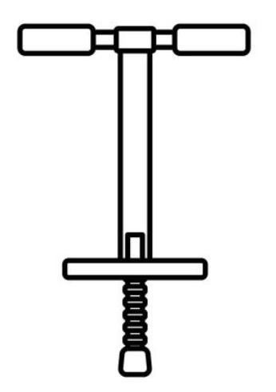

Pogo Stick

Toy Rocket

Bouncy Castle

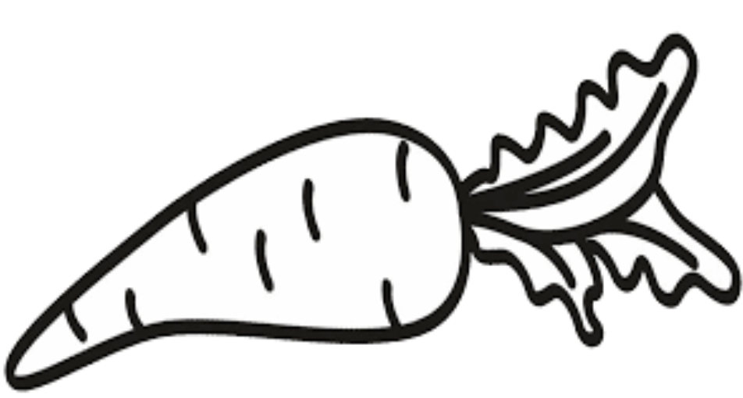

Carrot

